by email to Hazel Schofield, [Bignal-Schofield@dft.gov.uk](mailto:Bignal-Schofield@dft.gov.uk) 27th January 2020

Dear Minister,

Thank you for your information request, which was passed on to us by (and discussed with) Hazel Scofield.

We are extremely pleased to hear that you are keen to progress a range of decarbonising measures as swiftly as you can, and can appreciate the urgency you must feel on this, particularly in light of the UK hosting COP 26 later this year. The risk of RTFO buy out, must also be focusing the mind. The RTFC price has been climbing steadily since August 2019, and has recently been at the buyout price. At this price oil majors have no additional financial incentive to blend biofuels or purchase certificates, and there is a risk that they could buyout. Some are of the view that all the while certificates are available, the oil majors will not buyout. However, the UK is already close to hitting the blend walls (of B7 and E5), which compounds the risk of buyout. The introduction of E10 would immediately allow more blending of bioethanol, which is the cheapest option. Media reports suggest that the oil majors are considering buy out. If one company starts buying out, the likelihood is that rest would follow. If buying out were to occur it would continue to cost the UK motorist some £1.2 billion per year, for no environmental benefit and would be a severe embarrassment at COP26.

We have some suggestions that should assist you in your rapid and deep decarbonisation objectives. The main measures, listed below, are elaborated on in this briefing, before we turn to your specific questions.

1. Introduce E10 to permit greater volumes of renewable fuel to be blended
2. Increase the basic target levels within the Renewable Transport Fuel Obligation (RTFO) to increase decarbonisation in transport
3. Retain the Greenhouse Gas Reporting Regulations
4. Introduce incentives for higher blend biofuel uptake in heavy duty vehicles and non-road mobile machinery
5. Introduce more pragmatic rules to encourage the production of hydrogen from renewable electricity, for use directly as a transport fuel or for use in the production of renewable drop in biofuels and aviation fuel

We would be delighted to work with you and your officials on the above topics.

One immediate request we have is to get a date in the diary with you and your officials for a meeting on options for decarbonising heavy goods vehicles, to discuss an initiative we are working on (in collaboration with the Gas Vehicle Network) and which covers both gaseous and liquid fuels.

Yours sincerely,

Gaynor Hartnell, Head of Renewable Transport Fuels, REA

## E10

E10 is the most cost-effective, rapidly-implementable and “oven-ready” decarbonisation action and it should be implemented immediately.

We are well behind Europe, and much of the rest of the globe on this issue.  E10 is currently available in the Baltic countries, Belgium, Bulgaria, Finland, France, Germany, Hungary the Netherlands, Romania and Slovakia. The CZ Republic will introduce E10 later this year and very likely Austria too, and Poland will introduce E10 in 2021. In Bulgaria, Belgium, Finland, the Netherlands and Romania E10 is the main petrol blend (98% of the petrol market) and in France the E10 share is around 60%.  It is the European test fuel for type approval fuel consumption and emission testing of petrol cars since 2016.  Its immediate introduction could help prevent the oil majors buying out of the RTFO.

The UK’s failure to have introduced E10, despite working on the issue since 2014 is lamentable. The events since 2014 are summarised in the table below.

|  |  |
| --- | --- |
| Date | Event |
| Sept 2014 | 29th Sept First meeting of the Transport Energy Task Force, set up by DfT and the LowCVP as a mechanism for stakeholders to help the Government with policy on decarbonisation. |
| March 2015 | The Task Force published its final report. It agreed that E10 would probably be required to meet the RED target and that the majority of petrol vehicles are currently compatible with E10, and identified it as being a low risk, lower carbon and sustainable fuel to |
| Aug 2015 | An E10 Group was set up at the request of the DfT to help the Government to examine and formulate options for its introduction. |
| March 2017 | The E10 Group issued its final report. It set out the requirements it identified as necessary to the successful deployment of 95 E10. |
| Nov 2017 | DfT established the AFID E10 Working group, and asked LowCVP to host a workshop to review with stakeholders covering • How to manage the introduction of labelling for vehicle and refuelling points by October 2018, and • How to prepare for the possible introduction of E10 fuel focusing on how best to communicate the implications to consumers. |
| July 2018 | Government published the “E10 petrol, consumer protection and fuel pump labelling” consultation, which contained a call for evidence on the introduction of E10. The document set out the benefits of E10 extremely clearly. |
| Oct 2018 | DfT announced that it would publish the conclusions of the “E10 petrol, consumer protection and fuel pump labelling” in two parts, with the E10 element “in the new year” |
| March 2019 | Still no consultation response, but DfT reported that the “Message from the call for evidence was clear –requiring retailers to supply three petrol grades across the UK would be challenging, expensive and take time to implement. Ministers have therefore requested we look at other policy options for the introduction of E10.” |
| June 2019 | At QSW DfT reported “Still planning to get a consultation out as soon as possible. Publication will include both a response to last year’s Call for Evidence and new proposals on next steps for E10” |
| Oct 2019 | QSW made no mention of E10 |
| Dec 2019 | REA members told publication of the E10 consultation response was imminent, and should the outcome of 12th December election see George Freeman and Grant Schapps be retained in DfT ministerial team there should be no impediment to its release. |

## Increase the basic target levels within the Renewable Transport Fuel Obligation (RTFO)

The basic RTFO target should be increased to a minimum of 15% next year, and then reviewed at the next opportunity with a view to a further increase, in order that that pressure on replacing fossil fuels with renewable alternatives continues to grow. DfT should also clarify that the RTFO continues beyond 2032 and that the crop cap should be revisited if it constrains domestic bioethanol production.

The percentage level of the basic RTFO[1] remains constant to 2032 (at 9.6%), whilst the volume on which the obligation is calculated is expected to fall. A small delegation of REA members recently presented the results of its modelling work to members of the DfT’s Low Carbon Fuels Department. They showed that if the expected trends listed below materialise, the absolute amount of sustainable biodiesel used in the UK will fall from 2 billion litres to around 0.8 billion litres by 2032.

It would be perverse to relax efforts on decarbonising fuels, and therefore in order simply to prevent biofuels’ contribution to greenhouse gas reduction from falling, the RTFO target needs to be increased from 9.6% to 15%. Increasing the target above this would be desirable, as the UK should be aiming to increase the effort on decarbonising fuels, not merely ensuring it remains at the same level.

Current trends and their impacts on biofuel consumption:

* The electrification of passenger cars will result in a reduction in the requirement for biofuel blending.
* The eventual introduction of E10 will result in a reduction in biodiesel blending.
* Biomethane will account for a growing proportion of biofuels (predominantly in large commercial vehicles and buses); in the modelling we suggest that it could rise to 0.855 billion litres equivalent (or 450k tonnes/yr.) by 2032.

We have provided a copy of our model, at the request of your officials.

The presentation made to DfT officials on 10th December is attached with the covering email accompanying this briefing. Alternatively it can be downloaded from [here](https://www.r-e-a.net/wp-content/uploads/2020/01/REA-modelling-on-potential-future-biofuels-target.pdf) [2].

The REA’s modelling also shows that the crop cap will constrain the amount of sustainable bioethanol that can be blended into the UK’s petrol to make it greener. This would be detrimental to the environment, jobs and our balance of trade and thus will need to be addressed.

## Retain the Greenhouse Gas Reporting Regulations (GHG regs)

Continuing with the GHG regs beyond this year would send an excellent signal that the UK is serious about taking a long term view on decarbonising transport.

The GHG regs create an incentive for biofuels producers to strive for greater GHG saving than the minimum threshold required for the RTFO (i.e. the 60% GHG saving for plants built after 5 October 2015). The policy is straightforward and logical, and deserves to be maintained. Its impact is probably significantly understated at present, given that the market understands it falls away after 2020. Anecdotal evidence we have from some members is that it is not worth investing in processes that reduce the GHG beneath RTFO thresholds due to the expectation that the mechanism will end in a matter of months.

## Boost incentives for higher blend biofuel uptake in heavier vehicles (and NRMM)

DfT should introduce policies to incentivise the higher blends of biodiesel (B20, B30, B100), and drop in fuels such as paraffinic diesels. It should also begin to examine the implications of a transition from B7 to B10.

Biodiesel can be blended at higher levels than 7%[3]. Blends of 20% and above are referred to as higher blend biodiesel and these can be a cost-effective fuel for some fleet operators. Not all OEMs warranty the use of these fuels, although some are prepared to warranty the engine but not the fuel supply line and the market has begun to find solutions to this situation, whereby the fuel supply elements can be insured separately.

We welcome the DfT’s intention to convene a high blends working group, and look forward to working with DfT and other stakeholders to find suitable policies or taxation methods to create an incentive for these blends. (There are a number of other anomalies in fuel duty which should also be looked at, for example there is no fuel duty on electricity and hydrogen (fossil or renewable) and there is no distinction between renewable fuels and fossil fuels, nor any incentive for more advanced fuels).

With respect to buses, TfL has made extensive efforts to bring about high blends to decarbonise its existing diesel and hybrid busses but it sees little prospect of movement from those OEMs that will not warranty B20[4]. Where buses are covered by warranty [5] the operating companies take full advantage of the ability to use the higher blends. TfL is looking for further decarbonisation of these vehicles and the REA has suggested that a 100% renewable fuel comprising 20% B100 and 80% HVO should be considered.

Renewable paraffinic diesel (eg HVO or gas-to-liquid fuels made from renewable methane) can also improve air quality emissions in some cases. NOx and other air quality emissions can be reduced on older, more polluting internal combustion engines, but with respect to Euro 6 engines, the improvement in air quality emissions is negligible. There is significant scope for improving air quality in city centres from requiring NRMM such as older construction site vehicles to adopt higher blends of biofuels. According to the most detailed air-quality study in the UK, the London Atmospheric Emissions Inventory, construction sites are responsible for approximately 7.5% of damaging nitrogen oxide (NOx) emissions, 8% of large particle emissions (PM10) and 14.5% of emissions of the most dangerous fine particles (PM2.5). The vast majority comes from the thousands of diesel diggers, generators and other machines operating on construction sites across the UK.

Tests by Kings College London (2015) of an 8 kilowatt generator (which is smaller than many found on construction sites) found it emitted roughly six times more nitrogen dioxide than the average London bus and 15 times more particulate matter per unit of work done. Reference Ennismore consultants presentation to REA[6] .

## Introduce more pragmatic rules to encourage the production of hydrogen from renewable electricity

To encourage hydrogen to play the role of a strategic fuel, as DfT desires, the RTFO rules on what constitutes qualifying electricity for its production must be made more pragmatic.

Renewable or green hydrogen should play an important role in transport in the future. It may ultimately take over as the long-term solution for fuelling of the heaviest of road freight machinery, and in shipping, along with those parts of the rail network that cannot be made electric. It may ultimately have a wider role in other road vehicles. It is also needed for the process of hydro-treating for HVO and sustainable aviation fuel production.

The current rules[7] for hydrogen constrain the beneficial role that hydrogen can play (in both transport and in the electricity system, where it assists in integrating increasing amounts of variable-output renewables). Your officials are working on proposals at present, but it is hard to gauge whether things are moving in a positive direction.

# Your specific questions

## Who are the key players in the UK biofuel industry (i.e. the top 50 companies)?

The reality is that there are fewer than 10 key players in biofuel production in the UK, and probably less than 50 in total. Listed by fuel they comprise the following:

### Bioethanol

* **Ensus UK** (located at Wilton on Teesside) primarily a wheat bio refinery. Capable of producing 410 million litres/year, 350,000 tonnes of animal feed and 300,000 tonnes of liquefied CO2.
* **Vivergo Fuels Limited** (Humberside) currently not operational. Its production capacity was 420 million litres/year, of bioethanol from wheat together with 500,000 tonnes of animal feed.
* **British Sugar** (Wissington), a sugar beet based bio refinery which produces bioethanol as a co-product. Capable of producing 70 million litres/year of bioethanol.

At full capacity these three plants could produce 900 million litres of sustainable, low GHG emitting, renewable fuel and support approximately 6,000 UK jobs.

There is a wealth of further information contained in the [E10 report by the All Party Parliamentary Group on British Bioethanol](https://ab94a26a-ce88-48d8-ac68-4ee5f3b1a63f.filesusr.com/ugd/3fb734_c7eab473d09b46a7abc8e164e57acbaf.pdf).

### Biodiesel

The only UK manufactures of any significance are:

* **Argent Energy**, which has two production facilities; one in Motherwell, Scotland, which uses distillation technology enabling it to take variable and low quality raw materials such as UCO, tallow and sewage grease. Including its new plant in Stanlow, Cheshire, Argent’s total UK production is 150 million litres per year (ml/yr.)
* **Greenergy** which has a 250 ml/yr. production facility at Seal Sands on Teesside, and another at Immingham (220ml/year). Both use UCO.
* **Olleco** which collects UK-sourced UCO, and processes it in Liverpool, where it also has an AD plant which generates the energy for processing the biodiesel from the biodiesel production waste products. It also has two larger biogas plants near Aylesbury which produce about 120 GW biomethane between them. Its overall biodiesel capacity is 40 ml/yr.

### Biomethane

Biomethane currently makes a very small contribution to the UK’s current consumption of renewable transport fuels, but it is growing rapidly. The majority of biomethane production in the UK is used to decarbonise the gas distribution network, i.e. it is primarily used for producing renewable heat and is rewarded under the Renewable Heat Incentive (RHI). At present the RHI legislation does not allow biomethane producers full flexibility in directing their output either to the transport market or the RHI. However, it is BEIS’s intention this should change, and is intending to rectify the problem in 2021.

Anaerobic digestion companies have not been listed in this briefing. Instead the key companies involved in sourcing and dispensing biomethane for transport are covered. It will be the companies that supply biogas or biomethane to these entities that will be the (future) producers of transport-directed biomethane.

An interactive map gas refuelling stations in the UK can be found on <https://businessbreathes.co.uk/refuelling>, and is illustrated below.

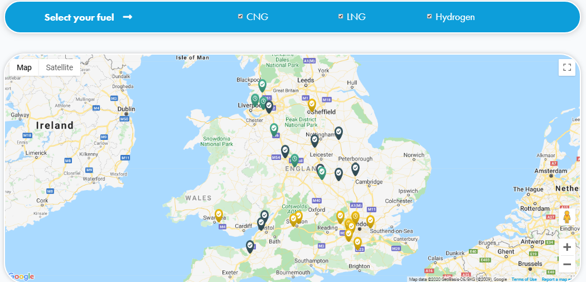

* **CNG Fuels** - develops, owns, and operates CNG Refuelling infrastructure and sources 100% biomethane for its stations. At present this is primarily imported CNG Fuels will therefore be a key source of information for the largest UK suppliers to the UK market in the future.
* **Gasrec** is a UK company that design builds and operates both private and publicly accessible compressed and liquefied biomethane refuelling facilities, and has a total of 9 stations. Gasrec has previously produced, liquefied and transported biomethane for transport and continues to supply biomethane as well as fossil gas. It is the designated off take from various advanced biofuels projects.
* **Air Liquide** Air Liquide operates across the whole supply chain; it works with various partners to convert organic resources into biogas; it designs and implements refinement technologies (Medal membrane) to produce biomethane and has a footprint of over 80 gas refuelling stations across Europe, tied to biofuel production. In the UK the business lead one of the consortia in the Low Emission Freight Trial looking at biomethane for HGVs. It also supplies biomethane for buses, and has developed, owns and operates a portfolio of 9 upgrading stations fed by biogas from waste (in 2019 100% of its vehicle refuelling was with biomethane).
* **BOC** is the UK & Ireland’s largest supplier of industrial, medical and special gases. It is part of Linde Plc, the largest industrial gases company in the world, who employs in excess of 80,000 people in over 100 countries. BOC designs, builds and operates both private and publicly accessible liquefied natural gas refuelling facilities throughout the UK. BOC supplies biomethane (Bio-LNG) as well as fossil gas.
* **Calor** has five LNG stations in the UK – and its sister company PrimaLNG, has stations with sites in France, Belgium, Holland and Italy. Its portfolio is increasing. It is also developing a battery electric commercial vehicle with a biopropane range extender.

## Other fuels

There are no UK HVO producers and no production facilities imminent, although there are companies that import it. Calor and Flogas supply biopropane.

## The size of the industry

A rough calculation suggests that the value of UK-produced biofuels (without Vivergo operating) to be in the region of £800m to £1bn. This is roughly in line with what is reported in a background paper by Innovas, commissioned by REA to inform its REview publication, (which also includes figures for distribution). REview will be uploaded to the REA website shortly[8]. It does not address biomethane.

Total market demand  in 2020 (based on the RTFO) is estimated at around 2.1 billion litres of waste biodiesel and 800 million litres of bioethanol. This would value the UK liquid biofuel market at  £2.5-£3.0 bn. There is capacity, were Vivergo to re-open, for the UK to be self-sufficient in sustainable bioethanol, which would bring significant economic benefit to the UK, in particular the North East.

Biofuels Commentary

The current level of use of biofuels in the overall petrol and diesel mix is below the potential for full take up of E5 and B7 levels for petrol and diesel respectively.

Therefore, the scenarios propose that full take up of E5, E10 and B7 targets are met fully.

It is not anticipated that overall fuel use levels will increase in the medium term due to the increased take up of electric vehicles cancelling out any increases in petrol or diesel vehicles.

Biofuels comparison between current levels of bioethanol and biodiesel and those if E5 are fully met.



The difference between current levels of bioethanol use in petrol and if **E5** was fully achieved is an increase in market value of **£78 million** with **355** more people employed.

Biofuels comparison between current levels of bioethanol and biodiesel and those if E10 and B7 are fully met.



The difference between current levels of bioethanol use in petrol and if **E10** was fully achieved is an increase in market value of **£1,400 million** with **5,030** more people employed.

The difference between current levels of biodiesel use in diesel and if **B7** was fully achieved is an increase in market value of **£1,010 million** with **5,807** more people employed.

There is clearly a large positive impact in both market value and employment terms to achieve both E10 and B7 targets. There will inevitably be job losses in the current petrol and diesel production and refining stages of the supply chain, but these will not be as high as the increases forecast for moving more towards the E10 and B7 targets.

The current petrol and diesel production processes are very labour efficient and mature with the source of oil being in a small number of locations and overseas, and there being a small number of main refineries such as Stanlow, Milford Haven and Fawley.

Whereas the production of bioethanol and biodiesel requires the growing of specific crops and collection of waste materials from a large number of locations, all of which will have requirement for people to do the work whether as a full-time employee or part time when required. There will be more and smaller refineries which will be spread around the country to reduce transport distances of feedstock and keeping logistic costs down. Biofuels are recognised as being much more labour intensive and with a greater spread around the UK including rural areas.

The vast majority of petrol/diesel vehicles can cope with E10 and E5 petrol and B7 targets, so conversion should not be too much of a technical problem. Supply to the end customers would be via the current supply network and as such there is no change required to the current supply infrastructure.

Costs for new biorefineries and modification of existing refineries is included in the production market values and jobs.

Though it is expected that by 2040 there will be no new petrol or diesel cars and light commercial vehicles being sold, there will still be a requirement for oil based fuels for buses, trucks, aviation, shipping and off-grid heating. Hence there will still be requirements for biofuels up to and beyond 2040.

### The size of the UK biomethane to transport industry

Biomethane for transport is nascent. The latest RTFO statistics report a total of 7.77 million litres equivalent (corresponding to just over 4,000 tonnes) was supplied over the period January – end June 2019. This is a low base, but growth is exponential. One of the dispensing companies has seen demand increase by more than 800% over the period Sept 2016 to Dec 2019. There are a variety of indicators that suggest growth will be exponential, including

* the number of large fleet operators and logistics companies doing trials with gas
* the fleet operators’ order books
* the OEMs’ focus on, and internal targets for, increasing gas fuelled HGV models and sales

## How the industry compares to that in other countries – in Europe and globally

### Positioning in Europe

The UK ethanol industry was the fourth largest in capacity terms in EU in 2018 and tenth largest biodiesel producer in the EU (in 2017). With the loss of Vivergo, it is now likely to have fallen into eighth place with respect to bioethanol.

|  |  |  |
| --- | --- | --- |
| COUNTRY (ranking biodiesel) (ranking bioethanol) | Thousand tonnes of biodiesel (2017) | Million litres bioethanol production capacity (2018) |
| Germany (1) (3) | 4,005 | 997 |
| Spain (2) (7) | 3,398 | 584 |
| Netherlands (3) (6) | 2,505 | 1081 |
| France (4) (1) | 2,080 | 2,034 |
| Italy (5) (9) | 1,525 | 418 |
| Poland (6) (2) | 1,239 | 589 |
| Belgium (7) | 846 | 514 |
| Greece (8) | 729 |  |
| Portugal (9) | 639 |  |
| UK (10) (4 in 2018, now 10) | 528 | 910 |
| Austria (11) (10) | 524 | 278 |
| Czech Republic | 464 | 227 |
| Finland* | 430 | 63 |
| Sweden | 362 | 239 |
| Bulgaria | 356 | 34 |
| Romania | 295 | 101 |
| Denmark | 250 |  |
| Hungary (18) (5) | 188 | 634 |
| Slovakia | 166 | 149 |
| Latvia | 154 | 24 |
| Lithuania | 147 | 25 |
| Slovenia | 100 |  |
| Ireland* | 74 |  |
| Croatia | 55 | 227 |
| Estonia | 35 |  |
| Cyprus | 20 | 63 |
| Malta | 5 |  |
| Luxemburg | 0 |  |
| TOTAL | 21,119 (thousand tonnes) | 8,901 (million litres) |

Sources:

European Biodiesel board. <https://www.ebb-eu.org/stats.php>

E-pure. <https://epure.org/media/1920/190828-def-data-statistics-2018-infographic.pdf>

In Europe, Sweden uses a high proportion of its biogas production as biomethane in transport (two-thirds of the biogas share in final energy consumption in 2016). In Denmark some biogas producers are switching from power generation to biomethane injection and in Finland an increasing proportion of new biogas projects for transport. Italy and France are significant and growing markets.

### Global positioning

In global terms, the US dominates in bioethanol. It produced almost 60 billion litres in 2017 mainly from corn feedstock. Its output is expected to slightly over the next years. The next most significant producer is Brazil (27.7 billion litres in 2017) produced from sugar feedstocks. Its production is anticipated to grow (to 36.5 billion litres by 2023). Brazil has a high proportion of flexible fuel vehicles (FFVs) able to use 85% ethanol blend (and above?). China follows, with an output of 3.5 billion litres in 2017, with plans to double output by 2023. It plans to introduce E10 nationwide by 2020, which if fully implemented, would create a demand of over 17 bl. Source [IEA](https://webstore.iea.org/download/direct/2322)[9].

The IEA’s figures for bioethanol production in Europe are significantly lower than that of e-PURE, (5 bl in 2017 as opposed to nearly 10bn (for 2018). The demand caused by the wide uptake of E10 being an important driver for the market.

In global terms, the US, Brazil and Indonesia are the top biodiesel three producers, with the UK ranking 13th, according to Statistica.

Leading biodiesel producers worldwide in 2018, by country (in billion litres) Source Statistica[10].

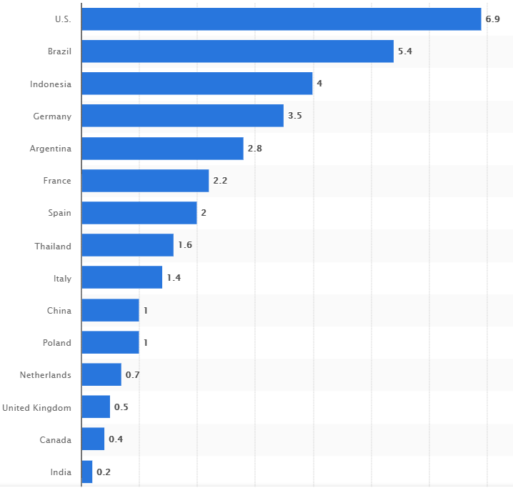

In 2016 the transport sector only accounted for around 1% of biogas demand in final energy consumption globally, with most used for heat and power generation. According to the Natural Gas Vehicle Knowledge Base[11] there were over 27million gas fuelled vehicles (in April 2019), and the following countries dominate; China 6,760,000; Iran 4,950,000; India 3,307,466; Pakistan 3,000,000; Brazil 1,859,300; Argentina 1,652,939; Italy 1,134,982.

## The R&D pipeline

There is plenty of R&D taking place on aviation and advanced fuels, bioplastics, marine fuels and hydrogen, but companies are reticent to share any of this because of commercial confidentiality. It goes without saying that for the industry to commercialise any of this R&D, investor confidence needs to be re-established, and this is not going to happen all the while that the early investments fail to reach their potential, because of failure of government commitment to e.g. introduce E10 and ensure the basic RTFO targets increase.

## Main investors (corporate and venture)

Of all the funders of renewable energy projects in the UK, those investing in biofuels have faced the most challenge. There have been no major investments in bioethanol since the Vivergo plant (where construction started in July 2008, and commissioning began in April 2012). Biodiesel investments have been made by Argent and Olleco, in response to the anticipated increase the obligation levels in 2018 and the decision to retain double-counting.

It is most likely that the only investments in biofuels for transport will be in biomethane, advanced and development fuels, and HVO. This is because there is already sufficient bioethanol capacity, and the Vivergo facility could conceivably re-open increasing capacity still further and also because at present biodiesel demand is likely to fall (unless the RTFO targets are more than doubled).

Whilst biomethane projects based on RTFCs alone are not regarded as “bankable”, income from the RHI can potentially underwrite the investment, as the income stream is fixed and has a 20 year term. This is not to say that the RHI does not have its own challenges regarding raising finance. This was addressed by a “Tariff Guarantee” arrangement, for which plants have to commission before the end of January 2021. At present there is no replacement or extension of the RHI on the horizon, but if this UK is serious about its decarbonisation targets, this must surely change.

The list below includes companies that have, and are currently considering investing in the biomethane sector.

* Allied Irish Bank (AIB)
* Aviva
* Bio Capital Platform (Equitix and Helios)
* Bioenergy Infrastructure Group (BIG)
* Downing
* Eternity Capital
* Ingenious
* Iona Capital
* JLEN (one of the Foresight Group managed funds)
* LAIN/ Future Biogas
* Macquarie
* Privilege Finance
* SQN Capital Management
* The Foresight Group – through various managed funds

We are not aware of any potential HVO production projects mooted for the UK, although there is considerable interest among fuel purchasers and a desire to see an indigenous source of this fuel in the future.

## % RTFC value in terms of revenue for sellers and buyers (profit/losses)

We understand this question to be seeking an idea of how the value of the RTFO (and RTFCs) flows within the industry. This varies by fuel.

An RTFC is awarded to the organisation that puts the biofuel across the duty line. This is mainly retailers of fuel in the case of biodiesel and ethanol. They will blend and distribute the blended fuel. These suppliers will normally be buyers of biofuel where an element of the RTFC price is effectively included in the flat price paid to the producer or biofuel seller.

Some producers of biodiesel may supply blends (including high blends and B100) direct to captive fleets. In this scenario the producer will receive the RTFC and will get the full value of the RTFC. However, it should be noted that the other main element of the price to a captive fleet customer is the diesel price. The producer in this scenario has to take on the risk of fossil diesel pricing.

With respect to biomethane, the vast majority of value (perhaps around 90%) is captured by the producers of biogas. At present, for reasons described above, biomethane is largely imported, but once the anticipated flexibility materialises, this is likely to change. Although fuelling infrastructure providers will still have the option of importing mass-balanced biomethane, it is anticipated that domestic sourcing will be more attractive as it avoids the costs of shipping the gas across borders. Any fuel that can be produced in the UK is of clear benefit for the balance of trade. The wider the sourcing options for biomethane the better, however, as it gives fuelling infrastructure providers and vehicle fleet operators greater confidence in the continued availability of the fuel.

1. I.e. Not development fuels. Development fuels are the only component of the target which increases over time, to 2032.
2. <https://www.r-e-a.net/wp-content/uploads/2020/01/REA-modelling-on-potential-future-biofuels-target.pdf>
3. There is a CEN standard for a 10% biodiesel blend which was published in August 2016, and the ACEA published a compatibility list the following year <https://www.acea.be/publications/article/b10-diesel-fuel-vehicle-compatibility-list> after B10 became available in France.
4. Mercedes, Daimler.
5. Stagecoach, Metroline and RATP.
6. <https://www.r-e-a.net/wp-content/uploads/2020/01/REA-TfL-Paraffinic-Diesels-presentation-rev-14-01-2020.pdf>
7. Two aspects of the current rules are a cause for concern.

   The derogations on qualifying electricity for RFNBO production (i.e. the derogations from the requirement to use the carbon intensity of the grid pertaining to 2 years ago) when an electrolyser is located remotely from the renewable electricity production site.

   The categorisation of hydrogen as a development fuel (which has mixed blessings).
8. REview can be found on <https://www.r-e-a.net/resources/review_achieving_net_zero/>
9. Renewables 2O18 Analysis and Forecasts to 2O23. INTERNATIONAL ENERGY AGENCY © OECD/IEA, 2018. <https://webstore.iea.org/download/direct/2322>
10. <https://www.statista.com/statistics/271472/biodiesel-production-in-selected-countries/>
11. <http://www.iangv.org/2016/12/ngv-statistics-updated/>