REA position paper on the decarbonisation of road transport
Draft for member comment, as of 24th April 2020
REA policy leads: Daniel Brown (dbrown@r-e-a.net) and Gaynor Hartnell (ghartnell@r-e-a.net)

Contents

Objectives of this paper 2
Executive Summary 2
1. GHG emissions from fuels 3
1.1 A brief note on other emissions 6
1.2 The decarbonisation options 6
2. Technology and fuelling options 7
2.1 The ICE and its potential replacement 7
2.2 Renewable fuels 8
2.2.1 Biofuels 8
2.2.2 Biodiesel 9
2.2.3 HVO (Hydro-Treated Vegetable Oil or “Paraffinic Diesel”) 10
2.2.4 Bioethanol 10
2.2.5 Bio Propane 11
2.2.6 Biomethane 11
2.3 Renewable Fuels of Non-Biological Origin 12
2.3.1 Hydrogen 12
2.4 Electricity 12
2.4.1 Fuel cells 12
2.4.2 Electric Vehicles and Charging Infrastructure 14
3. REA anticipated roadmap to 2040 15
4. REA recommended policy actions for renewable fuels 16
5. REA recommended policy actions for electrification 16
6. Conclusion 17
Appendix 1

Objectives of this paper

- To give an overview of the REA’s position on the role that electrification and fuels (including hydrogen) can play in decarbonising the UK road transport system to 2040
- To suggest policies to hasten the decarbonisation of road transport

Executive Summary

Decarbonisation of the transport sector, in line with UK Carbon Budgets and legal commitment to Net Zero greenhouse gas (GHG) emissions by 2050, is an urgent national priority and one for which there are numerous solutions available to industry and policy-makers. Strategic and timely intervention by Government, in coordination with industry, can result in the UK achieving its decarbonisation goals whilst creating jobs at home and products that can be exported abroad.
The REA is well-placed to comment on this major industrial shift as the UK’s largest trade association for renewable energy and clean technologies, with over 550 members operating across the power, heat, transport, and natural capital sectors. Specifically, the REA’s Renewable Transport Fuels Forum and Electric Vehicle Forum represent companies involved in renewable fuels, renewable power developers and generators, project developers, and the electric vehicle charging infrastructure supply chain.
This paper focuses on road transport, which accounts for over 90% of domestic CO₂ emissions from transport. It agrees with the Government’s position that both fuels and electrification have a major role to play. Other means of reducing Greenhouse Gases (GHGs) are also important, (such as demand reduction, vehicle efficiency improvements, modal shift, improved logistics etc.) and such actions may be higher up within a transport hierarchy – but these are beyond our scope of expertise and are not considered in this paper. Irrespective of the transport hierarchy, action on fuels and electrification is necessary, in parallel with other measures.
At present the sale of new cars is dominated by those with internal combustion engines (ICEs), with 25% of the new car market made up of diesel sales in 2019 and 65% by petrol sales. In comparison, new electric vehicle (BEV and PHEV) registrations in 2019 represented 3% of the market. However, EV sales are surging and Battery Electric Vehicle (BEV) sales increased 144% in 2019 compared to 2018, with an additional 23 new electrified car models set to become available in 2020. New diesel car sales, in comparison, fell by 22%.
With the UK Government committed to Net Zero greenhouse gas emissions by 2050, the phase-out of new conventional petrol and diesel car and van sales by 2040 (and a consultation currently underway to bring forward that date to 2035), new supportive tax measures for BEVs and an extension to vehicle grants announced in the Budget, the rate of EV deployment is expected to increase rapidly.
Politically, the push to decarbonise the transport sector comes from the twin forces of public pressure to address air quality and public concern over climate change. Simultaneously, the range of viable options for decarbonising a range of market segments is steadily improving.
Although impacted by different policy drivers, the market for electric light vans is also expected to increase rapidly in the coming decade, driven by similar technology advancements underpinning the advance of electric cars and the roll-out of clean air zones in cities across the UK.
For other vehicle classes, such as heavy goods vehicles (HGVs), the pathway to Net Zero looks different with multiple technologies likely to drive decarbonisation. This is the result of the weight of current battery technology likely restricting the capacity for long-distance haulage for some usage cases.
By 2035 the REA expects that:
- the global economics underpinning electric drive chains, batteries, and expanded manufacturing capacity to result in widespread deployment of electric cars and vans in the UK and globally
- petrol and diesel consumption to fall. Modelling by the RTFG suggests petrol and diesel consumption in cars (check to see if light vans included in model) will have declined from around 40 billion litres in 2018 to 32 billion litres by 2032, and will continue on a downward trend as older cars and vans are retired
- Gas-fuelled Heavy Goods Vehicles (HGV) sales are also expected to grow such that biomethane may account for around 1.7 billion litres equivalent by 2032
- hybrid vehicles (using gaseous renewable fuels), fully gas fuelled vehicles (biomethane and renewable hydrogen) and some electrification of road infrastructure will be the longer-term solution to decarbonising road freight (coupled with a range of options higher up the transport hierarchy)
- By 2032 liquid fuel for road freight will have fallen from around 52 to 43 billion litres
- the road passenger mass transit option will be dominated by low-carbon busses, predominantly electric but also fuelled in some instances by gaseous fuels
- Renewable fuels in road transport should continue to be part of the Government’s decarbonisation strategy in order to best decarbonise the existing vehicle parc both now and for the remaining petrol and diesel cars and vans on UK roads following the phase-out of new petrol and diesel car and van sales
- As the market for fossil and renewable road transport fuels shrinks due to the rise of electric vehicles, the renewable fuels sector (both made from biomass and from renewable electricity) will expand into the aviation and marine transportation as a leading decarbonisation option.
It is clear that in the transition to electrification of Light Duty Vehicles (LDVs) and the decarbonisation of HGVs, liquid fuel consumption in ICEs will continue to be significant, and all efforts must be made to decarbonise the fuels consumed as rapidly as possible. It is also important that growth in renewable power generation capacity is accelerated, so that the well-to-tank carbon contributions from electrification and renewable fuels of non-biological origin (e.g. hydrogen) deliver the overall GHG reductions required.
[Insert graphic to illustrate how actions now are more effective than equivalent savings levels delivered later. Member view sought on best source for this]
The transport sector is responsible for the largest share of greenhouse gas emissions of any sector in the UK economy, accounting for 23% of total UK emissions with 90% of this coming from road transport. Emissions from this sector are not currently falling and significant action is needed now on behalf of Government and industry to ensure that we are on-target for the fifth and sixth Carbon Budgets.
The Government’s Road to Zero strategy of 2018 goes some way to identifying the policy needed to decarbonise the road transport sector. At the time of publishing, a window presently exists to inform future road transport policy as Government prepares its Transport Decarbonisation Plan. The REA is also expecting further policy in the Government’s response to the current consultation on moving the ban on the sale of new petrol and diesel cars and vans from 2040 to 2035 (or sooner), and in the lead up to the UN climate conference COP26, to be hosted by the UK in 2021. REA policy recommendations to Government can be found in Appendix A.

1. GHG emissions from fuels

The environmental impacts of decarbonisation options can be misunderstood and the terminology is often misleading. The table below summarises the terminology. The emissions in the unshaded rows are within the scope with respect to this paper.
Terms used | What emissions does this refer to?
Tank-to-wheel (TTW) or tailpipe emissions | The emissions that come out of the exhaust pipe (if there is one).
Well-to-tank (WTT) or upstream emissions | The emissions incurred in the production, processing and delivery of fuel, i.e. the upstream carbon emissions
Well-to-wheel  (WTW) | The two above considered together, i.e. upstream emissions and tailpipe emissions
Non exhaust emissions | Tyre and brake wear particulate emissions. As above, these are also not considered further in this paper
Lifecycle emissions | The emissions associated with the manufacturing of the vehicle, through use to end of life recycling or disposal options. Due to the battery and the zero tailpipe characteristics of EVs, ICE and EVs have very different lifecycle impacts. This is important, but is largely outside the remit of this paper.
Other negative socio-economic / health impacts | E.g. Child labour etc. etc. Again, out with the scope of this paper, but clearly not a subject to be overlooked.

The use of the term “Zero Emissions” vehicle is widespread, but usually in the context of tailpipe emissions only. Such vehicles are not necessarily zero carbon in terms of WTW emissions. Depending on the pathway of the fuel (or electricity) production, lifecycle emissions can vary significantly. For electric vehicles, both the supply of electricity to vehicle in use and the supply of energy during the manufacturing of batteries and the vehicle body itself needs to be accounted for. Figure X highlights the importance for a decarbonised electricity system at the point of use and in manufacturing processes.

Note for REA members reviewing this document: the REA is seeking a graphic/graphs to demonstrate Well to Tank and Tank to Wheel emissions factors of a range of conventional fuels, biofuels and zero tailpipe solutions (i.e. EV and H Fuel Cells) enabling a fair comparison. Such a graphic should demonstrate that all fuels have well to tank emissions, with those from hydrogen and electricity varying markedly depending on the fuel production pathway. It should also enable comparison of efficiency of vehicles (i.e. take account of the increased drive train efficiency of the electric motor). Potential sources include the Transport Energy Model and the Carbon Brief analysis These are shown below, but will be replaced if we receive better suggestions from members as to what graphics to use.
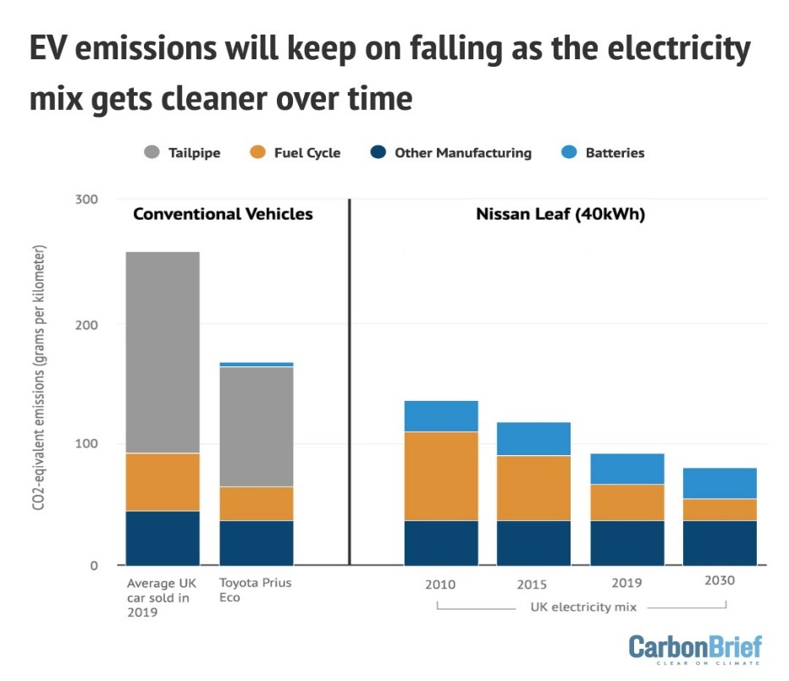
Figure X: EV emissions depending on electricity mix – 40kW Nissan Leaf
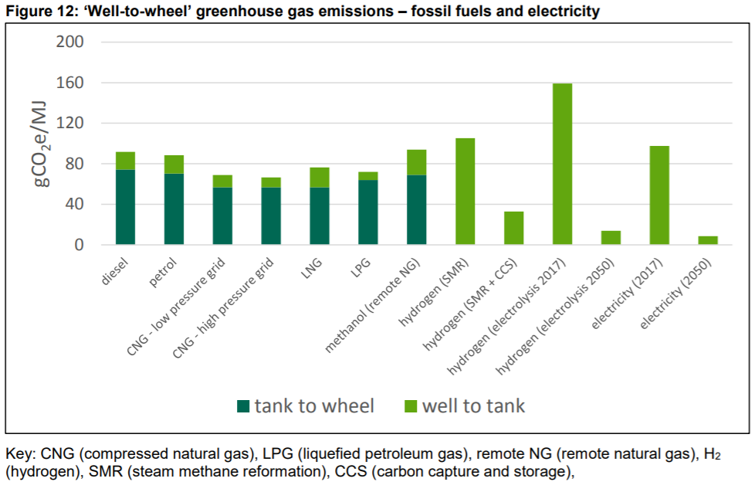
The Department for Transport’s Transport Energy Model is an additional authoritative source which shows both WTT and TTW for fossil fuels, for hydrogen, and for electricity. Note that the below above outlines CO₂ intensity per unit of energy, and does not account for the efficiency that vehicles convert that energy into propulsion.
The image below shows the CO₂ intensity of biofuels in comparison with fossil equivalents. The “other” emission shown below are due to ILUC – emissions from indirect land-use change (i.e. emissions from cropland expansion caused by impact of biofuels on global agricultural commodity demand).
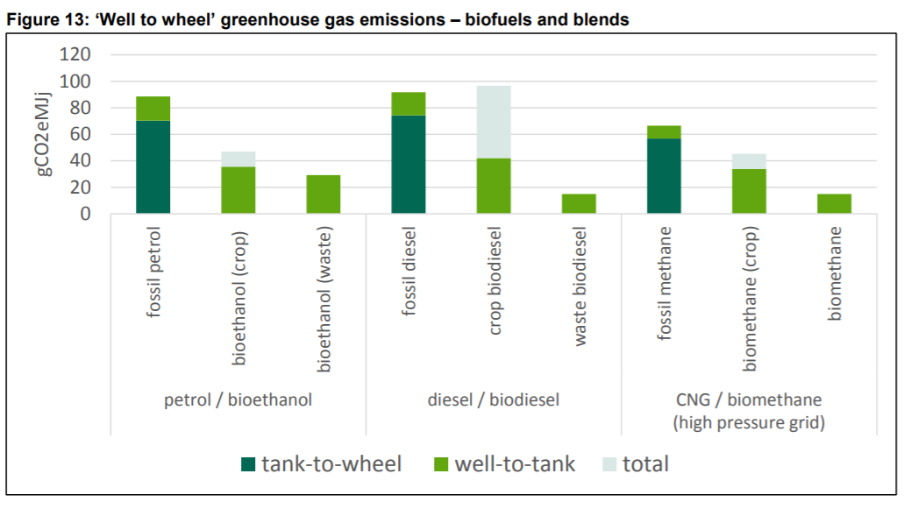
Source: Transport Energy Model (2018)
It is clear from the above that it is important to consider WTW emissions, not just tailpipe emissions, and to note that the situation is evolving. The WTT emissions from ”Zero emissions” vehicles will fall as the carbon intensity of the grid falls, but it is essential that the proportion of renewable electricity generation grows continually, and outstrips the absolute growth associated with the extra demand for the electrification of transport and heating.

1.1 A brief note on other emissions

It is widely accepted that the transition from ICEs to electric vehicles involves a shift in GHG emissions away from those produced during vehicles’ use, to those produced during their manufacture, and that due to the components involved in batteries, wider lifecycle emissions and impacts become important.
The achievement of GHG and sustainability requirements are effectively a licence to operate in the biofuels sector. Sustainable metal and mineral extraction and recycling processes as well as GHG reductions are essential to delivering the environmental performance potential of electric vehicles (and other clean technologies).
The REA encourages the battery and vehicle manufacturing industry to commit to use sustainably-extracted and processed materials for EVs (and any other technology) just as only sustainably-sourced biofuels feedstocks should be used. Whilst it is not the REA’s job to develop certification schemes it is supportive of effective schemes being developed elsewhere.
Non-exhaust emissions (NEE) from road traffic are particles from brake, tyre and road surface wear. These are not covered by legislation and are increasing as a proportion of road traffic emissions, a trend which is expected to continue. They currently account for 7.4% and 8.5% of all UK primary PM2.5 and PM10 emissions. Regenerative braking (as is used in EVs) does not give rise to NEE, although tyre and road wear emissions increase in proportion to vehicle mass. The impact of electrification of LDVs has not been quantified. The LowCVP has carried out a useful analysis of NEE and WTT from different drive-chain and fuel types in the UK.

1.2 The decarbonisation options

To achieve the aim of all new cars and vans to be effectively zero tailpipe emission by 2035 ‘or sooner’, and to support the decarbonisation of the vehicle parc prior to then and beyond, four prevailing technologies are apparent; biofuels used in ICEs, hydrogen fuel cell vehicles, battery electric vehicles and plug-in hybrid electric vehicles. Each holds benefits at varying scales and in different sectors, in addition to their own infrastructure requirements.
To provide insight into the transition of the transport sector, the purpose of this report is to give a combined vision of potential decarbonisation pathways for the UK. This will include market factors encouraging trends and policy steps to be taken to drive forward the decarbonisation of the transport sector.
Biofuels, hydrogen fuel cells and battery electric vehicles will each play a role. An overview of the current state of each method of decarbonisation in the UK is provided, alongside relevant policies and market/industry trends and barriers to widespread rollout. An REA comment will follow each section to provide advice on future applications, current barriers to the market and further policy requirements.
The REA is well-placed to bring together the views of these industry as the UK’s largest trade association for renewable energy and clean technologies. The REA represents around 550 members across the decarbonisation of heat, power, and transport, ranging from renewable power generators to biofuels and hydrogen manufacturers, and the electric vehicle charging infrastructure supply chain.
The biofuels examined in this report include biodiesel, bio-propane, bioethanol, and biomethane. The characteristics of each are described. Secondly, hydrogen fuel cell electric vehicles are examined. The final decarbonisation pathway included is that of battery electric vehicles and the charging infrastructure network required as the market grows.

2. Technology and fuelling options

2.1 The ICE and its potential replacement

The Internal Combustion Engine (ICE) has played a fundamental role in the creation of the modern global economy, and in propelling growth in the 20th Century. However, for many market segments it will not be economically or environmentally sustainable to maintain internal combustion engine production into the future.
For new cars and light-duty vans in the European Union (EU), the Euro 6/VI standard is now in place which represents a significant improvement in air quality and greenhouse gas emissions over the previous Euro 5/V standard. Further improvements are planned. However, improvements in engine efficiency coupled with renewable fuels will not achieve Net Zero and for many market segments we are approaching the point where the continuation of ICE power trains will no longer be a viable option to achieve national policy goals. The Government has acknowledged this in its announced ban on the sale of new ‘conventional’ petrol and diesel cars and vans by 2040, and in its consultation to move forward that date to 2035 ‘or sooner’.
In the interim and for all the while that petrol and diesel cars remain on the roads, the Government should ensure that renewable fuels make the maximum contribution they can. Where these fuels are made from biomass, only sustainable biomass should be used, and policies should encourage the maximum GHG savings possible (i.e. going beyond the minimum thresholds in REDII) and encouraging higher blend rates. Different renewable fuels and their characteristics are described below.
It is likely that the ICE will dominate heavier duty powertrains well into this century, as alternatives such as battery electric HGVs, electrified road infrastructure (induction / catenaries) or hydrogen fuel cell vehicles are currently earlier in the technology development cycle. The CCC commissioned work on decarbonisation options for HGVs. It concluded that “Moving to zero-carbon infrastructure for HDVs is a significant challenge and requires planning, co-ordination, supply chains, resource and materials and a skilled workforce as well as strong government policy to enable the market to deliver. However, our analysis and discussion with stakeholders found that the infrastructure required to serve scenarios reaching a near zero HDV fleet by 2050-2060, could be delivered.” ….. “From a cost perspective, the hydrogen infrastructure scenario represents the least cost investment option for a transition to zero emission HGVs by 2060.”

2.2 Renewable fuels

Renewable fuels can be made from biomass feedstocks (“biofuels”) or from renewable energy (“RFNBOs” or Renewable Fuels of Non Biological Origin). Hydrogen from electrolysis using renewable electricity is the most straightforward RFNBO. The latter have no land use implications, and the DfT is encouraging their development via awarding RFNBO hydrogen (and drop in fuels) “development fuel” status in the Renewable Transport Fuels Obligation (RTFO) due to their strategic importance.
The following paragraphs discuss biofuel, RFNBO and electricity as fuel sources.

2.2.1 Biofuels
The current percentage of UK liquid biofuels required in road transport is around 5%, due to the incentive provided by the Renewable Transport Fuels Obligation (RTFO). The target level for basic biofuels is 9.6% in 2020 and remains at that level until 2032. [Describe what development fuels are]. The sub target for “development fuels” is 0.15% in 2020, and grows to reach 2.8% in 2032.
In order to maintain the current level of biodiesel consumption the basic RTFO needs to be increased to over 16%. This takes account of the introduction of E10 in 2020, the expected growth rate in electrification between now and 2032, coupled with vehicle efficiency improvements, the anticipated growth in biomethane for HGVs.

Summary table – low carbon fuel types
Fuel | Feedstocks | GHG savings | Comments on blend levels | Fuel duty and VAT rate | Equivalent in terms of £ per tonne of CO₂ saved
Biodiesel | Used cooking oil, waste fats and greases(can be made from crop feedstocks, but the GHG savings are poor). | 85% | Regularly blended at 7%. Higher blend use possible with vehicle modifications. | 57.95p/litre, VAT @ 20% | To be added. Member suggestions on sources, welcome.
Bioethanol | Feed wheat, corn, starch waste and other cellulosic wastes | 55% - 65% | Petrol specification allows for blends of up to 10% | 57.95p/litre, VAT @ 20%
Biomethane | Putrescible biomass wastes and energy crops |  | A drop in fuel, which can be used in any gas vehicle designed to run on methane. | 24.7p/kg VAT @ 20%
Biopropane | Produced as a by-product from HVO manufacture |  | A drop in fuel, which can be used in any gas vehicle designed to run on LPG (propane). | 31.6p/kg VAT @ 20%
HVO | UCO, vegetable oils, wastes |  |  | 57.95p/litre, VAT @ 20%
Hydrogen | Electricity, methane reforming, biosyngas/biogas reforming |  |  | 0 fuel duty, VAT @ 20%
Electricity | Grid electricity / renewable electricity |  |  | VAT @ 5% for home charging, 20% for public charging

2.2.2 Biodiesel

Biodiesel has numerous supply sources and it is globally recognised that waste-based raw materials should be the preferred production precursor. These feedstocks give the highest carbon savings.
In 2019, the UK produced 1,400 million litres equivalent of verified renewable fuel. Of this, 60% was biodiesel. 81% of UK biodiesel was produced from used cooking oil in 2019 (DfT 2020). Biodiesel achieves 88% GHG savings compared to diesel vehicles.
In the UK diesel contains a blend of up to 7% biodiesel and the fuel is known as B7. An estimated £250 million/pa worth of biodiesel is produced in the UK. Higher blend biodiesels up to 20% (B20) and B30 are also found, and require only a small modification of the fuel tank and storage infrastructure. The fuels are more viscous and can be associated with increased component wear (Royal Academy of Engineering 2017). The majority of OEMs warranty new vehicles for blends of B20 and B30, and upgrade packages including heated fuel tanks can be fitted to certain engine types to enable the vehicles to run on 100% biodiesel.
Biodiesel production is a success story for the UK’s waste sector. ‘Fatbergs,’ which build up in the sewage system and need to be systematically cleared, have been used to produce 85 million litres of 20% biodiesel by Argent Energy () and Olleco produces biodiesel from used cooking oil at its plant in Liverpool.
The percentage of biodiesel that can be used in an engine can be limited as some OEMs do not warranty the use of higher blends in their vehicles. This may be due to the required tests not having been done, rather than genuine concerns over engine impact. Thorough validation of the supply sources of feedstock is paramount given some of the recent practices that have been uncovered (this premise applies to all renewable fuels).

2.2.3 HVO (Hydro-Treated Vegetable Oil or “Paraffinic Diesel”)

Similar feedstock criteria apply to HVO as apply to biodiesel. HVO is a drop in fuel, closely aligned to the chemical composition of diesel and with identical performance characteristics. Warranty concerns are therefore not an issue.
It is more expensive to produce than diesel (and biodiesel). Where feedstock is waste, it benefits from double counting, but only HVO produced from feedstocks which are not “segregated oils or fats” would qualify as a development fuel.

2.2.4 Bioethanol

The current EN228 petrol fuel standard permits the use of the supply of a 5% or 10% ethanol blend. The 10% ethanol blend, E10, has been the reference fuel for new car approval for fuel consumption and emissions standards since 2016. The Government is intending to mandate fuel suppliers to start offering E10 during 2021, and issued a consultation document on this in March 2020. 98 octane E5 will still be available as the protection grade (meaning it will have to be offered at certain filling stations, to ensure that the minority of cars for which E10 is not compatible continue to have access to fuel). The consultation proposals have been summarised by the REA and can be found on our website. A switch from E5 to E10 would reduce the CO2 emissions from a petrol vehicle by around 2% .
It is possible to run cars on higher blends than E10. The French Government approved the sale of conversion boxes, which allow standard petrol cars to run on Superethanol E85 (fuel containing 85% ethanol), which is sold at a significantly cheaper price than standard gasoline. Brazil also has a high proportion of flexible fuel vehicles (FFVs) able to use 85% ethanol blend.
It was estimated that in 2017 the UK had a production capacity of 985 million litres of renewable ethanol; this was the third highest volume in Europe at the time. However, a lack of urgency in the introduction of E10 and low bioethanol prices has overseen a downturn in the UK industry. An accumulation of market factors has contributed to the shutting down of the Vivergo plant in Hull and Ensus plant in Teesside in 2018. The Vivergo plant had employed over 130 people and supported 3,000 jobs while contributing £600 million to the UK economy. It is estimated that around 2,000 farms are involved in the UK domestic bioethanol market. The figures for 2019 reveal a slight deficit based on UK capacity. 462 million litres of bioethanol was produced in the UK in 2019, with 31% of this coming from non-EC corn.

2.2.5 Bio Propane

LPG is a mixture of propane and butane. Bio propane is the renewable equivalent of this fuel, and is a by-product from the production of hydro treated vegetable oil (HVO). It may be possible to produce propane via a RFNBO route, but this has not been explored, due to its prevalence as a by-product of natural gas and oil extraction and oil refining. It boils at a low temperature and is stored in pressurised steel vessels such as gas bottles or bulk LPG tanks. It is particularly used in forklift trucks.
It is estimated that between 120,000 and 170,000 vehicles currently run on LPG (propane), although the vast majority of this is fossil fuel. One UK supplier offers bio propane and is selling it in a 40% blend with fossil-derived LPG.

2.2.6 Biomethane

Biomethane, derived from anaerobic digestion of wastes and other biological materials, can provide significant environmental benefits over traditional fossil fuels and delivers negative emissions if produced using livestock manure. The UK currently mixes 0.4% (Note to members: seeking input on biomethane blend rate) into the natural gas network from over 80 sites, largely situated in agricultural regions of the UK. Biomethane is typically mass-balanced and is provided either in compressed or liquefied form. It is used predominantly for 42 tonne HGVs and buses. Compressed biomethane requires more storage space on the tractor and is generally used on 2 axle tractor configurations. It is stored at pressures of [250bar], whilst LNG is stored at 5 – 10 bar but requires refrigeration at around -160 Celsius. Production pathways vary considerably, which accounts for the fairly wide WTT emissions factors in (XXX TBC once we have decided on what data to use earlier in the report.)
The primary barrier to the widespread implementation of biomethane within the HGV sector is the location and availability of refuelling stations. Currently, there can be a wait of up to three years before a proposed biomethane fuelling station is functional (CNG Fuels 2019).
A map of gaseous filling stations, with information on access arrangements can be found on the Business Breathes website.
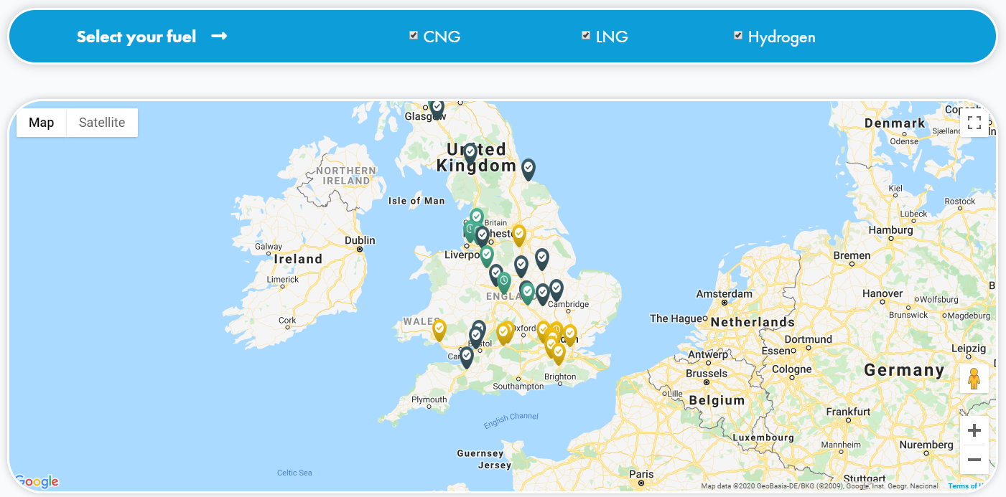

2.3 Renewable Fuels of Non-biological origin

2.3.1 Hydrogen

Hydrogen from natural gas requires carbon capture and storage in order to be a low carbon proposition. Without carbon capture and storage hydrogen’s capability of being mass market is negated. Hydrogen from electrolysis requires substantive amounts of low carbon electricity (e.g. renewable). Around 60 kWh are required to produce 1kg of hydrogen.
There are two specifications for hydrogen in the marketplace. For use in transport (i.e. in fuel cells) the hydrogen has to be extremely low in moisture and very high purity (99% plus). For adding to the distribution network, to decarbonise the gas grid the specification is nowhere near as tight.
At standard room temperature and pressure hydrogen has one third the calorific value of natural gas and half the calorific value of diesel. Pressurising and then storing hydrogen in excess of 700 bar to enable high-pressure filling is energy intensive.

2.4 Electricity

The production of electricity from any form of combustion source results in the order of 40 to 50% loss of energy compared to the original source. Renewable electricity from non-thermal sources is not subject to these losses. The transmission and distribution of electricity result in further losses of energy (around 8%).

2.4.1 Fuel cells

Hydrogen fuel cell vehicles are improving as a technology and, whilst earlier in their design and development for cars and vans than battery electric drive chains, could play an important role in HGVs and some aspects of the bus and coach market.
Per ITM Power, an electric vehicle powered by a hydrogen fuel cell can be refuelled in three minutes and has a range of 350 miles with 5kg of hydrogen. Quick refuelling and a potentially large range are key factors making FCEVs well suited for HGVs.
A small number of FCEV cars are available in the UK, in addition to one FCEV light van and some non-road machinery such as forklifts. Around 200 hydrogen fuel-cell powered vehicles are operational on UK roads at present.
Global price parity with other powertrains could be achieved by 2030, but for the car and van market segments electric vehicles will likely have made significant inroads by that time and significant global manufacturing capacity for BEVs built up.
Hydrogen buses have been running in London since 2011, covering over 1 million miles. Ten hydrogen buses have also run in Aberdeen since 2015. For HGVs, there is currently a relatively small selection of models on sale, providing a hindrance to the growth of Hydrogen Fuel Cell HGVs, despite the theoretical suitability of hydrogen for HGV fuelling.
Infrastructure is a prominent barrier to wider adoption of hydrogen fuel cell vehicles in the UK parc. ITM Power operates eight electrolysers to produce potentially green hydrogen in the UK with six refuelling stations under construction. There are currently a total of 15 installed Hydrogen refuelling stations in the UK and while these can collectively deliver the output of 900 BEV fast-chargers, they fail to provide as effective spatial coverage.
Refuelling stations incur costs mostly in the storage and compression of the fuel. These costs would need to come down for widespread implementation. Refuelling stations currently are broadly located in accordance with manufacturer launch plans and would require support to develop a more strategic network to ensure widest coverage.
The proliferation of low-cost variable renewable power generation technologies, such as onshore and offshore wind, and solar PV, are creating a new opportunity for hydrogen generation. Modelling by Bloomberg New Energy Finance indicates that these technologies are becoming, or already are, the lowest-cost form of new power generation today.
Hydrogen Fuel Cell Vehicles are most promising as a decarbonisation solution for HGVs, and some classes of busses and coaches. This is due to their potential for long ranges and short refuelling times, both of which are comparable to ICE powertrain vehicles.
Investment in the production of cleaner, ideally ‘green’, hydrogen for use in a growing number of public sector fleets will encourage the uptake of hydrogen fuel cell electric vehicles. The production of green hydrogen could also encourage more variable renewable power projects to come forward in the future, as onsite electrolysis could provide a new income stream for developers during periods of curtailment or low wholesale prices.
The development of a strategic refuelling infrastructure for hydrogen is behind that being developed by the private sector for electric cars and will require further investment and planning.
Significant cost reductions in electrolysis are required for wide-spread deployment by 2030.

2.4.2 Electric Vehicles and Charging Infrastructure

Acronym | Full name | Drive trains | Fuelling method | Potential range
BEV | Battery electric vehicle | Electric motor only | Plug in charging
PHEV | Plug-in Hybrid Electric Vehicle | ICE and electric motor | Plug in charging and liquid fuelling
Parallel hybrid |  | ICE and electric motor | liquid fuelling
Range extender |  | Electric motor | Plug in charging and liquid fuelling

Battery electric vehicles represent a significant departure from traditional thinking around ICE manufacturing and value creation. There is significant debate about their role compared to that of Plug-in Hybrid Electric Vehicles (PHEVs), with concerns over the environmental performance of vehicles that are run sub-optimally (i.e. where the battery is seldom if ever charged and primarily relies on liquid fuel). The current Government consultation on phasing-out new petrol and diesel car and van sales by 2035 is questioning whether PHEVs should be included.
When PHEVs are used appropriately, however, they can be among the best performing vehicles in GHG terms. Those which are always charged, and predominantly do shorter journeys (with only the occasional journey requiring the use of the ICE engine) can have a superior performance, as the smaller battery is appropriately sized for the majority of journeys. When coupled with high blend biofuels, eg E85, this can currently give lower GHG emissions/ mile than BEVs.
The creation of a BEV supply chain is requiring the re-organisation of the existing automotive manufacturing industry. In the REA view, with declining ICE sales it will become increasingly difficult and expensive for automotive manufacturers to maintain two distinct supply chains (one EV, the other ICE) and the trend towards automotive manufacturers quickly transitioning to 100% electric car and van manufacture, as is the case with VW, will gain speed.
The UK has a burgeoning EV industry, supplying 20% of all EVs sold in the EU in 2016, with low emission vehicles in general being exported to a value of £2.2 billion, largely due to the Sunderland Nissan plant manufacturing the LEAF.
To address concerns around the new demands that EVs will place on electricity distribution networks in the UK, the Government is consulting on mandating all new charge points to be ‘smart’, meaning being able to send and receive load control signals.
For public charging, a network of accessible fast and rapid chargers are currently being rolled out on existing forecourts, at retail sites and other destinations, in workplaces, and on-street. Additionally, Government and National Grid are coordinating the rollout of ~50 strategically located ultra-rapid (up to 350kW) charging hubs along the major motorway network. There are currently over 11,000 public charging points across the United Kingdom totalling 21,500+ connectors at approximately 6,500 locations. (Numbers to be updated prior to publication).
The shift towards electric cars and vans is being driven globally by policy interventions in some of the largest markets. The Zero Emission Vehicle Mandate in California and New Energy Vehicle Mandate in China are disrupting global supply chains, as is the European Commission’s CO₂ requirements which require significant reductions in the CO₂ intensity of the fleets manufactured in Europe from a baseline of 2020/21.
In the UK, a key driver for electric vehicle deployment is the roll-out of Clean Air Zones in major cities as proposed in the Clean Air Strategy of 2019 and the Air quality plan for nitrogen dioxide (NO₂) in UK in 2017. London has been the first to launch an Ultra-Low Emission Zone (ULEZ), which chargers divers who enter the area £12.50 per day for cars and light vans, and £100 per day for heavier vehicles. Further clean air / ultra-low emission vehicle zones are expected to be launched in major cities including Birmingham, Oxford, and Leeds.
Due to their weight and the availability of battery supply, it is expected that uptake of battery electric heavy goods vehicles will be limited based on current battery technology. ICE (including full hybrid) powertrains are predicted by some to remain the powertrain type in 80% of HGVs by 2030. Following the implementation of stringent Euro 6/VI standards on HGVs, hauliers may have low confidence to invest in emerging powertrain developments. Future policy would require clear standards and pathways for HGV decarbonisation to encourage investment.
For electric vans, the focus is currently on shorter-range city distribution channels rather than long-haul journeys.
Purchase price parity for battery electric cars with conventional vehicles is expected in the mid-2020s. Price parity for running costs including fuel and maintenance over a five year period has already been achieved. This will be a major milestone for the sector, as evidence from Norway indicates that once upfront price parity is reached, sales of battery electric vehicles spike due to lower running costs and driving experience.

3. REA anticipated roadmap to 2035

The REA expects the following to happen in the UK road transport market to 2035:
- Purchase price parity for battery electric cars with conventional ICE cars will be achieved before 2025
- A wide variety of new battery electric car models to be available to consumers by 2025
- Global BEV share in new vehicle sales is predicted to eclipse 20% by 2030 and reach 57% by 2040
- Electric buses will become increasingly economic and become more widespread in the mid 2020’s
- A national public charging network continues to grow, at a range of locations, prices, and speeds
- Steady improvements in fuel cell electric vehicle design and in economics of electrolysis improves the viability of hydrogen as a transport fuel for several market segments
- Auto OEMs and oil & gas majors become increasingly active in the renewable energy, charging, and software markets to make up for declining revenues from services and products targeting ICE vehicles
- The market for road renewable transport fuels to shrink as the volume of fuel used in road transport declines, creating a diversification challenge for manufacturers (alternative markets for diesel fuels as bio oils for hard-to-heat-homes, aviation and marine fuels are likely to develop and endure)
- Farming and northern manufacturing communities reliant on biofuels production to suffer due to declining liquid fuels production

4. REA recommended policy actions for renewable fuels

Note the following actions for fuels and EVs will be updated as the REA hones its response, in conjunction with members, to the 2035 consultation.
Government should take the following renewable fuel-related policy actions:
- Immediately introduce E10
- [for discussion encourage the development of E85 range-extended hybrids]
- Promote the uptake of higher blend biodiesel
- Increase the RTFO targets to ensure that road vehicles continue to consume current production levels of biodiesel
- Retain the GHG reporting regulations
- Enable hydrogen production from contractually-linked (rather than physically-linked) renewable generating stations and electrolysers

5. REA recommended policy actions for electrification

Government should take the following EV-related policy actions:
- Government should set out its intentions with respect to recovering income from fuel duty as conventional fuel sales decline. This should remove uncertainty for would be purchasers of EVs.
- Continue to support EV infrastructure roll-out, particularly high-power hubs, for electric vehicles
- Support co-location of EV charging hubs with solar, wind, and battery storage to ensure low-carbon (and low cost) power supply to vehicles
- Support trials for onsite production of green hydrogen (via electrolysis) at renewable power generation locations.

6. Conclusion

Both renewable and low carbon fuels (including hydrogen), as well as electrification are necessary in the challenging journey of decarbonising road transport. In parallel there must also be an increase in renewable electricity generating capacity. Full electrification is not the solution for all road transport modes, and the ICE fuelled by 100% renewable fuels may be an enduring feature of the heaviest duty vehicles.
Even in the transition to electrification, renewable fuels play an important near- and medium-term role, as even if no new ICE cars are sold from 2035 (or earlier) onwards, it will take decades for the existing car parc to fully turn over. The carbon savings made now, from renewable fuels, are valuable as they come sooner and thus contribute more significantly to the savings required to meet our carbon budgets.
Renewable fuels and electrification – should not be seen as in competition. Both are needed – and much more besides, such as demand reduction, modal shift and various passenger and freight efficiency measures.

Note to reviewing members: the conclusion section to be further built out following member feedback on text body.

Appendix 1

Note to reviewing members: the following section is under review and will be honed as the REA drafts its response with members to the 2035 consultation.
Specific actions required to decarbonise the lighter end of the LDV segment (specific classes) include:
- Significant expansion of electric van manufacturing capacity, as there are anecdotal reports that demand currently significant exceeds supply
- Expansion of vehicle offerings by manufacturers, particularly differentiated on cost, weight, range and charging speeds.
- Clarifications from Government around their proposals relating to amending building regulations (ensuring a charge point in every new home with off-street parking, ensuring charging infrastructure in new commercial premises and, in some cases, retrofit into existing commercial premises).
  - This is particularly relevant for use cases where vehicles are primarily charging at home or workplaces
- Clarifications from Government around their proposals relating to ‘smart charging’ and how it will be rolled out, including on a technical level.
  - This is particularly relevant for use cases where vehicles are primarily charging at home or workplaces
- From electricity distribution networks, deeper and more integrated markets for grid ‘flexibility’ are needed in addition to some (in well-justified cases) anticipatory investment in capacity
  - This is particularly relevant for use cases where vehicles are primarily charging at home or workplaces
- EV-industry related work on standards in order to streamline smart charging and vehicle-to-grid
  - This is particularly relevant for use cases where vehicles are primarily charging at home or workplaces
- Clarifications from Ofgem relating to distribution network access and usage charges (e.g. Access and Forward Looking Charges Review)
  - Relevant to all use cases, but particularly for workplace charging, depot charging, and rapid-charging hub use cases
- Clarifications from Government relating to how the Rapid Charging Fund will be deployed, and the role Government will take to support the roll-out of ultra-rapid charging infrastructure along the strategic motorway network
  - Particularly relevant for use cases which primarily rely on public charging
- Industry and Government collaboration to deliver roaming (known as interoperability) across public charging networks, improved public charging infrastructure reliability, and expanded access to customer service hotlines across networks
  - Particularly relevant for use cases which primarily rely on public charging

To be added – specific actions we are seeking from the government relating to decarbonising those sectors we don’t envisage being battery operated by 2035.

The ImechE, Accelerating Road Transport Decarbonisation (Jan 2020)L https://www.imeche.org/docs/default-source/1-oscar/reports-policy-statements-and-documents/imeche-decarbonisation-report-final.pdf
SMMT, Record year for zero emission cars fails to reboot UK market, as sector calls for supportive policies to boost uptake (06 January 2020): https://www.smmt.co.uk/2020/01/record-year-for-zero-emission-cars-fails-to-reboot-uk-market-as-sector-calls-for-supportive-policies-to-boost-uptake/
BloombergNEF, Electric Vehicle Outlook 2019 (May 2019): https://about.bnef.com/blog/electric-transport-revolution-set-spread-rapidly-light-medium-commercial-vehicle-market/
KPMG, Mobility 2030: Transforming the mobility landscape (February 2019): https://assets.kpmg/content/dam/kpmg/uk/pdf/2019/08/mobility-2030-transforming-the-mobility-landscape.pdf
In 2018 National Grid forecasts that the % of EVs in 2032 will range from 8.91% to 24.09%. In 2019 they forecast between 9.11% and 45.72%. A figure of 9% was used (giving the decline in fuel consumption figure above) by the RTFG for the purposes of arguing that the RTFO target should be increased. NB This was a deliberately conservative figure. A higher rate of electrification would lead to an even greater percentage increase in the RTFO being required. The presentation made to DfT can be seen on https://www.r-e-a.net/wp-content/uploads/2020/01/REA-modelling-on-potential-future-biofuels-target-dr-2.pdf
BloombergNEF, Electric Vehicle Outlook 2019 (May 2019): https://about.bnef.com/blog/electric-transport-revolution-set-spread-rapidly-light-medium-commercial-vehicle-market/
https://www.carbonbrief.org/factcheck-how-electric-vehicles-help-to-tackle-climate-change
Carbon Brief, Factcheck: How electric vehicles help to tackle climate change (updated 7 February 2020): https://www.carbonbrief.org/factcheck-how-electric-vehicles-help-to-tackle-climate-change
Transport Energy Model (2018): https://assets.publishing.service.gov.uk/government/uploads/system/uploads/attachment_data/file/739462/transport-energy-model.pdf
Air Quality Expert Group. Non-Exhaust Emissions from Road Traffic. Prepared for: Department for Environment, Food and Rural Affairs; Scottish Government; Welsh Government; and Department of the Environment in Northern Ireland. Crown copyright 2019
LowCVP, Home: https://www.lowcvp.org.uk/
Zero Emission HGV Infrastructure Requirements. Final Report. Ricardo Energy & Environment. Report for Committee on Climate Change. ED1238, 15/5/2019.
REA presentation to the Department for Transport (January 2020): https://www.r-e-a.net/wp-content/uploads/2020/01/REA-modelling-on-potential-future-biofuels-target-dr-2.pdf
Department for Transport 2018. Fuller reference to be added.
https://www.r-e-a.net/resources/department-for-transport-consultation-on-mandating-e10/
Introducing E10 Petrol: Consultation. DtT, March 2020. https://assets.publishing.service.gov.uk/government/uploads/system/uploads/attachment_data/file/876383/introducing-e10-petrol-consultation.pdf
https://epure.org/news-and-media/news/france-s-clean-mobility-move-e85-conversion-boxes-approved-for-motorists/
Hinson, S., Sutherland, N. and Brien, P., House of Commons Library (2019) The Future of the British Bioethanol Industry. https://commonslibrary.parliament.uk/research-briefings/cdp-2019-0004/
Inquiry on the Introduction of E10 in the UK , Final report. https://www.britishbioethanol.co.uk/single-post/2019/07/16/E10InquiryFINALReport
Renewable fuel statistics 2019: Third provisional report data tables RF_01 (RTFO tables) https://www.gov.uk/government/collections/renewable-fuel-statistics
https://businessbreathes.co.uk/refuelling
M Newborough, ITM Power - Presentation (2019) Hydrogen production from electrolysis, its potential and costs. https://www.r-e-a.net/wp-content/uploads/2019/12/Marcus-Newborough.pdf
Staffell, I., et all (2019). The role of hydrogen and fuel cells in the global energy system. Energy & Environmental Science, 12(2), pp.463-491. https://pubs.rsc.org/en/content/articlelanding/2019/ee/c8ee01157e#!divAbstract
ibid
BloombergNEF, Beyond the tipping point: flexibility gaps in future high-renewable energy systems in the UK, Germany and the Nordics (Nov 2017): https://about.bnef.com/blog/high-renewable-future-uk-germany-create-new-power-systems-flexibility-challenge/
VW Newsroom, VW plans 22 million electric cars in ten years (March 2019): https://www.volkswagen-newsroom.com/en/press-releases/volkswagen-plans-22-million-electric-vehicles-in-ten-years-4750
Rhodes, C. House of Commons Library (2019) The Motor Industry: Statistics and Policy Briefing Paper: https://commonslibrary.parliament.uk/research-briefings/sn00611/
NextGreenCar, Statistics: https://www.nextgreencar.com/electric-cars/statistics/
Transport for London, Ultra Low Emission Zone (as of April 10 2020): https://tfl.gov.uk/modes/driving/ultra-low-emission-zone
KPMG (2019) Mobility 2030: KPMG’s UK powertrain deployment insights. https://assets.kpmg/content/dam/kpmg/nl/pdf/2019/sector/kpmg-mobility-2030-transforming-the-mobility-landscape.pdf
Department for Transport (2018) The Road to Zero Strategy. https://www.gov.uk/government/publications/reducing-emissions-from-road-transport-road-to-zero-strategy
ICCT 2018 https://theicct.org/publications/using-vehicle-taxation-policy-lower-transport-emissions

