NEW INNOVATIVE FINANCE OPTIONS FOR YOUR BIOGAS UPGRADING PROJECT.
Greenlane Biogas has set up a joint venture agreement with SWEN Impact Fund for Transition, a European fund dedicated to biomethane managed by SWEN Capital Partners, with the purpose of providing Biogas Upgrading as a Service to developers and owners of biomethane projects in Europe. Greenlane Biogas Finance B.V., will remove the burden of ownership on our customers by allowing them to replace initial capital outlay with a monthly fee.
Many projects are profitable on paper, but have difficulty securing access to the capital required to realize the project. Our team of professionals — with experience from the fields of trade finance, leasing and financial project development — will help customers and project developers to get their projects from the ”technically viable” stage to financial closure.
“The difficult investment environment in Europe has prevented several projects getting off the drawing board. This joint venture will help customers or developers of biomethane projects reduce their initial upfront capital investment, sometimes by as much as Euro 4.5 million, in exchange for a monthly fee. Geenlane will install, operate and maintain the plant, guaranteeing performance and availability or you don’t have to pay!” Brent Jacklin, Senior Vice President, Sales.

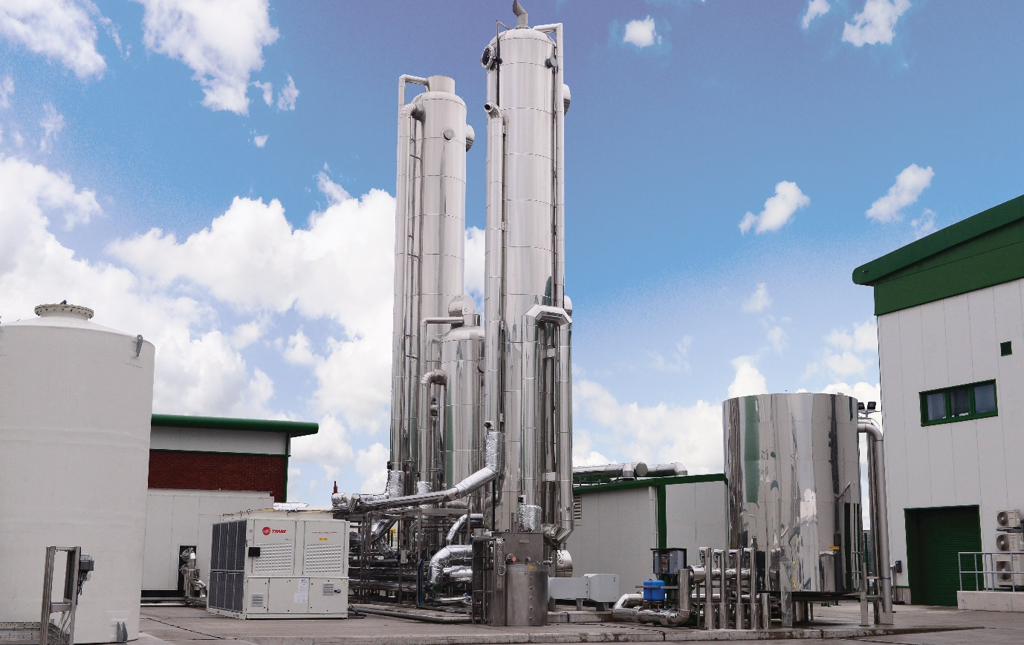

- Membrane, PSA & water wash biogas upgrading provided as a service, not a system.
- Zero initial Capital Expenditure - Upgrade your gas without upfront cost.
- Reduces the amount of capital you need to raise and frees up your balance sheet
- Switch your CapEx to OpEx.
- Zero operational risk - We service, maintain and manage the equipment, and guarantee annual uptime.
- Zero performance risk - We guarantee performance and recovery for the duration of the contract - if it doesn’t work, you don’t pay!
Let our experienced team deal with the Biogas Upgrading on your behalf.
Contact mark.storey@greenlanebiogas.com for more details.
https://www.greenlanerenewables.com/biogas/greenlane-biogas-finance/

Tags: AD Biogas Biomethane

