Manufacturer Feedback form for Chargepoint Certification
Name of respondent
Organisation
Contact details
Responding on behalf of (individual/organisation)
Date:
To Respond: Please send completed response form to Abdul Choudhury (Abdul.choudhury@dft.gov.uk) with ‘Chargepoint certification consultation response – [company/respondent name]’ in the subject line.

Deadline: 25th Jan 2021

Introduction
- OZEV (The Office for Zero Emission Vehicles) is consulting stakeholders on proposals for the introduction of product certification for electric vehicle chargepoints.
- OZEV is responsible for the Electric Vehicle Homecharge Scheme (EVHS) and the Workplace Charging Scheme (WCS), which provide grant funding for the installation of ‘approved chargepoints’. The process for approving EV chargepoints is based on manufacturers self-certifying compliance against a set of Minimum Technical Specifications (MTS).
- We are seeking your views on our proposal to change how we approve chargepoints to a system based on third party certification. We are interested in your opinion on the merits of certification, the appropriate level of certification to use, timelines for introducing such a change, and what impact the different levels may have on your businesses.
Expected benefits of third-party certification
- There are a number of reasons for introducing product certification under the grant schemes:
  - A higher degree of confidence in compliance – OZEV does not have the capability to fully verify manufacturer claims of compliance or adjudicate in cases where designs may or may not be compliant with standards. This reduces the effectiveness of the approvals process, especially where manufacturers are innovating. Independent testing would fill this capability gap.
  - Creating a level playing field for manufacturers in the UK – third party certification would ensure that all manufacturers undergo a standardised set of tests and approvals, that are independently conducted.
  - Increased consumer confidence – third party certification would provide extra assurance to consumers that products are meeting safety and quality standards.
  - Better implementation of the standards – it is expected that feedback and experience of third-party accreditation will provide a more consistent understanding of the standards and assist in future reviews of standards to ensure they are current with industry practices.
  - More consistent treatment of minor modifications to equipment – The process will enable “families” of equipment and minor modifications to be processed according to established rules for certification. This should allow a more efficient and consistent approval process, for example to enable listing of “family members” of chargepoints, than current practices allow.
Proposal
- The OZEV proposal for the approval of EV chargepoints for the EVHS and WCS is as follows:
  - The third-party certification may be conducted by any certification body offering certification at ‘ISO/IEC 17067:2013 Conformity assessment — Fundamentals of product certification and guidelines for product certification schemes’ standard. For example, BSI offer product verification to this standard. OZEV will accept other similarly accredited bodies.
  - Equipment will be evaluated against the standards stated in the MTS (please see the Electric Vehicle Homecharge Scheme: minimum technical specification and Workplace Charging Scheme minimum technical specification for more details) The results of the third-party certification will be submitted by a manufacturer to OZEV for equipment to be approved, alongside any other required information.
Topics for further consideration
- The following describes areas where we would like your input to help define how product certification is introduced.
- The level of certification required is to be determined. It will be consistent with the ‘ISO/IEC 17067:2013’ standards. Table 1 below provides an overview. The initial proposal is either level 1a or level 5.
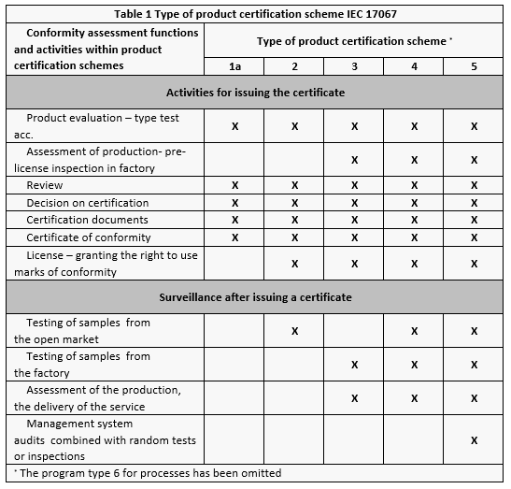 Table 1
- The timeline for introducing any new requirements for equipment to be certified is to be determined. This will be informed by the outcome of this consultation. Any timeline will follow a decision on the level of certification appropriate for the market, the time it takes to get products certified to that level, the capacity of certification bodies to deliver certification for all manufacturers, and consideration of wider regulatory changes that may impact or be folded into the certification system.
- It is proposed that current chargepoint models that are on the OLEV approved list should undergo third-party certification and a deadline be set for this to occur. After that date the equipment will be removed from the EVHS/WCS approved list. The timeline for requiring this is to be determined. This will similarly be informed by the outcome of this consultation.

Questionnaire:
- What are your views on the introduction of product certification for chargepoints?

  - What would be the impact on your business of product certification?

  - Are there any existing third-party certifications that you already use?

  - When should certification be introduced into the schemes (if it is)? What are your key considerations in relation to timeline for introduction?

  - Would product certification add value to your products?

- What is your preferred level for product certification and why?

  - What do you estimate the costs of certification might be for your company for level 1a certification and level 5 certification?

  - What would you see as the benefits to your company of level 1a certification or level 5 certification?

  - Do you have quality assurance systems in place to check for compliance with the requirements of the MTS? If so, is it compliant with ISO 9001?

- Are there any other points you would like to make in relation to the introduction of product certification for EVHS and WCS chargepoint approvals process?

Currently, BSI offer certification to Level 1 and Level 5 (Kitemark) standard.

