
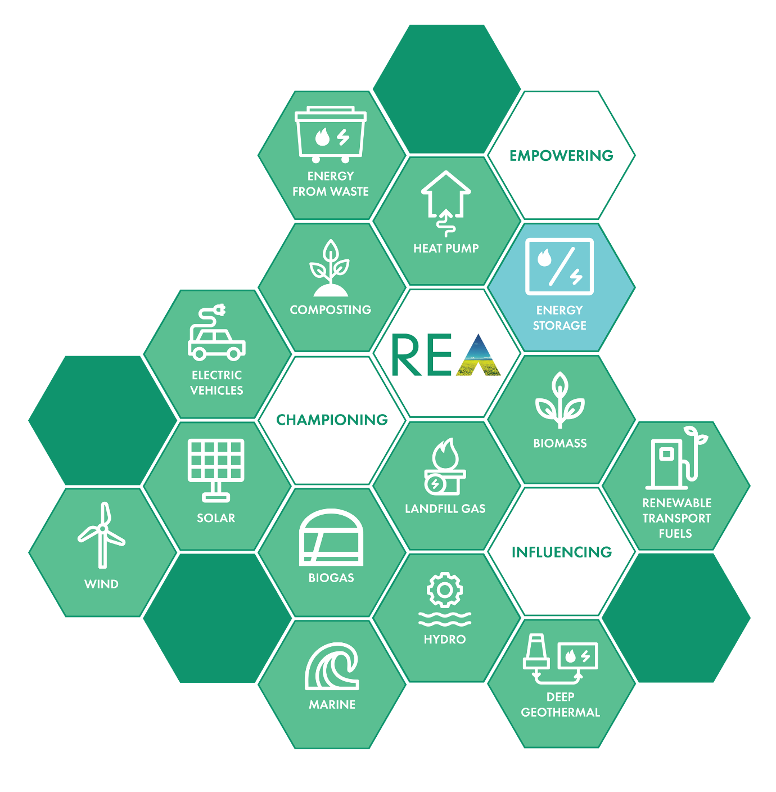
Longer-Duration Energy Storage: The missing piece to a Net Zero, reliable and low-cost energy future
Supporting Green Jobs

Prepared by the REA’s Energy Storage Forum – Longer-Duration Energy Storage Working Group

Contents

Executive Summary………….………………………………….…  Introduction.................................................................................  The need for longer-duration energy storage ………..........…  Barriers to deployment ……….………….………………………..  Enabling investment in longer-duration storage……………...  Conclusions……………………...………………………………….  Sources……….………………………………………………………. | 3  5  8  11  15  21  22

Executive Summary

- An energy system powered in the main by variable sources will require drastically increased provision of energy storage at all scales. Flexibility markets are presently dominated in the UK by fossil fuel assets, and the recent encouraging take-up of short-duration energy storage technologies has not been matched by growth in longer-duration technologies.
- Currently, the UK has 2.8GW of Pumped Hydro energy storage and a limited number of Compressed Air Energy Storage and Liquid Air Energy Storage sites in development. By contrast, several major studies that have been published in the last few years on the need for longer-duration energy storage in the UK estimate at least 20GW-40GW (exceeding 200GWh) will be required. These estimates could change, but if they do, are likely to increase rather than decrease as the energy transition accelerates.
- Clean forms of synchronous longer-duration storage can play a greater role in addressing the growing challenges associated with system stability and network constraints. The paper discusses a range of clean technologies with duration of more than 4 hours, with some of them reaching up to 24 hours, though arguments made may also have some relevance to energy storage solutions capable of providing an even longer duration, such as hydrogen.

- The existing market framework provides investors in longer-duration storage with very low certainty of income, which disincentivises deployment when viewed in context of the high Capex cost of such projects, which are typically on a large scale.

- The paper clarifies why existing market mechanisms are not unlocking investment in longer-duration storage technologies and outlines some of the options the UK could consider to enable deployment of these technologies, including an Income Floor and a Regulated Asset Base model.

- The REA calls the Department for Business, Energy and Industrial Strategy (BEIS) and Ofgem to issue a joint Call for Evidence on longer-duration storage alongside the forthcoming update to the Smart Systems and Flexibility Plan:

- Seeking input from National Grid ESO, the wider industry, and academia on how much electricity storage will be required in a Net Zero energy system across different timescales;
- Looking into the challenges of capital-intensive, large scale flexibility projects with long construction periods and exploring possible options to enable their deployment; and
- Assessing how existing barriers to wider deployment of longer-duration energy storage can be removed and an appropriate market framework put in place.

Introduction

All pathways to Net Zero have one thing in common: they require large amounts of flexibility in our energy system to support high levels of variable renewable generation coupled with changes in consumer behaviour. In the Sixth Carbon Budget, the Committee on Climate Change noted that ‘storage will be important to manage variable output’ from an electricity system based on renewables. Managing an energy system predominately powered by renewables and with greater flexibility will lower the cost of the energy transition and enable the electrification of heat and transport.
Several independent organisations have published studies on the future role of flexibility in Great Britain’s electricity system. The findings are clear - flexibility will be critical for solving the future challenges of a decarbonised electricity system that relies on variable generation, delivering net benefits in the order of billions of pounds per year.

A lack of greater system flexibility could further increase system costs by more than £16 billion per year
Imperial College London, report commissioned by the Committee on Climate Change (CCC)
As illustrated in the figure below from National Grid Electricity System Operator’s 2020 Future Energy Scenarios (FES), flexibility can be provided by a host of different technologies, both from the demand and the supply side.

Flexibility can also be supplied by overseas providers through interconnectors, as well as through synergies with hydrogen and various forms of gas, including green gas.

Figure 1. System Flexibility:

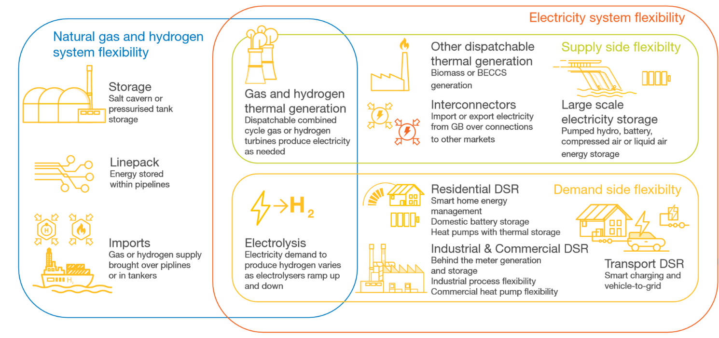
Future Energy Scenarios 2020, National Grid ESO

Despite an increase in the number of low carbon technologies, GB flexibility markets remain dominated by higher carbon assets today. According to analysis from the Department for Business, Energy and Industrial Strategy (BEIS), during the early COVID-19 lockdown period (April-May 2020) emissions from Balancing Mechanism (BM) actions made up between 15-25% of total power sector emissions.

Figure 2. Balancing mechanism emissions as a proportion of total electricity sector emissions

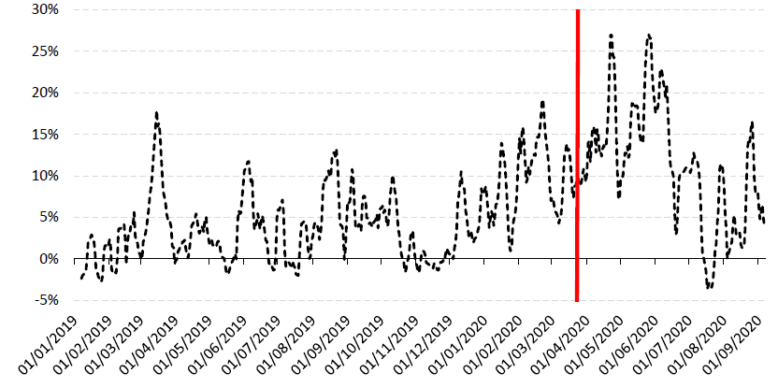

Department for Business, Energy and Industrial Strategy, Carbon in Flexibility Markets Workshop (October 2020)

Increasing the amount of flexibility on the system is not the only challenge ahead of us. Ensuring that flexibility comes from the lowest possible carbon sources will be essential to reaching Net Zero. To this end, it is important that the market framework sends clear price signals to drive investments in clean flexible technologies, including energy storage.

Energy Storage is one of the most important sources of low-carbon flexibility, delivering multiple consumer and environmental benefits:

- reduces the amount of costlier investment in other dispatchable backup generation with lower efficiencies, whilst contributing to security of supply;
- Provides a range of ancillary services at reduced cost to consumers, increasing system stability and resilience;
- Reduces the need for investment in transmission capacity and interconnection;
- Distributed storage can reduce the need for distribution network reinforcement; and
- Enables greater utilisation of renewables by reducing the need to curtail wind output to manage constraints.

Energy storage systems provide a wide array of technological approaches to managing our power supply in order to create a more resilient energy infrastructure and bring cost savings to consumers. They can be classified into five broad categories:

- Mechanical, including Pumped Hydro, Compressed Air Energy Storage (CAES)
- Electrochemical, including Lithium-ion Batteries, Flow Batteries;
- Electrical, including Superconducting Magnetic Energy Storage (SMES) and Supercapacitors;
- Chemical, including Power to Hydrogen and Power to Methane; and
- Thermal, including Molten Salts, Pumped-Heat, and Liquid Air Energy Storage (LAES);

Figure 3. The five key forms of energy storage and the main technologies

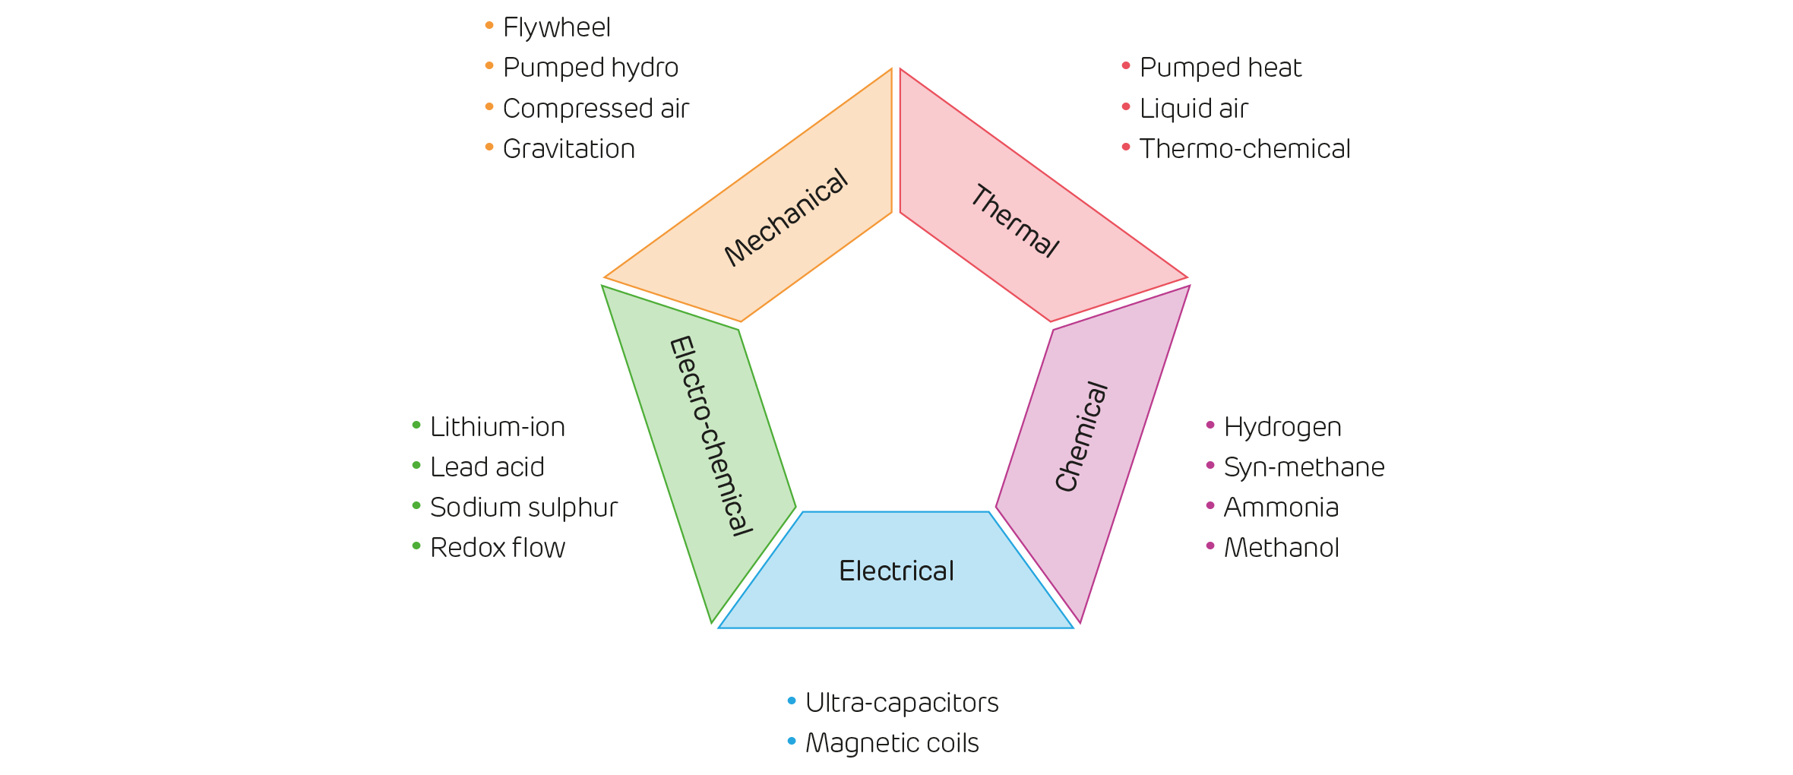

Drax Electric Insights Quarterly (Q3 2019)

The pandemic has brought forward pressures on our electricity system that were anticipated to occur in a few years’ time. The lack of dispatchable synchronous resources at times of low residual demand increased the system operability challenges. Furthermore, extreme weather events are occurring at a higher frequency and intensity than previously forecast by climate change scientists for this period. Storage technologies can provide cost-efficient solutions to system stability and resilience. A new report from Imperial College for SSE Renewables estimates that by 2050 up to £411m per year could be saved ‘in a highly flexible GB system (a high level of distributed demand-side response is available)’ by just 2GW of new long-duration pumped hydro storage plants, while up to £511m savings could be made ina less flexible system. The authors of this report, however, argue that even more could be saved and further system stability could be secured with much more capacity introduced from new plants using a diverse range of longer-duration energy storage technologies.

The need for longer-duration storage

In a power system dominated by variable renewables, the scale and the duration of our flexibility needs will be determined by weather patterns. Bulk energy storage from a variety of sources will be needed to ensure the lights stay on when the wind is not blowing and the sun is not shining. Storage will be equally crucial for absorbing excess renewable generation at times when supply exceeds demand.

There is not yet a universally agreed definition of long-duration energy storage, hence why this paper chooses the term ‘longer-duration storage’ to reflect the fact that a very wide range of technologies may be defined as providing longer-duration storage, and to highlight the current situation in deployment where short-duration storage (and not medium or long-duration energy storage) technologies currently are seen as more investable in terms of returns on investment.

Energy storage technologies can be classified in the following groups with respect to duration:

- Providing energy up to four hours
- Providing energy up to 24 hours
- Providing energy up to two weeks
- Inter-seasonal

We have chosen these four categories because technologies that fall into each have different needs and provide varying services. For instance, lithium-ion batteries, which fall into category A in terms of duration, are relatively easy to build, have a shorter lifetime and are less capital intensive compared to large scale long-duration storage projects (e.g. Pumped Hydro). Longer and shorter-duration technologies face arguably different challenges and this paper focusses on the larger scale as that segment generally receives less attention in regulatory efforts at present.

This paper will look primarily at category B, with some relevance to C and D. Category B includes (but is not exclusive to) the following technologies:

- Compressed Air Energy Storage (CAES);
- Liquid Air Energy Storage (LAES);
- Pumped hydro energy storage;
- Gravity batteries;
- Flow batteries;

There are two main reasons why the paper focusses on Category B. First, because an evidence base is being formed highlighting that GB will need considerable amount of additional longer duration storage operational by 2030. The second reason is that although several technologies within this category are readily available for commercial deployment, the current market framework acts as a barrier to investment in them. Categories C and D remain emerging and therefore face different challenges. It is important to note, however, that other technologies may join Category B and that some of those listed as ‘Category B’ may in time evolve to be capable of providing energy for an even longer period.

In the latest FES publication, National Grid ESO estimated that in 2050 total electricity energy storage will range from 110GWh to 200GWh, corresponding to total capacity ranging from approximately 20GW to 40GW. National Grid ESO expect a significant share of this to come from longer-duration technologies, such as Pumped Hydro, CAES and LAES.

Some consider that National Grid ESO’s modelling approach in FES relies upon a series of assumptions that may not be sufficiently robust, thereby underestimating the amount of storage required, however we consider this debate to be beyond the scope of this paper. Indeed, it is likely that even FES’ most ambitious scenario (‘Leading the Way’) underestimates the role storage could play, as it doesn’t consider the system’s stability requirements (i.e. need for ancillary services) or thermal network constraints. Therefore, it does not capture the full value that storage could deliver to the system.
“it will be necessary to develop large-scale storage with longer durations to support the decarbonisation of the power system”
National Grid ESO, Future Energy Scenarios 2020

Two major industry reports have recently assessed the need for long-duration storage and have argued a need for up to 40GW. Aurora estimates that by 2050, daily storage needs will reach 216GWh corresponding to 30GW of capacity, and it projects a weekly back-up capacity need of 21GW. Jacobs argues that ‘our analyses show that there is a compelling case for developing a further 40 GW of long-term storage, with a storage capacity of some 5,000 GWh’. Jacobs estimates that even its lower end scenario of 30GW of new-build long-duration storage needed would be more than a tenfold increase compared to current levels. Achieving this objective would require a major development programme for longer-duration storage comprising Pumped Hydro, CAES, LAES and hydrogen storage, implemented in 10 GW stages between now and 2050, with the first stage being implemented by 2030.

Currently, the UK currently has a capacity of c.2.8GW of Pumped Hydro, and an unknown amount of CAES and LAES storage (likely into the 100s of MW) is in development. Trial projects for gravity batteries and other innovative technologies also exist. However, the current level of capacity leaves the UK very far short of all the major forecast requirements for longer-duration energy storage.

We acknowledge however that all forecasts must make assumptions in their modelling, and that these models incorporate some assumptions as to which technologies (including electricity via interconnectors) will be available at what cost – these factors are likely to change in the future. There are a range of views within the industry on how the modelling could be further advanced, however the authors of this paper are of the view that while a close forecast for the ‘need’ for long-duration storage in the long-term is still under debate, the scale of the ‘need’ by comparison to the level of longer-duration storage we currently have, is indisputable. We would welcome the Future Energy Scenarios modelling to take a more in-depth look at the role for longer duration storage in its future iterations.

Figure 4. Evolution of flexibility needs

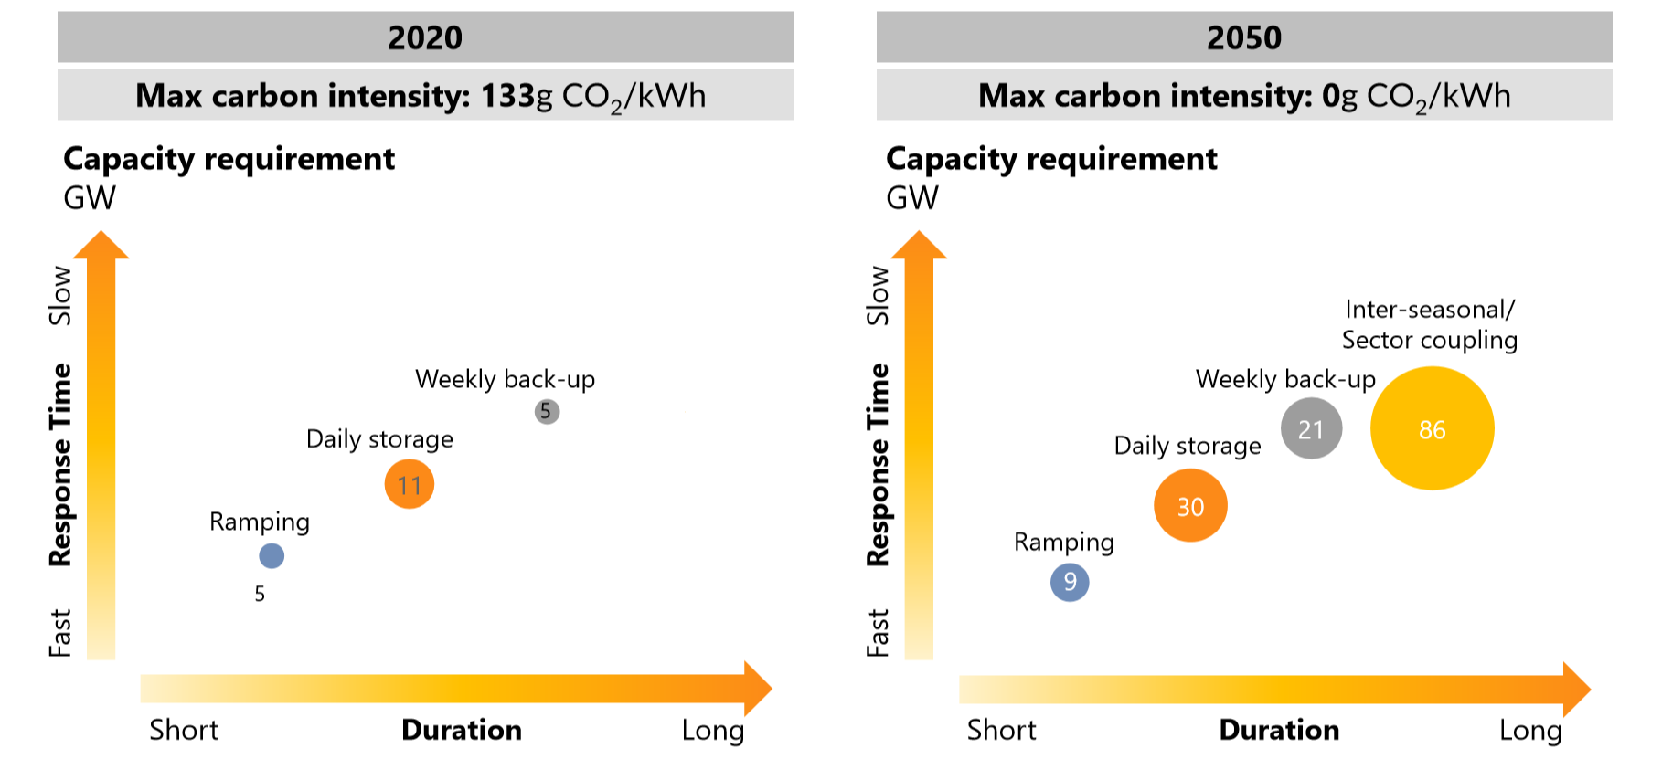

Aurora (2019), The Road to 2050: The need for flexibility in a high renewables world

Barriers to deployment

Although there is clear evidence that Longer-Duration Storage delivers substantial benefits to GB consumers, development of new projects has been limited in the last few decades. Below we explore some of the reasons why the current market structures and incentives do not provide a favourable environment for investment in existing or new longer-duration storage technologies:

- Wholesale Market: revenues derived from net-energy sales through arbitrage payments do not currently provide bankable and adequate investment signals due to the price uncertainty involved and their short-term nature. Longer-term bilateral contracts between market participants (e.g. suppliers or renewable energy generators) and flexibility providers may be further developed in the future, but it is unlikely that these would deliver the scale of investment required in longer-duration storage, especially considering the high capital requirements and long consultation times involved (e.g. 5-8 years for Pumped Hydro). Much of the value provided by energy storage comes from its capacity, balancing, ancillary, stability and other services, benefits which are not recognised by Power Purchase Agreements.

- Capacity Market (CM): the CM aims at ensuring resource adequacy at the lowest cost; as currently designed, it does not send clear investment signals to support the deployment of large-scale, low-carbon flexibility. Critically, the CM does not acknowledge the key benefits that longer-duration storage technologies deliver to the system, in areas such as network constraint management, frequency and voltage regulation, system stability, and restoration (Black Start). These are procured separately by National Grid ESO, in a fragmented manner and in shorter timescales, involving income uncertainty. As result, developers do not see a combined, reliable, long-term price signal that would allow them to attract funding at a reasonable cost of capital. Also, the CM does not facilitate projects with construction periods in excess of four years, such as Pumped Hydro, as the CM auctions take place four years (T-4) and one year (T-1) ahead of the delivery year. While technically, a developer could start building a project and then bid when four years of construction time remains, this is not a feasible way of developing any project and would be close-to impossible to finance.

- Contracts-for-Difference (CfD): the CfD scheme is the government’s main instrument to support investment in low-carbon and renewable generation (e.g. wind, solar, nuclear, etc.). Enhancing investment in flexible capacity is not its main objective. The CfD model incentivises generators to produce as much electricity as possible. As such, it is not appropriate for stimulating investment in flexible technologies, which bring value by operating at specific times, responding to market conditions and system requirements.

- Balancing & Ancillary Services:

  - The contract duration is short (e.g. one day, one week or one month). Yet investments in large scale infrastructure projects depreciate over many years (e.g. 15-25 years) in order to reflect their operational lifetime, which can in certain cases exceed 50 years (e.g. Pumped Hydro).
  - Different ancillary services are procured separately and contracts from various services cannot always be stacked effectively. This fails to send a clear price signal for investment in technologies with superior technical characteristics that could provide several services at a lower cost overall. Some separately-procured services cannot be provided separately by longer-duration energy storage plants – for instance, all provide inertia. If, for instance, a plant wins a contract for one service but not another, and the services cannot be separated out, the plant will not be fully renumerated for the services it provides. This also puts the System Operator in a difficult position.
  - Unlike the wholesale energy market, ancillary services markets are relatively shallow and illiquid. They are often location-specific (e.g. reactive power) and come with specific technical requirements set by National Grid ESO. This means investors cannot estimate with confidence how their value will evolve over long horizons.
  - The ancillary services market has been under review for several years. Constant change makes it difficult for investors to predict what is the value that can be extracted from these services through the course of a lifetime of an asset.
  - Contracts do not account for long construction lead-times that some longer-duration storage technologies require (e.g. 6-8yrs for Pumped Hydro). Therefore, no value from ancillary services can be secured at the point of final investment decision in new capital-intensive assets. Uncertainty over returns makes these projects less attractive to investors and drives up the cost of capital.
  - Stability services (currently under Pathfinders): based on real inertia but including inertia, reactive power / load and frequency / voltage control. Energy storage plants are currently not renumerated for the inertia they provide.
  - Black Start/ Distributed ReStart project(currently under Pathfinders), is currently difficult for some longer-duration energy storage technologies to access as there is a lack of clarity over whether energy storage is considered the primary plant or the main plant, with each having different requirements.
  - Some of the ancillary services, such as inertia and reactive power, which are essential for secure system operation are not ascribed the correct economic value today. For example, the inherent inertia produced by power plants and synchronous longer-duration storage technologies, is not appraised or rewarded separately, so is effectively provided for free, alongside energy. Thus it is significantly underpriced, which belies its value to the system’s stability. Also, most reactive power is currently compensated under a regulated price which does not reflect its true value to the system.

- Network Constraints:

  - The transmission system and distribution systems need to transfer large amounts of energy from the generation areas to major load centres. Network constraints limit the amount of power that can be transferred from where it is generated to where it is consumed. The prime example of this in GB is the Scottish-English border where at times of high wind generation more power is generated in Scotland than can be carried to the large demand centres in England. Where this is the case, National Grid ESO uses the Balancing Mechanism (BM) to redispatch plants from the market schedule to a profile which can be delivered given the network constraints.
  - The potential for storage to reduce the cost of managing network constraints, by deferring or avoiding the need for network reinforcement where efficient to do so, remains largely untapped, as the current market provides limited price signals to reflect this. National Grid ESO’s efforts to explore the role that storage could play in addressing network constraints is welcome. However, effective competition between network and commercial service providers can only happen if there is a level playing field.
  - While certain components that make up network charges could be charged in a more dynamic and cost-reflective manner to incentivise flexibility, these signals alone would most likely be insufficient (i.e. they would not provide an adequate and bankable revenue stream to incentivise investment in capital-intensive projects).
Together the factors set out above create an onerous environment for investment in longer-duration storage projects. Some of the barriers detailed above, such as the lack of certainty over returns, can be particularly difficult to overcome where projects involve high Capex requirements and long lead-time before they begin operation (e.g. 6-8 years). The barriers that inhibit all large-scale, longer-duration energy storage projects present a strong risk for investors looking to aid the development of full-scale plants using new or partially new technology.

Case study of barriers to deployment: A proposed CAES facility in Cheshire
This case study concerns Storelectric’s proposals for a 40-100MW CAES facility providing around 5 hours of energy storage duration, including the potential application of Thermal Energy Storage (TES) which could be run with green hydrogen, with a high level of grid-to-grid efficiency.
Storelectric’s proposals concern several salt caverns which are man-made and pre-existing, in an area where there is active solution mining of salt as a feedstock for the chemical industry; though elsewhere, salt caverns can be created specifically for this purpose.
CAES systems can provide a range of services to national and local electricity grid operators, which will be vital to help manage the grid as we progress towards Net Zero, including natural inertia (in this case, delivered 24/7), stability, voltage/frequency control, imbalance pricing and arbitrage hedging services, Black Start, Power Purchase Agreements, and other services.
Moreover, there are a very wide range of viable salt cavern location sites in the UK, with potential for far greater deployment. These often coincide with areas of intensive former industrial activity and with coastal areas close to wind farms, where the grid is currently heavily constrained. Pressure on the grid will only increase as the energy transition progresses. Co- location of storage and wind farms can help reduce capital costs and help deliver both balancing and stability services where the grid most needs them. Development of these sites would therefore fit with the Government’s ‘levelling up’ agenda which seeks to regenerate post-industrial regions, and they would also take up little space above ground. They also support the government’s green agenda, enabling the cost-effective, reliable and resilient decarbonisation of the grid.
Many of the key requirements to make this site viable are in place. Planning authorities and the local populace are supportive of salt cavern development and use in the area. Contractors who are interested in supplying the equipment, and system operators for the long-term management of the facility, have provided written statements of intent in the project and in other potential sites for development.
While these projects have been appraised by third parties as economically viable there does however, remain one major barrier to the development of the proposals – longer term security of returns for investors. As a pioneering project for a technology which is proven but which has not yet been deployed in this version, investors cannot currently have full confidence about the levels of long-term returns on the project.
For first-of-a-kind plants such as that outlined in this case study, the absence of a long-term contract prior to construction, and planning consent, can present an insurmountable risk for investors. The short lengths of contracts for energy storage are a particular barrier for such projects, which require several years to develop and will be operational for many years beyond the short contracts on offer, along with the lack of financial reward for providing important services to the grid such as inertia. Contracts for services tend to have a short period between the contract being tendered and agreed, and the commencement of services, which further hinders the development of assets, due to the long construction time and length of time required to undertake grid connection works. Though not a perfect solution, the development of Enhanced Frequency Response contracts, with a term around half the life of a battery was an important step in increasing the deployment of batteries as it provided greater certainty for investors than before.
The salami slicing of services, where different services have separate contracts, also complicates navigating the market for larger, longer-duration assets which are able to provide a range of services, as investors need to be confident of gaining several different services contracts to make the business model viable.

Enabling investment in Longer-Duration Energy Storage Projects

The current merchant model presents a significant barrier to the development of large-scale, longer-duration energy storage projects. Given the long construction period of large infrastructure projects, and the time that will be required for consenting and procurement, action needs to be taken now if we are to see the first batch of new longer-duration storage commissioned by 2030. Therefore, while a more fundamental review of the market design may be desirable, we believe that government, supported by Ofgem, should aim to establish a future-proof income stabilisation mechanism to de-risk investment in longer-duration energy storage, building on the existing market arrangements. This would enable longer-duration energy storage projects to truly compete with smaller-scale and shorter-duration technologies that require a much smaller Capex but target the same revenue streams. Such a mechanism would be a significant and ‘no regrets’ step towards setting the UK on track to achieve Net Zero target by 2050.

The REA considers it important that the mechanism should meet the following criteria:

- Compatible with the operational profile of storage, incentivising efficient dispatch through price signals
- De-risks investments effectively, reducing the cost of capital, while protecting consumers from undue risks and excessive costs.
- Enables participation from a range of technologies, including emerging ones, ensuring effective competition in the process and encouraging growth of new technologies.

Meeting these criteria will be necessary to ensure the growth in deployment of longer-duration energy storage technologies.

Below we use a ‘traffic light’ (green, amber, red) scoring approach to illustrate how four different approaches to revenue stabilisation would meet these criteria when applied to longer-duration storage projects. We recognise that the extent to which the different mechanisms meet certain criteria is largely contingent on their detailed design, which may vary.

The mechanisms assessed are:

- Income Floor;
- Regulatory Asset Base (RAB);
- Capacity Market (CM);
- Contracts for Difference (CfD).

Criteria | Income Floor | Regulated Asset Base (RAB) | Capacity Market (CM) | Contracts for Difference (CfD)
1) Compatible with the operational profile of storage, incentivising efficient dispatch through price signals | Under the Income Floor model, dispatch decisions would still be driven by price signals (e.g. wholesale market, balancing market, ancillary services). An Income Floor model would give energy storage providers an incentive to maximise the commercial value of plant operation, a benefit to consumers also. | Would involve complex design to incentivise efficient operation though price signals, but theoretically it could be possible. | As currently designed, the CM does not incentivise flexibility or consider other system needs that longer-duration storage can address (e.g. ancillary services). | Incentivises plant to maximise their energy production (guaranteed price per MWh produced). This is incompatible with the operational profile of storage which should be incentivised to import electricity when prices are low and export at times of scarcity, and to maximise delivery of value-added services.
2) De-risks investments effectively, reducing the cost of capital, while protecting consumers from undue risks and higher costs. | The Income Floor model would de-risk all revenue streams (i.e. energy, capacity and ancillary services), providing long-term certainty (e.g. 20 years) to investors. This should reduce the cost of capital, benefiting investors and consumers.  REA acknowledges that the Government may consider including a ‘cap’ as part of an income floor mechanism – in which instance a high cap should be used to avoid disincentivising investment. Revenue above the cap could be used to support a wide shared across funding pots for a wide range of energy storage technologies.  Construction risks would sit with the developer, removing exposure of consumers. However, this could make it more difficult for emerging technologies to attract investor support. | The traditional RAB approach regulates returns fully, de-risking the investment more than the other mechanisms.  Investors benefit from high levels of protection from risks, including during the construction phase. From an investor perspective, this is favourable when considering investment in technologies that are relatively new to the energy market.  However, this means customers may face risks from cost overruns (depending on the detailed methodology set by the regulator). | The CM leaves investors exposed to merchant risk from energy arbitrage and system support services.  In its current form (which doesn’t consider system support capabilities, CO2 emissions, etc), it is unlikely to result in sufficient revenues to enable investment in capital-intensive longer-duration energy storage projects. | The CfD has been successful in improving the bankability of low carbon and renewable energy projects, as illustrated by the high uptake and investment over the years in some of the technologies supported by it. However, it would not de-risk investment in longer-duration energy projects effectively. This is because it applies only to energy revenues, and does not secure possible additional income from balancing and ancillary services, vital to the profitability of energy storage. This leaves investors exposed to merchant risk from balancing and ancillary services and could discourage investment.
3) Enables participation from a range of technologies, ensuring competitive tension in the award process. | Income Floor(s) could be awarded to projects following competitive tender processes, which would involve participation from a range of technologies. | Could involve competitive pressure in the award process, but possibly less compared to the Income Floor as may require a regulatory regime to be developed for each project separately – a resource intensive exercise that may not be easily delivered for many projects at the same time. | As currently designed, the CM favours low Capex/ high Opex projects (e.g. OCGTs over CCGTs).  Also it isn’t suitable for new build technologies with construction time in excess of four years (T-4), such as Pumped Hydro. | The CfD has been effective in enabling competition between projects. It can also enable competition between different technologies, (depending on the chosen pot structure).

- Compatible with the operational profile of storage, incentivising efficient dispatch through price signals

The Income Floor model appears the most compatible with the operational profile of storage, which focusses on the provision of flexibility and ancillary services. Under the Income Floor approach, dispatch decisions would be driven by market price signals (e.g. wholesale market, balancing market, ancillary services).

The RAB could be compatible with the operational profile of storage, but incentives would need to be carefully designed to avoid potential market distortions.

The CM, as currently designed, aims at ensuring system adequacy at the lowest cost. It does not incentivise low-carbon flexibility or consider system stability and resilience needs.

The CfD model, if applied to storage, would likely lead to inefficient dispatch decisions, distorting market operation. This is because the CfD incentivises assets to maximise their energy production, by guaranteeing a fixed price per MWh produced. This is incompatible with the operational profile and value of storage, which should be incentivised to import when prices are low and generate at times of scarcity, rather than maximise its output.

- De-risks investments effectively, reducing the cost of capital, while protecting consumers from undue risks and excessive costs.

Both the Income Floor and the RAB could de-risk investments in long-duration energy storage projects effectively.

The RAB provides fully regulated returns, providing the highest level of certainty to investors compared to the other mechanisms. Under the RAB approach, payments can be made from consumers to developers during the construction phase. This may also involve consumers facing construction risks (e.g. cost overruns) depending on the detailed arrangements set out by the regulator.

Under the Income Floor all revenue streams (i.e. energy market arbitrage, capacity market and ancillary services) are taken into account in determining whether returns (gross margin) are below the Floor. The contract would be for an annual income floor value in £/MW terms, conditional upon the availability of flexibility resources, including MWhs of storage, MVArs of reactive power, and a frequency response/inertia capability. Under the Income Floor, construction risks are borne entirely by investors, which may be appropriate for more mature technologies, such as Pumped Hydro.

The CM would leave investors exposed to merchant risk from electricity trading, balancing and ancillary services, failing to drive lower cost of capital for investment in longer-duration energy storage projects.

While successful in improving the bankability of low carbon and renewable energy projects, the CfD would not de-risk investment in longer-duration energy projects effectively. This is because it applies only to energy revenues, and does not secure possible additional income from balancing and ancillary services, vital to the profitability of energy storage.

- Enables and encourages participation from a range of technologies, ensuring effective competition in the process

Both the Income Floor and the RAB approaches could be designed around system needs rather than around specific projects or technologies. Successful projects and allowed returns could be set through a competitive tender process, involving participation from a range of technologies.

Due to the scale and lead-time associated with these assets, the number of participants in tender or gateway processes may be limited. If this is the case, then it may be appropriate for a floor value to be set by BEIS or Ofgem through an administrative process.

The CM, as currently designed, does not enable new build longer-duration storage technologies with construction times in excess of four years (T-4), such as Pumped Hydro. It also favours low Capex/ high Opex projects (e.g. OCGTs over CCGTs). Therefore, in its current form, it is unlikely to enable competition from capital-intensive longer-duration energy storage projects.

The CfD has been effective in making use of competition between projects and technologies to drive costs down. However, as discussed above, the CfD isn’t a suitable mechanism given the operational characteristics of longer-duration storage.
Conclusion

Increasing the development of longer-duration energy storage projects is a necessary step to managing a grid powered by high levels of variable generation and therefore is vital to Net Zero. As other analyses also show, increasing the amounts of new longer-duration energy storage plants coming onto our electricity system also has significant cost-saving benefits.

There is another indisputable and overarching benefit to consumers from wider deployment of longer-duration energy storage – a more stable energy supply and cushioning from price volatility. A larger, and diverse, portfolio of longer-duration storage projects in the UK would also provide greater security of supply. As Britain’s neighbours gradually increase the proportion of variable generation powering their grids, there will likely be periods where Britain and its neighbours experience system stress at the same time due to the impacts of weather on renewable energy outputs.

Our analysis suggests that the two models currently used to incentivise investment in renewable generation and ensure security of supply, the Capacity Market and Contracts for Difference, would not be appropriate tools for encouraging investment in longer-duration energy storage due to their inability adequately help de-risk earnings from balancing and ancillary services.

There are therefore two options that could offer appropriate solutions: Income Floor, and RAB. An Income Floor could be the most simple mechanism for incentivising investment, ensuring that dispatch models continue to be driven by price signals, and encouraging plant operators to maximise the value of the plant for themselves and for consumers, however REA appreciates that it would require very careful design.

The REA therefore calls on the Department for Business, Energy and Industrial Strategy to issue a Call for Evidence on how the barriers inhibiting wider development of longer-duration energy storage projects can be removed. This could be issued alongside the updated Smart Systems & Flexibility Plan, however the Government should also explore whether there are any options for removing some of the regulatory barriers to longer-duration energy storage in the interim period while developing a permanent market mechanism.

Sources:

- Aurora (2019) The road to 2050: The need for flexibility in a high renewables world.
- Committee on Climate Change (2020) Sixth Carbon Budget – Electricity Generation.
- Department for Business (2020), Energy and Industrial Strategy, Carbon in Flexibility Markets Workshop.
- Drax (Q.3 2019) Electric Insights Quarterly.
- Greentech Media (2020), ‘So, what exactly is Long-duration Energy Storage?’
- Imperial College and Carbon Trust (2016) Can storage help reduce the cost of a future UK electricity system?
- Imperial College for the CCC (2018) Analysis of alternative heat decarbonisation pathway. See also: Imperial College for the CCC (2015) Value of flexibility in a decarbonised grid and system externalities of low carbon generation technologies.
- Imperial College for SSE Renewables (2021) Whole-System Value of Long-Duration Energy Storage in a Net-Zero Emission Energy System for Great Britain.
- International Hydropower Association (2018) Country profile – United Kingdom.
- Jacobs (2020) Strategy for Long-Term Energy Storage in the UK.
- National Grid ESO (2020) Future Energy Scenarios.
- National Grid ESO (2021) Network Options Assessment (NOA).
- REA (2016) Energy Storage in the UK: An Overview.
- Zhou et al (2019), ‘A review of thermal energy storage in compressed air energy storage system’, Energy Vol.188.

Find Out More and Support the Sector

The report is available on the REA website, here:
https://www.r-e-a.net/our-resources/

Follow us on Twitter: @REAssociation

For further information, please contact:

Isobel Morris – Policy Analyst, REA
imorris@r-e-a.net

Jack Abbott – Public Relations and Communications Manager, REA
jabbott@r-e-a.net

If you’re interested in REA membership, please contact

Lindsay Barnett, Head of Membership, Marketing & Events, REA
lbarnett@r-e-a.net

THE ASSOCIATION FOR RENEWABLE ENERGY AND CLEAN TECHNOLOGY
Brettenham House, 2-19 Lancaster Place, London, WC2E 7EN
Tel: +44 (0)20 7925 3570 Email: info@r-e-a.net Web: www.r-e-a.net
Company no: 04241430 Registered in England and Wales

Committee on Climate Change (2020) Sixth Carbon Budget – Electricity Generation, 21.
Imperial College for the CCC (2018) “Analysis of alternative heat decarbonisation pathways”, 39. See also: Imperial College for the CCC (2015) “Value of flexibility in a decarbonised grid and system externalities of low carbon generation technologies”.
In addition to Biomass or BECCS, other dispatchable generation could include generation-integrated energy storage technologies, such as concentrated solar power.
National Grid ESO (2020) Future Energy Scenarios, 99.
Department for Business (2020), Energy and Industrial Strategy, Carbon in Flexibility Markets Workshop
Imperial College and Carbon Trust (2016) "Can storage help reduce the cost of a future UK electricity system?",6.
Drax (Q3 2019) Drax Electric Insights Quarterly)
Imperial College for SSE Renewables (2021) Whole-System Value of Long-Duration Energy Storage in a Net-Zero Emission Energy System for Great Britain, 7.
See the debate in Greentech Media (2020), ‘So, what exactly is Long-duration Energy Storage?’ for a range of definitions.
See REA (2016) Energy Storage in the UK: An Overview for more information on how each technology works.
National Grid ESO (2020) Future Energy Scenarios, 112.
National Grid ESO (2020) Future Energy Scenarios, 112.
Aurora (2019) The road to 2050: The need for flexibility in a high renewables world)
Jacobs (2020) Strategy for Long-Term Energy Storage in the UK, 13.
Jacobs (2020) Strategy for Long-Term Energy Storage in the UK, 63.
International Hydropower Association (2018) Country profile – United Kingdom
Network Options Assessment (NOA)
Further information on how such a system works can be found in Zhou et al, ‘A review of thermal energy storage in compressed air energy storage system’, Energy Vol.188 (2019).

