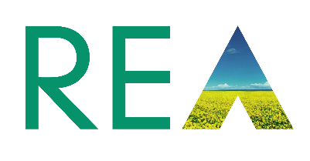
Nomination Form REA Wood Heat Forum Steering Group

Open Positions:
• Wood Heat Forum Steering Group Members

Closing date: 1pm Monday 18th October – Revised 5pm 20th October 2021
Name of applicant: Amy Fielding

Contact details: | Email: amy@envirocompliant.co.uk | Mobile telephone: 07540576571
 |  | Office telephone: 01785859225
REA member organisation name: Environmental Compliance Solutions Limited

Personal Statement – 200 words
How you would propose to contribute to the Wood heat Forum and your visions for the biomass heat industry:

As a Director and Founder of Environmental Compliance Solutions, I have spent over 25 years working within the industry. I have gained a wealth of experience in the deployment of biomass and waste wood projects from conception to post completion. Over this time, I have witnessed the challenges faced with reliable fuel supply, suitable equipment specification, funding, planning, permitting and compliance.

After working at the frontline of a biomass boiler manufacturing company have collaborated with a wide range of agencies and associations such as the Carbon Trust, DEFRA, BEIS, FIRA, AEA Technology, Ofgem and attended Downing Street to participate in the Copenhagen Climate Change reception held in 2009.
I now use this experience to help businesses minimise any financial risk associated with investing in biomass and waste wood boiler technology, ensuring on going compliance to such schemes as the NDRHI and meeting environmental permitting requirements. I also work with a leading global fuel analysis company, adding to my strengths and capabilities.
As a member of the steering group my aim would be to help the drive for Biomass and Waste Wood to Energy be deployed appropriately and continue to be recognised as a suitable technology to help towards decarbonisation.

Date: 20/10/2021
Please send your completed form along with a picture by email to pjohn@r-e-a.net.

