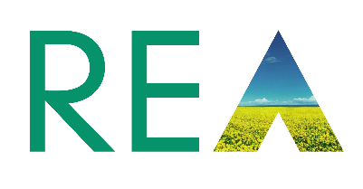
Nomination Form REA Wood Heat Forum Steering Group

Open Positions:
• Wood Heat Forum Steering Group Members

Closing date: 1pm Monday 18th October
Name of applicant:
Mark Lebus
Contact details: | Email: m.lebus@lcenergy.co.uk | Mobile telephone: 07834496696
 |  | Office telephone:
REA member organisation name: LC Energy

Personal Statement – 200 words
How you would propose to contribute to the Wood heat Forum and your visions for the biomass heat industry: (Note: this personal statement will be published to the rest of the membership, either during a contested election or upon appointment to the board)

After a decade of strong growth, the biomass industry is in a state of flux with Government support ending/ended and no clear strategy to decarbonise heat. The WHF has created a strong presence with cross industry representation to educate and influence the policy makers especially in this critical period for the next 1-2 years.

As a biomass business owner since 2007, my aim is to bring experience and ideas to the steering group through a long-term direct involvement in the biomass industry and as a director of the UK Pellet Council.

The biomass sector has a history of delivering decarbonisation of heat however the task ahead for the WHF is to convince the policy makers that it can continue to play a key role particularly in the off-grid market where the options are very few. The political risk is huge, and the WHF has a duty to educate Government on behalf of its members and the industry.

The risk of no action or support for the industry is already being felt through job losses and an exodus of expertise. There is little time left to show a solid front and this is one of the reasons I am keen to add my support the steering group.
Date: 08 Oct 2021
Please send your completed form along with a picture by email to pjohn@r-e-a.net.

