
Nomination Form REA Wood Heat Forum Steering Group

Open Positions:
• Wood Heat Forum Steering Group Members

Closing date: 1pm Monday 18th October
Name of applicant: Michael Ingoldby

Contact details: | Email: | Mobile telephone:  +44 (0) 7766 757997
 | mike@bowlandbioenergy.co.uk | Office telephone: +44 (0) 1200 440437
REA member organisation name: Bowland Bioenergy Ltd.

Personal Statement – 200 words
I have been producing wood chip fuel to ISO 17225-4 and selling wood pellets complying with EN plus for seventeen years. Production of high quality fuel has always been the objective, with customer service to match. Our fuel is force dried using a biomass boiler to heat a continuous flow dryer bed. Chip fuel is sold by calorific value at specific moisture content to meet customer specification.
Wood Fuel Testing Ltd. was acquired to facilitate regular tests of chip particle size and moisture content on all fuel produced before despatch.
This policy has won awards at District and County level business competitions.
As a Chartered Forester and Chartered Environmentalist, I well understand the practicalities of sylviculture, in particular establishment, protection and harvesting of woodland. Management experience has been gained throughout the UK and Europe. Consequently I am able to refute the convoluted thinking of the well meaning but ill informed anti felling campaigners, with documentary evidence of the beneficial effects of conventional harvesting on lowering CO2 atmospheric levels.
I believe that the combination of the two factors above provide me with the ability to both promote good wood fuel and defend the use of woody biomass in our boilers.

ENDS

Date: 15/10/2021

Date: 15/10/2021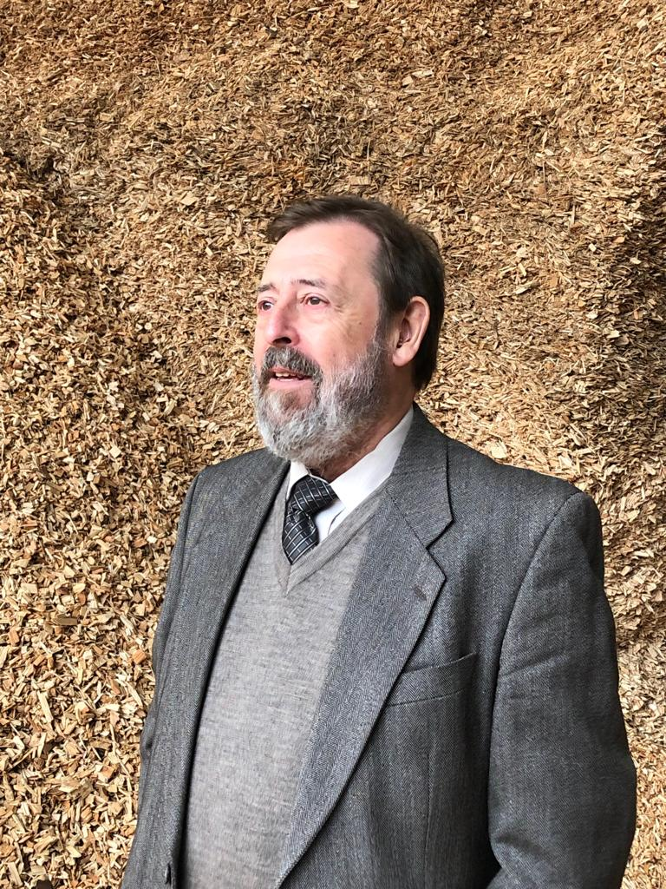
Please send your completed form along with a picture by email to pjohn@r-e-a.net.

