REA Member Briefing on the Government’s Biomass Policy Statement

Introduction and Context
On 4th November the Department for Business, Energy and Industrial Strategy (BEIS) released its Biomass Policy Statement which provides a strategic view on the role of biomass across the economy in the medium- to long-term to meet net zero.
This policy statement is an interim step in the development of the UK Biomass Strategy, set to be published in 2022, providing an indication of the direction the Government is taking. As such the statement should be read as the Governments early positions which will evolve further in coming months.
BEIS set out key principles for the biomass priority use framework to deliver towards net zero.
It also highlights:
- the key policy aims for sustainable biomass use across the economy, such as in the electricity, heat, transport and industry sectors;
- the government’s view of the role bioenergy with carbon capture and storage (BECCS) can play in contributing to net zero and the potential routes for BECCS deployment; and
- a summary of research and innovation gaps which need to be addressed to enable biomass, bioenergy technologies, and the wider bioeconomy to deliver net zero, and ongoing and planned projects that will inform the Biomass Strategy.
We have summarised below key highlights from the Statement:
Priority Use Framework
Given that sustainable biomass is a limited resource, BEIS wants to ensure that it is prioritised within the economy where it offers the greatest opportunity to reduce greenhouse gas emissions (GHGs) in ‘hard to abate’ sectors (where there are fewer options to decarbonise through alternative low carbon technologies).
Taking their lead from the Climate Change Committee advice on developing a hierarchy for best use for biomass, within this policy statement BEIS has provided an outline of a new Priority Use Framework However note that the Biomass Strategy, due to be released next year, will set this out in further detail.
This framework is focused on delivering net zero targets and creating a flexible framework under which biomass decarbonisation pathways can be developed. Overall, in the long term, it prioritises the use of Biomass in Bioenergy Carbon Capture and Storage (BECCS) or harder to treat sectors with limited or no low carbon alternatives. It is illustrated in the image below taken from the Biomass Policy Statement. 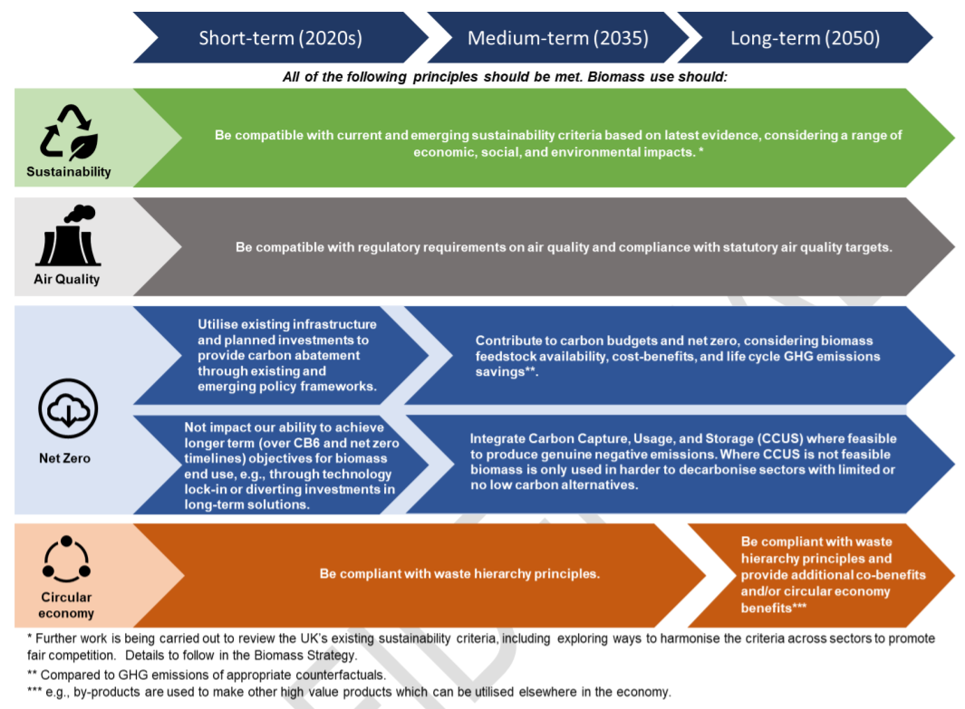

Power
- There are no current plans to change how Government supports biomass under the CfD, but the priority use framework will inform future decisions on what changes may need to be made to the scheme after allocation round 4. They also intend for future large-scale biomass electricity generation not to be supported without the addition of CCS.
- BEIS acknowledges the role of small-scale systems in the generation of baseload and dispatchable power for the grid. BEIS recognises that these systems may not have access to the CO₂ transport and storage infrastructure needed for CCS. Any future changes to support for small-scale fuelled technologies under the CfD will depend on the priority use framework. For Government the focus for biomass power is on BECCS, with Government committed to establishing the role which Bioenergy with Carbon Capture and Storage (BECCS) could play in delivering negative emissions as part of a wider Biomass Strategy, setting out how the technology could be deployed across power, industry, hydrogen and biofuel sectors.
- The Government recognises that deployment of CCS at waste management facilities, will be necessary (e.g. EfW facilities). CCS at EFW facilities offers an opportunity to generate ‘negative’ emissions from the capture of biogenic CO₂.
- BEIS is continuing to consider the case for setting tighter emission controls for biomass installations to reduce PM pollution from energy generation.

Heat
- BEIS re-iterates the commitments set out in the recently released Heat and Buildings Strategy. They believe biomass has a role in decarbonising certain properties, which are unsuitable for heat pumps. Particularly recognising a role in both domestic and industrial off-the gas grid locations.
- BEIS emphasises appropriate mitigations must be set in place to minimise air quality impacts.
- BEIS also recognises biomass' role with biomethane for injection into the gas grid, or to use for heat.

Transport
- BEIS expects biofuels to continue to play a significant role in transport decarbonisation.
- While currently almost all fuels are used in road transport, by 2050 BEIS would expect fuels produced from biomass to be mainly used in aviation.
- BEIS expects biomass for aviation fuel to be produced in combination with CCS to ensure they are net zero.
- Demand for liquid and gaseous fuels in road transport is expected to decrease over the coming decade. Biomass transport fuel will still be required for achieving GHG savings from the remaining existing fleet.
- HGVs might rely on renewable fuels for longer where decarbonisation options may remain limited.

Industry
- BEIS wishes to prioritise use of biomass in industry where it can be combined with BECCS. Otherwise, biomass' use will be limited to applications where there are limited alternative options to decarbonise.
- Modelling identified that BECCS may be particularly cost effective in the cement, glass and paper industry.
- BEIS recommended that the use of wood in construction should increase as it contributes towards GHG abatement.
- BEIS argues more work needs to be done to determine whether biomass use in the chemicals sector can form part of the long-term priority use. Any future use of biomass in the chemicals sector will be expected to follow the overarching priority use principles
- The strategy also intermates that they expect to see a role for biomass in Hydrogen production, particularly for use in industry – although state they will say more on the role of potential hydrogen production technologies, including those using biomass, in early 2022.

Domestic Bioenergy Feedstocks
The policy statement also commits to updating the evidence on the amount of domestic arable (food and feed) crops for bioenergy use that could be available for bioenergy purposes. This includes establishing the amount of land that could be used in the UK for perennial energy crop production and short rotation forestry.

Research and Innovation
The policy statement reaffirms a commitment to delivering innovation in the biomass sector through the Biomass Strategy. This includes looking at innovations in biomass supply, routes to BECCS and addressing air quality impacts.

Sustainability Criteria
BEIS are reviewing existing sustainability criteria to understand any gaps. This includes options to incorporate sustainability criteria for biomass use in the wider economy, and to ensure the criteria for the sourcing of feedstocks are in line with up-to-date scientific evidence.

Pollutant Emissions
The Government intends to review the impact of new and innovative fuels, such as waste based fuels, on human health and the environment. Defra is currently undertaking a study to develop emission factors to better understand air pollutant emissions from biomass

Key Actions Summary for the Biomass Strategy
The Biomass policy Statement has set out a number of key activities BEIS hopes to engage stakeholder on further to inform the final Biomass Strategies, these include:
- BEIS will engage with stakeholders to review the priority use framework to ensure it is consistent with net zero targets.
- BEIS will identify key policy gaps we need to address to deploy biomass in the priority areas for net zero.
- BEIS will review the amount of sustainable biomass through work on the UK and Global Bioenergy Resource Model.
- BEIS will review the evidence on the amount of domestic arable (food and feed) crops for bioenergy use that could be available for bioenergy purposes, plus establish the amount of land that could be used in the UK for perennial energy crop production for short rotation forestry.
- BEIS will review the current sustainability criteria for biomass applied across government.
- BEIS will assess the regulatory landscape for pollutant emissions from biomass to ensure any gaps are addressed.
- BEIS will use the outcomes of these activities to develop a comprehensive and detailed strategy with clear actions for the coming decade.

The REA will be further engaging with the BEIS Biomass team to understand the next steps in the above programme and will look to facilitate further opportunities for industry to feed into the development of the final Biomass Strategy

