REA’s draft position on hydrogen blending – for members’ consultation

The REA believe hydrogen blending into the gas network has a key role to play, both in the short and long term, to support the scale up of the UK clean hydrogen sector. It will also be critical to maintain the resilience of our energy system by enabling energy storage and balancing of the network between the peaks of generation and demand. We have set out detailed reasons for this statement below.

Paper contents
- The short-term case for hydrogen blending
- The long-term case for hydrogen blending
- Financial support for hydrogen blending
- Quick action for Government to unlock barriers to blending
- Future Billing regime
- Oher important barriers to be addressed

The short-term case for hydrogen blending
In order to achieve the UK’s ten-point plan of 5GW hydrogen production by 2030, Government and industry have been working together on how to enable this. The two areas where Government is actively pursuing the development of a low carbon hydrogen production is through hydrogen mobility (e.g. development fuels sub-target and Renewable Transport Fuel Certificates under the Renewable Transport Fuel Obligation), the Hydrogen Business Model (HBM) for low-carbon hydrogen production (e.g. variable premium price mechanism) and the Net Zero Hydrogen Fund.
Hydrogen producers and project developers will look at these policy mechanisms to see how to create an investable project, in a similar way to how project developers used policy mechanisms such as the Feed-in Tariff Scheme, the Renewable Obligation, the Renewable Transport Fuel Obligation, the Renewable Heat Incentive and the Green Gas Support Scheme. History has shown that to facilitate production of a renewable energy (such as wind, biogas, solar) capital grant schemes have not always worked. Examples of this include the Bioenergy Capital Grant Scheme, which has resulted in limited deployment. Energy production developers look to de-risk the investment through having a regular payment for the energy produced.
One of the critical risks to successful deployment and scaling up of low carbon hydrogen production in the UK is that currently the two sectors which will have ongoing policy support mechanisms in place are the transport sector (under the RTFO) and the Commercial and Industrial (C&I) sector (under the HBM, which appears to be particularly geared towards this end user type). Both sectors require that project developers must align the production and demand of hydrogen to make a project viable. Furthermore, the creditworthiness of the demand has considerable importance as failure of demand or fluctuations in demand have a material impact on the financial performance of the investment. BEIS is looking to mitigate this in part with the proposed variable premium mechanism by having a ‘top-up’, however the risk of being reliant on an end-use customer is still material and more complex to achieve.
Comparing the early stage of the industry that is looking at hydrogen production against other sectors such as solar, wind and biogas generation, the key difference between hydrogen and the other sectors is that they did not rely on end-use customers but were able to connect their production facilities to the grid and dissipate the energy relatively easily through either a gas or an electricity supplier. The way in which Government is currently looking to create a low-carbon hydrogen production market is to rely solely on the end-user demand rather than the ability to inject hydrogen into the grid.
We can see in the past how impactful this has been when we look at the biogas sector, whereby developers have historically had an option to produce biogas for mobility (through the Renewable Transport Fuel Obligation/RTFO), and also for gas injection. One of the key barriers to developers having relied solely on mobility was that it created greater investment risk due to the uncertainty of demand, combined with the volatility of the value of the RTFCs. Similarly, ‘private-wired’ wind and solar assets are more common today, but at the start of the sector nearly all projects were grid connected. The RTFC mechanism now works well but this is normally achieved via mass balancing so the waste derived biomethane is injected into the gas grid at the AD plant and taken out at the truck depot. Less than 1% of RTFCs are directly generated biomethane going into trucks and no compressed or liquid biomethane is moved by road.
Hydrogen is very expensive to move by road in compressed form with only around one third of the energy moved compared to moving natural gas. Liquid hydrogen is not produced in the UK but requires around 30% of the energy in the hydrogen to make it. In addition to the difficulty of moving large volumes of hydrogen by road, UK safety legislation (in particular Hazardous Substances Consent and COMAH) restricts how much hydrogen can be stored above ground on a site which effective means hydrogen delivered by road is not a viable option for most industry.
Given the experience of biomethane, the safety and low density of hydrogen, blending of hydrogen is crucial in the first years of the electrolyser market as it allows a materially lower risk option for hydrogen production developers to be able to develop projects, fund and build them, with the ability to inject directly into the existing gas grid. This materially de-risks the project and, crucially, allows for a much larger uptake of hydrogen production. Once this production is in place, Government can see the benefits of new dedicated hydrogen pipelines that can take advantage of a certain amount of this hydrogen production, provide a link to the blue hydrogen CCUS clusters and provide hydrogen via pipeline to industrial customers and truck filling stations. This approach allows the hydrogen production market to develop without having to wait for new dedicated hydrogen pipelines which may take 10 years or more.
Even a relatively small blending acceptance will generate a significant demand for hydrogen on the network. With the current gas demand of 800TWh, 20% volume blend gives around 64TWh of hydrogen (to put this in context, the Government have set an ambition to deliver 5 GW hydrogen production capacity by 2030, expected to provide up to 42 TWh of low carbon hydrogen). Realistically a target of 10% blend by 2030 is around 4% by energy and 32 TWh/annum. Going alongside hydrogen made at industrial sites using renewable electricity delivered by wire, this gives a good chance of meeting or even exceeding the Government 2030 target.

The longer-term case for hydrogen blending
The UK Government is committed to decarbonising electricity by 2035. This will require significantly more electrical generation to be installed in the UK. In 2020, curtailment costs were c. £ 250million according to Bloomberg. A paper released by Edinburgh University “Utility-scale subsurface hydrogen storage: UK perspectives and technology” estimates that wind production alone could result in 7.72TWh of curtailed generation by 2030. Reports from the Climate Change Committee also show significant curtailment of power as shown below:
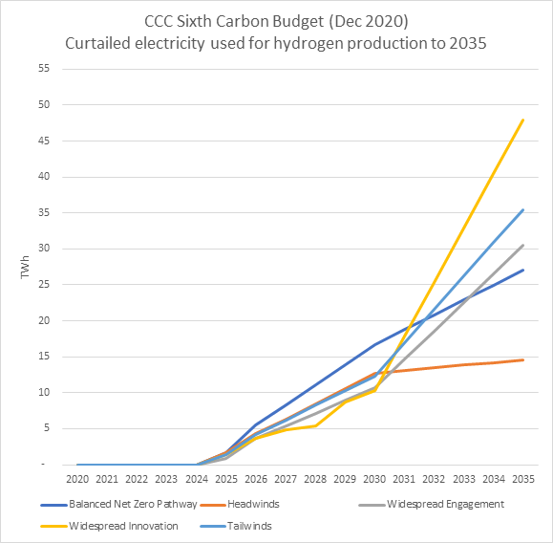
Source: CCC, Sixth Carbon Budget Report, December 2020
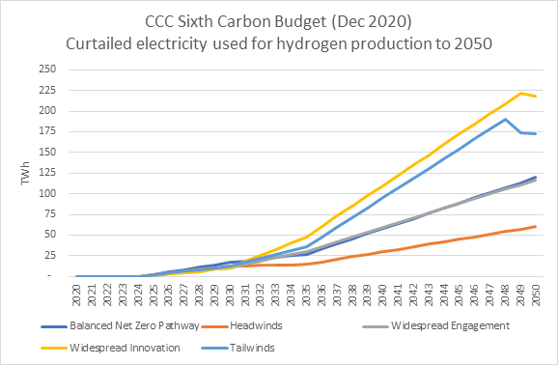
Source: CCC, Sixth Carbon Budget Report, December 2020

There is a pressing need for long-duration, large-scale seasonal renewable energy storage in order to help balance the increasing shares of renewables which will be required to meet the UK Government’s commitment to decarbonising the power grid. Future wind and solar projects which will be faced with curtailment prospects, will cause investment risk and in turn either make the projects non bankable, or more expensive to fund (as the cost of capital will be higher as the risk premium is higher). Seasonal storage (different to battery, short term) such as hydrogen production and injecting into the gas network to be stored as gas-hydrogen blend and then later dedicated hydrogen pipelines will be the foundation blocks of enabling large scale balancing of the network between the peaks of generation and demand. It means that the green electrons that may have been curtailed can be instead converted into green molecules and used to decarbonise the gas network. Taking this further as hydrogen concentrations increase within the network it can be linked to large storage facilities such as salt caverns and depleted gas storage facilities such as Rough to balance the profile between production and demand and cope with the ‘Dunmkelflaute’ (periods of low wind in winter in NW Europe).
Blending hydrogen into the grid will be strong facilitator to avoid curtailment as the gas network can absorb variable production rates of hydrogen from electricity. Support to blending of hydrogen in the network will help deliver one of the huge potential benefits of hydrogen – i.e. that you can store and dispatch renewable energy at demand times, whilst reducing the cost of curtailment.

Financial support for hydrogen blending
In the context of the Hydrogen Business Model that BEIS is developing, the department has recently sought stakeholders’ views on whether the role of blending in the hydrogen economy should be primarily as a ‘demand backstop’ for hydrogen producers facing volatile, or temporarily unavailable demand, rather than financially supported by the government as a long-term, majority offtaker. They also sought views on potential commercial options to deliver the backstop strategic role of blending and how they could ensure that, if supported commercially, blending would not displace supply of hydrogen to higher-value end-users such as industry or power.
For the reasons highlighted above, we believe blending should be commercially supported under the Hydrogen Business Model Support. BEIS concerns that blending may come ahead of preferred offtakers such as in industry, transport and power, if commercially supported, could be addressed by setting a discounted strike price for blending. In addition, as explained above, BEIS should consider the technical issue of physically getting the hydrogen to industry in the absence of a new national hydrogen pipeline network.
We also believe that clean hydrogen should be supported under a variant or revision of the Green Gas Support Scheme (GGSS) and under any policy for greening the gas grid that will come after it. BEIS are planning to engage with stakeholders in 2022 on a market-based mechanism to follow the Green Gas Support Scheme and the REA believe hydrogen injection should be incentivised under such mechanism, along with other green gases. The mid-scheme review of the GGSS will also take place in 2023 and so there is a window to amend the current support scheme if this timeframe is possible.
This could provide an important route to market for smaller scale projects (e.g. <20 MW of electrolyser capacity, which is <2,000 scmh of hydrogen) if BEIS decides to introduce a variable price support mechanism that is more geared towards large scale production.
Injecting low-carbon hydrogen into the gas grid to displace natural gas and selling it at the wholesale price [p/kWh] of natural gas will not provide a viable business case on its own. Power to gas and low carbon hydrogen injection into the gas grid will require a financial support mechanism, similar to the GGSS. This scheme could be adapted to include support for injection of clean hydrogen based on the equivalent CO₂ savings compared to biomethane.
In practice the hydrogen molecules would be blended in the gas grid, but green gas certificates associated with each kWh of hydrogen injected could be linked to I&C customers, who are aiming to reduce their natural gas use. Guarantees of Origin for clean hydrogen awarded under the GGCS or other equivalent schemes will create opportunities to drive a market value for this gas, thereby reducing the direct subsidy required over time.
The combination of commodity value, GGSS type support and certificate value (GoO) could make injection of hydrogen into an economic option which would help to develop the supply chain in 2023-25, in the same way the original Renewable Heat Incentive did in successfully creating the biomethane supply chain in 2012-16. The low carbon hydrogen injected into the gas grid and used to displace natural gas could also be considered a hydrogen storage project (the kWhs of hydrogen are stored in the same way as natural gas).
The advantage of injecting low carbon hydrogen into the gas grid is that on day one all the hydrogen can find a market (e.g. the I&C customer). For example, making green hydrogen to use as a bus fuel requires the buses to be available on day one and this does not happen in practice as it is more likely to need a three year build up. Having a low carbon hydrogen ‘sink’ of the gas grid can also facilitate the use of low carbon hydrogen into trucks and buses.
Note on Implementation for the mid-review of the GGSS
The GGSS uses the same primary legislation as the RHI, which allows support to producers of biomethane, which must be made from biogas – where biogas is defined in section 100(3) of the 2008 Act as gas produced by the ‘anaerobic or thermal conversion of biomass’. Although the GGSS has chosen to limit eligibility within the scheme to gas produced from anaerobic conversion, this was a policy choice to keep the scheme relatively simple – it remains within the scope of the primary legislation to include biomethane produced from thermal conversion as well.
Arguably, hydrogen made from gasification of biomass already falls within this definition – or would be if otherwise met requirements for injection to the gas grid. The legislation also allows the biogas definition to be ‘modified’.[1] It should be possible to modify the definition to include hydrogen made from electrolysis – and a similar approach has been taken to the RTFO, where such fuels are known as Renewable Fuels of Non-Biological Origin.

Quick action for Government to unlock barriers to blending
There are some quick wins that could greatly assist the sector and unlock barriers to deployment of clean hydrogen - for example members believe that a low-level blending of hydrogen into the National Transmission System (~5%) could and should be greatly speeded up given the current energy security crisis.

Future Billing regime
Cadent and Xoserve have recently consulted industry on the Future Billing methodology and sought industry’s feedback on what solutions should be progressed to maximise the amount of renewable or “Green Gases” which can be carried in the gas network without negatively impacting consumers and ensuring fair billing. Our full response to this consultation can be read here.
For the reasons set out in this paper, we support a Future Billing regime that accommodates blending of green gases into the network. It is very uncertain at this stage whether all parts of the network will move to 100% hydrogen in the future and, if this happens, in won’t be for a long time. So, the best approach at this stage is to assume that we are moving to a situation in which the long-term gas in the network is a mix of different gases and ensure the solutions in place can accommodate this and are swiftly implemented. We need to ensure that the billing regime addresses both hydrogen and biomethane: a solution that accommodates only one of them and undermines the other will not be suitable - both green gases are set to play an important role to advance the decarbonisation of the gas grid and reach net zero.
Notwithstanding this, we believe that there needs to be a clear political steer from Government on what they want to see in terms of blending. Once Government has set a clear direction of travel, then industry experts can work out the best solutions to deliver those priorities.

Other important barriers to be addressed
Reducing the cost of grid electricity
As previously highlighted to BEIS, one of the key barriers to the deployment of electrolytic hydrogen projects connected to the grid remains operational costs. In addition to the cost of electricity itself, further costs are added by regulatory support levies and system fees applying to electricity bills. if Government wishes to see a high number of electrolytic projects being developed in the short and medium term, measures could be taken to reduce these costs so that electrolysers can access cheaper grid electricity. Such measures could be considered as part of the upcoming Government’s Fairness and Affordability Call for Evidence.
The REA believe it is paramount that, in addition to developing business models, providing capital grants, and supporting blending, measures are taken to reduce the running cost of grid connected electrolysers by enabling them to access cheaper renewable electricity. This can be done by:
- Exempting electrolysers from ’green levies’ on electricity bills – i.e. electrolysis could be on the list as energy intensive users (see EII Scheme), thereby qualifying such sites for exemption from the indirect costs of funding Contracts for Difference (CFDs), the Renewables Obligation (RO) and the small scale Feed in Tariff (FIT).
- Exempting electrolysers that provide grid services from use of system fees (on a time limited basis), or adopting an approach similar to the new rules for grid balancing charges borne by energy storage assets – i.e. on a net usage basis (exemption from final consumption levy double charging like storage devices[1]).

[1] S100(5) of the Energy Act 2008
[1] When charging and discharging from the grid, storage devices in the past were paying fees for both these activities on a gross basis. However, there have been grid modifications made that allow them to be charged only on a net usage basis. This recognises the fact these devices are aiding the electricity system flexibility. A similar approach needs to be applied to hydrogen electrolysers that are grid connected.

