Developing a long-term bioresource strategy

Social media message sharing sheet
The treatment of sewage (or urban wastewater) produces sludge that has to be treated, managed, used or disposed. Within the UK, sewage sludge is typically treated using anaerobic digestion and treated organic matter, known as biosolids (or bioresources) are primarily recycled to agricultural land.
Recognising the potential impacts on water, soil and air quality the water industry needs to comply with a diverse range of changing regulatory requirements. The water industry is now considering the cumulative impact of key industry sustainability challenges (e.g., Net Zero Carbon target ambitions), managing environmental impacts, market challenges, resilience of the supply chain and the potential for opportunities around improved environmental outcomes.
A strategic and systems thinking approach to regulation and the delivery of opportunities for bioresources needs to be developed and embraced by those involved in the management of biosolids. This collaborative approach should consider the end-to-end management of sludge and the creation of bioresources to provide greater certainty for the sector, reduce environmental impacts and develop a holistic and affordable solution.
A clear long-term strategy for 2050, balancing the drivers for change impacting the sector is essential for effective regulation and the development of long-term asset plans. This can only be achieved with a clear policy framework, a shared timeline and the robust consideration of innovation and technology.
CIWEM together with Atkins, on behalf of Water UK is bringing together the English water industry, environmental and economic regulators as well as other key stakeholders to collaborate and co-create a long term strategy for the safe and sustainable management of bioresources. An overview of the project can be downloaded here..
The project is underpinned by stakeholder engagement, a key element of this is an industry survey on bioresources, which will be complemented by focus groups and workshops.
A survey designed for all those involved and interested in managing biosolids and bioresources (particularly in England) has been created. It will explore the drivers for change, policy/regulation and relevant technology and innovations that can impact the way biosolids can be managed.
The survey is a great opportunity to influence the development of the strategy and vision for 2050. If possible, we would like your help by sharing the survey weblink to your colleagues, members and contacts. The closing date for the survey is July 18th 2022.
The online survey can be completed here.

Links for overview and survey
Google forms survey: https://forms.gle/tUJauC1qEnqZxkag9
Project overview: https://www.ciwem.org/assets/pdf/Policy/Reports/Bioresources%20strategy%20-%20Project%20overview.pdf

Text for newsletter/intranet

Contribute to developing a long-term bioresource strategy
The treatment of sewage (or urban wastewater) produces sludge that has to be treated, managed, used or disposed. Within the UK, sewage sludge is typically treated using anaerobic digestion and treated organic matter, known as biosolids (or bioresources) are primarily recycled to agricultural land.
The water industry is considering how to manage the environmental impacts of biosolids management, improve outcomes and accommodate key industry sustainability challenges (e.g., Net Zero Carbon target, circular economy ambitions).
A clear long-term strategy for 2050, embracing systems thinking and balancing the drivers for change is essential for effective regulation and certainty for the water industry and their stakeholders. This can only be achieved with a clear policy framework, a shared timeline and the robust consideration of innovation and technology.
CIWEM together with Atkins, on behalf of Water UK is bringing together the English water industry, regulators and other key stakeholders to collaborate and co-create a long term strategy for the safe and sustainable management of bioresources.
A key element of this project is a survey designed for all those involved in managing biosolids and bioresources (particularly in England). It will explore the drivers for change, relevant technology and innovations that can impact the way biosolids can be managed.
The survey is a great opportunity to influence the development of the strategy and vision for 2050 and CIWEM would welcome your input.
The survey can be completed here: https://forms.gle/tUJauC1qEnqZxkag9
The deadline for responses is July 18th 2022.

Image
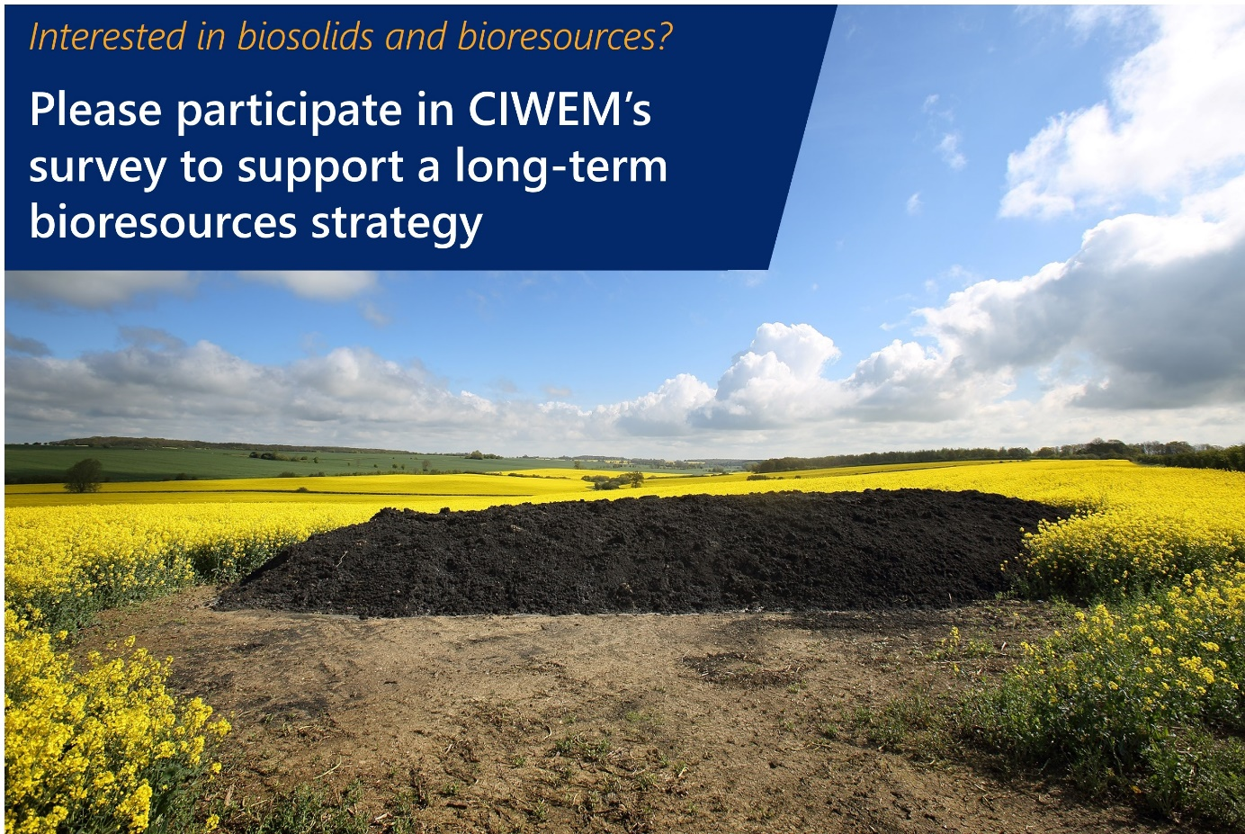

Text for LinkedIn

Contribute to developing a long-term bioresource strategy
The water industry is considering how best to manage biosolids and potential environmental impacts as well as accommodate key industry sustainability challenges (e.g., Net Zero Carbon target, circular economy ambitions).
A clear long-term strategy for 2050, embracing systems thinking and balancing the drivers for change is essential for effective regulation and certainty for the water industry and their stakeholders. This can only be achieved with a clear policy framework, a shared timeline and the robust consideration of innovation and technology.
CIWEM together with Atkins, on behalf of Water UK is bringing together the English water industry, regulators and other key stakeholders to collaborate and co-create a long term strategy for the safe and sustainable management of bioresources.
A key element of this project is a survey designed for all those involved in managing biosolids and bioresources (particularly in England). The survey is a great opportunity for you to influence the development of the strategy and vision for 2050 and CIWEM would welcome your input.
The survey can be completed here: https://forms.gle/tUJauC1qEnqZxkag9
The deadline for responses is July 18th 2022.
#bioresources2050 #biosolids #bioresources #circulareconomy #wastewater #sludge #sewagesludge

Text for Twitter
Involved or interested in managing bioresources from wastewater? Please complete this survey https://forms.gle/tUJauC1qEnqZxkag9 and contribute to developing a long-term #strategy for #bioresources. #bioresources2050 #biosolids #circulareconomy #wastewater
Contribute to developing a long-term strategy for bioresources from wastewater. Please complete the survey here https://forms.gle/tUJauC1qEnqZxkag9. #bioresources2050 #biosolids #bioresources #circulareconomy #wastewater
Do you have views on how wastewater and resultant bioresources can be managed? Please complete this survey here https://forms.gle/tUJauC1qEnqZxkag9 and contribute to a long-term #bioresources strategy. #bioresources2050 #biosolids #circulareconomy.
Want to help co-create a long-term #bioresources strategy for wastewater? Please complete this survey here https://forms.gle/tUJauC1qEnqZxkag9. #bioresources2050 #biosolids #circulareconomy.

