Note: the Environment Agency has prepared this draft guidance as a template for trade associations and professional bodies within England to develop their own guidance on climate change adaptation for their members.

Climate change adaptation is a fast-developing field; whilst care has been taken to prepare this template, it should not be taken as an authoritative statement of good practice, the latest research, or the law.

It is the responsibility of users of this template to ensure that any guidance they ultimately draft using this template:

- is tailored to the needs of their trade association or professional body; and
- reflects the latest best practice, research, and legal positions.

The Environment Agency accepts no liability for errors or omissions in this document.

Users should delete this red text and any subsequent red text before finalising and issuing their own guidance based on this template.

Climate change adaptation – [Good Practice] guidance

Introduction
This guidance will help you understand how your business could be affected by extreme weather events and climate change. It will provide practical advice to enable your business to adapt and build resilience to the physical risks of climate change and extreme weather. There will be lists of suggested actions, but this is not exhaustive and completing all actions does not guarantee resilience. You should always consider the specific circumstances of your business. This document will go through a stepped process and will follow the format of the ISO 14090:2019 standard to help you develop a plan for climate change adaptation. This document is intended to be shaped as required to suit various audiences and should be viewed as a template. Once completed as suited to your industry needs, it is intended to be a resource your industry could use for onwards publishing.

Climate change adaptation

The impacts we are already experiencing from climate change are projected to intensify. Further impacts are inevitable due to the locked in emissions of Greenhouse Gases (GHG’s) already in the atmosphere. The changes that will occur depends on how successful we are in reducing greenhouse gases globally. The latest set of projected changes in climate can be found from the 2018 UK Climate Projections. The future scenarios below show potential average temperatures and rainfall in summer and winter. Representative Concentration Pathways (RCP) describe different climate futures, all of which could be possible, depending on volume of GHGs emitted in the years to come.
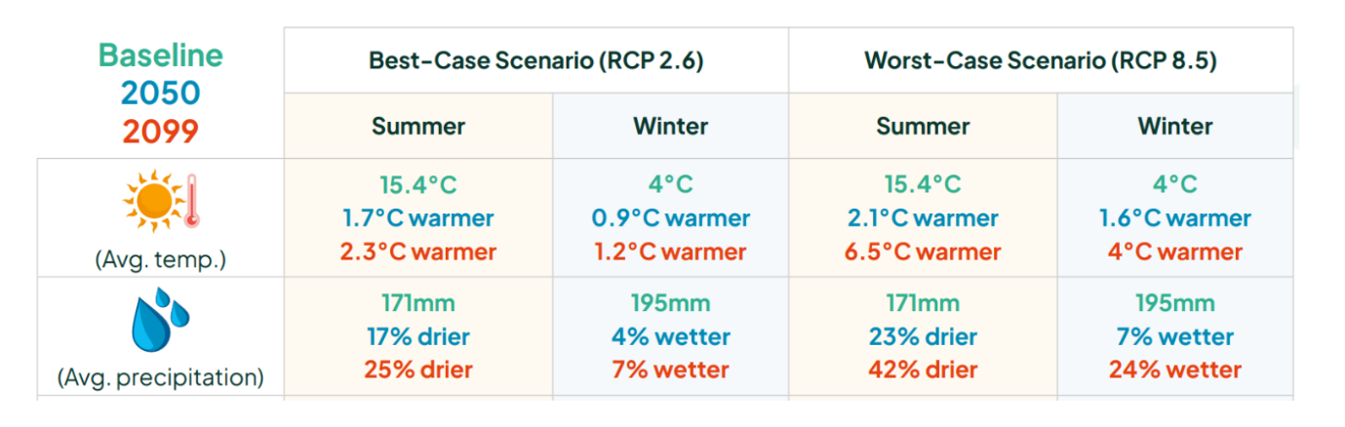
Fig 1: The best and worst case scenarios for future average temperature and precipitation. Source: Sustainability West Midlands WMCA Sustainability Benchmarking Report Sep 2018 Final.docx (sustainabilitywestmidlands.org.uk)
This will influence the extent to which your business will need to adapt. The latest set of climate change projections predict impacts on businesses by changing temperatures, weather patterns and extreme events.
Climate change adaptation is defined by the United Nations Framework Convention on Climate Change as” adjustment in natural or human systems in response to actual or expected climatic stimuli or their effects, which moderates harm or exploits beneficial opportunities”. Businesses that are proactively thinking about managing risks from climate change are less likely to be negatively impacted. They could see long term benefits such as business continuity, long term savings and competitive advantages. As stated in the Climate Change Act, adaptation reporting is required for some organisations (e.g., energy, water, ports). The third round of adaptation reporting occurred in 2021 and the published reports include a wealth of examples on good and best practice. The reports have been evaluated by the Climate Change Committee (2022).

Getting started
The benefits of developing an informed approach to climate change adaptation is that it will enable identification of what action is required of your business now and what can be done in the future.
To prepare your adaptation plan think about the following:
- Set out broad objectives to maintain business continuity and productivity to ensure resilience in a changing climate. If your adaptation plan is set to be business-wide, this should reflect in the objectives of your plan.
- Read the published standards: Adaptation to climate change – Principles, requirements, and guidelines (ISO 14090:2019)/ISO 14091:2021 Adaptation to climate change – Guidelines on vulnerability, impacts and risk assessment. This standard contains guidance on assessing risks of the potential impacts of climate change, understanding vulnerability, and how to implement a risk assessment.
- Make sure you have the correct people on your team including senior management support to implement your plan and the right departments involved.
- Identify and collect information on how your business has been affected by severe weather events in the past and how those risks are currently managed. This will enable you to understand weather related vulnerabilities and gaps in business continuity.
- Plan to integrate your adaptation plan into your existing operations such as your environmental management system, financial budgets, and business continuity plans.

Assessing risks from extreme weather and climate change

Identify potential impacts
Identify the potential impacts of extreme weather such as heavy rainfall, extreme temperatures, flooding, drought, and strong winds. Consider how these could affect your business areas and brainstorm these impacts aiming for a long list. At this stage, you should not worry about how likely these impacts would happen or how significant they could be. To help prompt you to think about impacts on your business, think of past events and near misses as well as impacts that could become more severe or frequent. Think about on-site and off-site impacts. Different scenarios arising from a combination of weather events (such as prolonged dry periods followed by heavy rain) could lead to disruptions. Involve people from a range of teams who understand the business and its operational processes.
Ask yourself: What past events or near misses has your business experienced?

Which teams in your business should be involved who understand your operational processes?

  - Operations
The risks of climate change can impact all aspects of a business. It is important to build adaptive capacity and resilience into existing operational and maintenance procedures rather than creating new channels.
Example risks to operations
- Freezing weather leading to burst pipes
- Flooding or snow prevents vehicle, customer, and staff access
- In drought, water shortages cause business interruptions
- Reduced river flows may lead to deteriorations in water quality, reduced dilution, and greater pollution in water.
- Identify equipment that is sensitive to climate change and could suffer reduced efficiency as a result
- Risks brought about by extreme summer temperatures where process equipment may be operating outside of safe design limits. Power outages caused by extreme heat may also curtail critical operations and their abatement.
- Consider impacts of extreme heat on staff welfare and their ability to work without increased breaks and reduced output.

Case Study impacting operations:
storm eunice, february 2022
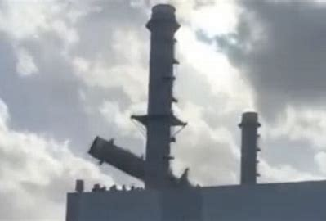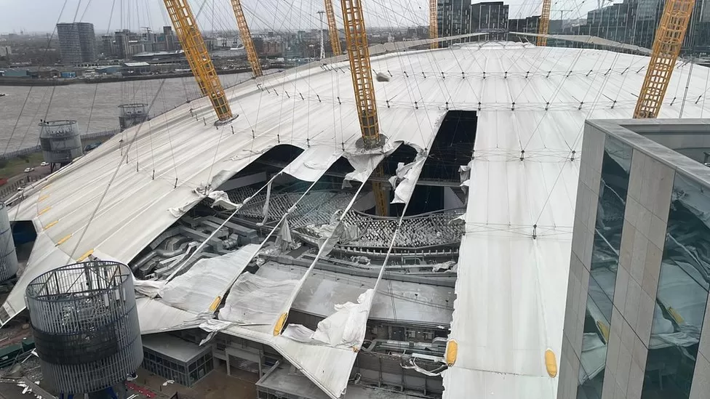
Powerful winds reaching up to 122mph during Storm Eunice in February 2022 caused a tall chimney stack in at a gas-fired power station to collapse in Kent, UK (left image). The central tower buckled and bent over in half. The plant was offline for a considerable period of time as a result. The power plant supplied one million homes with electricity. The plant was evacuated beforehand therefore there were no casualties or injuries.
Sections of the fabric roof of London's O2 arena were shredded by winds during Storm Eunice causing the venue to close temporarily.
Ask yourself:
What operational processes are climate dependent or temperature sensitive processes?

Could any site activities be affected by weather? Could weather events damage materials or stock stored on site?

What risks weather and climate related risks could your staff face?

Opportunities
As well as risks, it is important to understand how extreme weather events could impact your business. A changing climate may also provide opportunities that your business could take advantage of. Can you think of other opportunities that a changing climate could bring to your business?
Here are ideas below:
- If your premises or equipment are damaged, there is the opportunity to re-instate it at a higher standard of resilience.
- Planning and designing your business, including engineering and architecture, can lead to innovative products and services that could increase your business resilience.
- Opportunities for those in-built environment industries to develop expertise and reputation in climate-related building services

cHECKLIST
Consider the actions to implement in your business. Think about tasks you could also add to this list.
Consider alternative power supplies e.g., renewable energy (solar, wind, hydroelectric) or backup generators, to ensure your business is more resilient to power cuts.
Install a smart meter to track and manage water usage.
Consider alternative water supplies such as installing rainwater harvesting to help save money and reduce your carbon footprint.
Talk to your suppliers on how to find out how to turn off gas, water, and electricity during an extreme weather event and how to turn them back on.

Resources:
- Business in the Community (BITC) and Environment Agency
The BITC Business Resilience Health Check Tool helps businesses to become more resilient to interruptions that they may face, identifies areas where business operations could be impacted by climate change, and offers advise on how businesses can adapt and prepare for these changes.
- Construction Industry Research and Information Association (CIRIA)
CIRIA provide information on the repair and restoration of buildings following floods.

  - Logistics
Industries can heavily rely on supply chain, transportation and utilities. These could have numerous interdependencies which could lead to disruptions to business and loss of productivity if one or more areas are impacted. Road and rail deliveries may be impacted by extreme weather causing delays to critical raw materials and product movements.
Example risks to logistics
- Power cuts caused by extreme weather causing loss of communications
- Disruption to transport of products and deliveries due to extreme weather
- Key suppliers being impacted by climate change and ability to source key components elsewhere
- Loss or hazards due to loss of containment during transport such as materials that need refrigeration.

Case Study: Extreme weather impacting logistics
July 2022 heatwave

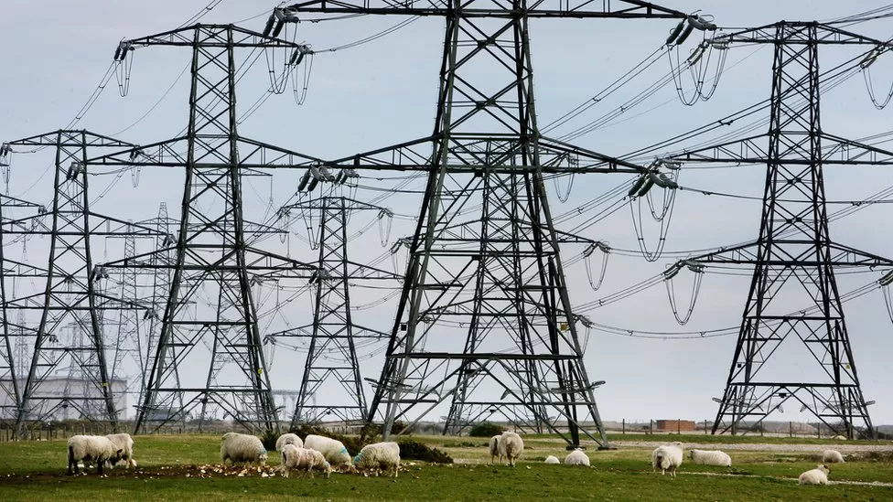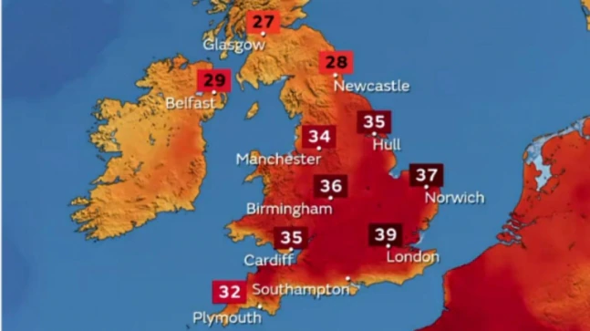
Temperatures in the UK soared to the highest the country has ever seen during the heatwave in July 2022. Due to extreme heat, conductors sagged, and transformers were overheating leaving approximately 8,000 properties in Yorkshire, Lincolnshire and North East without electricity. Heat related impacts also affected Transport and Technology sectors, leading to significant disruption.
Industry impacts that occurred affected multiple sites with fire, explosion, and other infrastructure / equipment failures.

Ask yourself: Would weather events affect or disrupt transport, utilities, communications, infrastructure, and services? Are any materials sensitive to weather or temperature?

Which of your key supplies could be impacted by an extreme weather event?

Opportunities
- Increased risk provides an opportunity to strengthen supplier relationships and increase oversight of the supply chain.
- Competitive advantage for companies with redundancy or flexibility built into delivery systems and supply chains or those undertaking business continuity planning.

cHECKLIST
Consider the actions to implement in your business. Think about tasks you could also add to this list.
Be aware that if your property is at risk of flooding that your stock/equipment could be damaged. Make sure to store it in a resilient space or not on the ground floor. Consider using shelves/racking with high bottom shelves and minimise storing items on the floor.
Consider alternative suppliers and/or increasing storage capacity to increase the ability to operate without deliveries in the event of transport disruption.

Resources:
- British Chambers of Commerce (BCC)
Your Chamber of Commerce can provide advice, support, and guidance on climate change adaptation issues. Find your chamber using the link to get more information.

Assets
Weather can damage and degrade key equipment, plants, or machinery. There can be long lead times for replacing key equipment. Ageing equipment or machinery could also be vulnerable to damage that extreme weather events and climate change could cause.
Example risks to assets:
- Flooding or severe weather damaged buildings leading to maintenance costs and disruptions.
- Snow, ice or heavy rain leading of containment on tank roofs.
- Flooding or extreme weather could lead to unserviceable machinery including electrical equipment, rotating mechanical equipment, or cabling.
- High winds causing structural damage to site.

Case Study: Extreme weather impacting assets
PoRT of immingham, december 2013
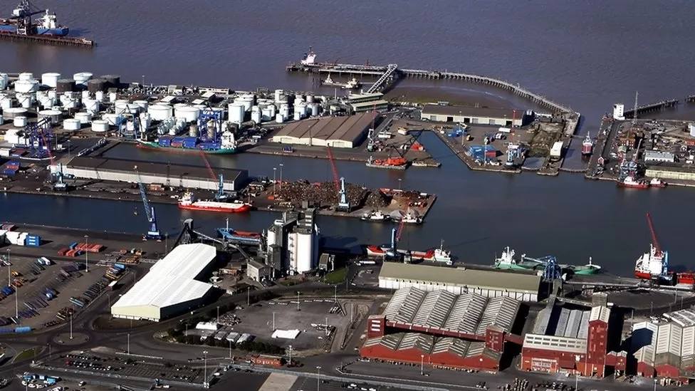

The Port of Immingham in the Humber estuary, the UK’s largest port by tonnage, was impacted by high wind speeds causing a tidal surge which breached flood defences in December 2013. The terminal is located in a highly vulnerable flood zone. The storm surge caused a 5.1m AOD river level rise which overtopped the dock entrance and filled the estate leaving the terminal inundated by 1m flood depth. The embanked protection failed, and electrical infrastructure was badly impacted. The terminal remained inoperable during immediate recovery. In March 2017, a £7.4 flood defence scheme works was approved.

Opportunities
- Opportunities for industries in the built environment to increase expertise and reputation in climate related building services.
- Thermal comfort in winter is less challenging.
- Opportunities to use external spaces outdoors in suitable weather conditions.
Ask yourself: Could equipment, buildings or machinery be damaged by climate change or weather events?

How long will equipment take to replace and how much will it cost?

What are the potential implications to business or potential environmental hazards you could be exposed to if equipment is damaged?

cHECKLIST
Consider the actions to implement in your business. Think about tasks you could also add to this list.
Ensure critical assets (e.g., ICT, machinery, electrics, heating systems, chemicals etc.) are moved away from the ground floor or basements and stored appropriately, especially if there are risks of flooding.
If you come to upgrading your assets or equipment, consider ways to make your property more resilient to severe weather.

Resources:
- Association of British Insurers (ABI) ABI provide advice on insurance issues.
- British Insurance Brokers’ Association Contact BIBA who can help you find a member broker

Strategic Risks
Examples of long-term risks to the supply chain:
- Extreme weather affects your supply chain or infrastructure on which you rely.
- Climate impacts overseas affect the price or availability of agricultural products or other materials or the delivery of supplies.
- Increased risk provides an opportunity to strengthen supplier relationships and increase oversight of the supply chain

Case Study impacting transport and supplies:
CLEONE FoODs
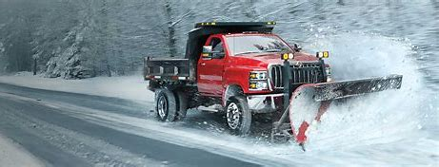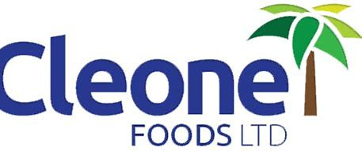
Cleone Foods is a small, food manufacturing business in the UK. It is a supplier to large supermarkets and late deliveries can incur financial penalties, presenting challenges for the company’s business and profitability. Extreme weather events, such as snowfall can disrupt transport as well as production. Cleone Foods took a number of adaptive measures such as purchasing of specialist equipment (including a forklift snowplough and a grit spreader) and became local ‘snow champions,’ clearing snow from public roads. This benefited this company as no recorded business disruption due to extreme weather events since 2009, when these measures were implemented and were winners of the Business in the Community (BITC) 2013 Business Resilience Award.

Ask yourself: What would happen if you could not get your product or services to customers because of weather related disruptions?

What specialist equipment would you require to clear roads and your site if you were impacted by an extreme weather event?

Opportunities
- An increase in frequency and intensity of heavy rainfall events will present opportunities to develop expertise and technology in water management and drainage.
- A warming climate may improve growing conditions and increase the productivity for agriculture and forestry. Warmer conditions and longer growing seasons could mean new species and varieties of plants can be grown.
cHECKLIST
Consider the actions to implement in your business. Think about tasks you could also add to this list.
Check your server or server providers have the IT equipment in a well-ventilated room.
Develop contingency plans for managing disruption to production processes.
Assess risks to climate sensitive processes and be proactive in testing solutions and alternative processes.

Resources:
- HM Government A toolkit to assist you develop a Business Continuity Plan.
- UK Climate Impacts Programme (UKCIP)
UKCIP helps organisations assess how they might be affected by climate change, so they can prepare for its impacts
Community Resilience
As well as considering the resilience of your business, it is important to think about how resilient the community is in where you are geographically located to hazards and extreme weather. A community is defined as’ a group of people situated in the same place or having a particular characteristic in common’.
You should think about the following:
- Engage the community’s Local Resilience Forum (LRF) who are there to help vulnerable communities at risk.
- Be familiar with any local flood response plans.
- Use other communications channels, such as social media, to maintain engagement. Consider accessibility needs and recognise that different forms of communication work for different people.

Case Study: Extreme weather impacting community reseilence
flood alerts
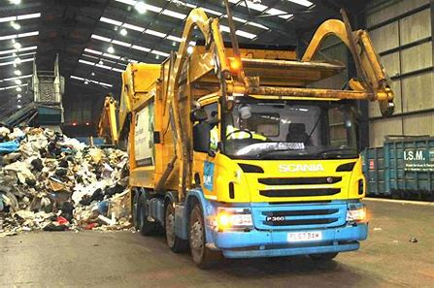
ISM is a recycling and waste management company in Ramsbottom, located near the River
Irwell. During Storm Eva on Boxing Day 2015, there were significant problems when the sewer
system was overloaded with rainwater and unable to cope. Using innovation, an inexpensive float alarm was fitted four feet below the ground into a sewer manhole on the property. When the water levels rise, the alarm is triggered, notifying staff to prepare flood barriers. ISM Recycling also partnered with the local community, providing this flood warning to several local residents to allow them to prepare.

Ask yourself: Do you know of any existing plans or projects taking place in your area to strengthen community resilience?

Are you aware of key risks that impacts your local area?

Does your community have a coordinator to act as a primary point of contact to ensure community resilience?

Opportunities
- Engage with LRFs and other bodies to provide training to local community leaders in resilience practices will increase visibility of your industry/business.

cHECKLIST
Consider the actions to implement in your business. Think about tasks you could also add to this list.
Develop a community emergency plan that will provide a document, which contains important details of how the community can respond to a threat should one occur.
Run engagement sessions across the community to develop this plan to ensure a collaborative approach.
Use other communications channels, such as social media, to maintain engagement.

Resources:
- Climate Just
Use the Climate Just tool to identify if your community is vulnerable to climate disadvantages and help you decide what actions to take.
- Local Resilience Forum
Engage the community’s Local Resilience Forum (LRF) who are there to help vulnerable communities at risk.
Markets
Changes in demand for goods and services results in changes in markets. This could create opportunities to enable industries to provide technologies, knowledge, and expertise to help people adapt to a changing climate.
You should think about the following:
- Identify risks from materials and supplies sources from international markets.
- Coping with fluctuations in raw material prices due to externalities.

Ask yourself: Where markets are vulnerable to climate impacts in different countries, is there scope to develop new markets elsewhere?

Could climate change result in an increase, decrease or change in seasonality of demands for your business?

Could climate change influence your investors?

Opportunities
- New markets for existing product or service.
- Advantages for early movers in response to changed markets and lifestyles
- Opportunity to develop new product or service.
- Market advantages gained by becoming resilient to severe weather and climate change
cHECKLIST
Consider the actions to implement in your business. Think about tasks you could also add to this list.
Ask your suppliers if they are climate resilient. Consider sustainable procurement
practices that require climate change resilience from your suppliers.
Review business plans and strategic documents to see if they could be
adjusted to align with new markets.

Finances
The expected transition to a lower-carbon economy is estimated to require around $1 trillion of investments a year for the foreseeable future, generating new investment opportunities. (International Energy Agency, World Energy Outlook Special Briefing for COP21, 2015) Industries could be impacted by climate change through disruptions, increase in costs due to damage in assets or property. It would also benefit your business to report progress on climate change adaptation to your stakeholders as identifying and mitigating climate related risks can help to access finance and investment.
You should think about the following:
- Current insurance policies and business continuity plans.
- Consumers willing to pay additional cost for adaptive and sustainable design features.
- Financing for assets and operational upgrades

Ask yourself: How would a severe weather event impact on your business’s finances?

When did you last check that you have the insurance you need?

Are there any time periods during which your business is more vulnerable to the impact of a flood or severe weather event?

Is your industry subject to legislation where climate change adaptation may be relevant?

Opportunities
- Financers, insurers and other stakeholders could be encouraged by good risk management, which could lead to reduced insurance premiums.
- Potential risks reduced and liabilities diminished through pro-active risk assessment and implementation.
- Clients and customers attracted to businesses that show resilience to climate change.

cHECKLIST
Consider the actions to implement in your business. Think about tasks you could also add to this list.
Check your insurance cover at least annually. Confirm that you have a policy that covers the full value of your business and keep documents safe from weather impacts (and store copies off site).

Resources:
- Task Force on Climate-Related Financial Disclosures (TCFD)
TCFD recommendations on climate related financial disclosures are widely adoptable for all industries and sectors covering four main areas: governance, strategy, risk management and metrics.
- Climate Financial Risk Forum
This tool created by the CFRF generates a summary narrative description of climate-related risks and opportunities for an industry/sector based on a set of pre-selected inputs (e.g., business activities, models, products, risks of the firm).
- Sustainability Disclosure Requirements (SDR) and investment labels – Financial Conduct Authority
Guidance for consumers of identifying sustainable investment products in the market and ‘anti-greenwashing’.

You may wish to use the following example template for help in identifying all these potential impacts on your business:

Business area | Responsibility | Weather-related hazard that could affect business area or cause environmental harm | IMPACTS (A)  Describe past or potential effects on business area or environment | Adaptation action already taken
Operations

Logistics

Assets

Community resilience

Markets

Finance

Table 1.1
Resources
- For businesses which fall under the scope of the Environmental Permitting Regulations (EPR) in England, the management system procedure should reflect the need to consider climate change adaptation. To find out ways to introduce climate change adaptation into your management systems, refer to the Develop a management system: environmental permits - GOV.UK (www.gov.uk)
- You may also wish to view the associated supporting guidance climate change risk assessment and adaptation planning in your management system.

Prioritising risks
After a list of impacts have been identified, these should be prioritised according to the risks they pose to your business. A simple risk-based approach can be used to determine these at the outset using ‘high’, ‘medium’ or ‘low’ categorisation. Between you and your colleagues, a judgement on risks can be made for both the likelihood and magnitude of each impact (Figure 2). Think about the following questions:

  - Assessing likelihood – ask yourself:
- Has the impact been experienced before?
- Are impacts related to flooding or drought?
- Can you identify any trigger points or thresholds where an impact becomes significant? e.g., above or below a specified temperature.
- Does the risk involve making decisions with long term consequences e.g., 10 years or beyond?
  - Assessing magnitude – ask yourself:
- How would your priorities and objectives for your business be affected by each impact? Consider how past weather events have impacted the processes or activities of your business and the extent of the consequences. In particular you should identify impacts which are critical and will have a high magnitude.
- Do you think the magnitude of this impact would make you more or less vulnerable considering a future time period?

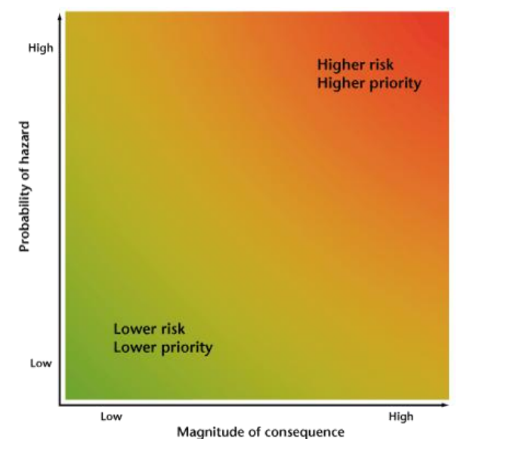

Figure 2. Risk map (Source: Climate Ready Food and Drink Federation Adaptation Guide.pdf (environment-agency.gov.uk))

Assessing flood risk
Flooding is the most frequent natural disaster in the UK. You should think about the following.
- Is your business premises located at risk of fluvial or flash flooding? Check the Flood Map for planning to get flood risk information.
- Do you have equipment to clean up after an extreme event?
- Have you created a flood plan and a risk assessment relating to health and safety of your employees? See this guidance for support on how to develop a flood plan: Preparing for flooding: A guide for sites regulated under EPR and COMAH.
- If you are moving premises, is the location located in a flood zone? Check the long term risk for flooding for an area in England.
- Has your property previously been affected by flooding? Check the history of flooding risk of a property here.
- If your business is at risk of flooding, sign up for local flood risk warning for free.

Assessing drought risks
Periodically droughts occur in the UK. Climate projections indicate hotter and drier summers. In July 2022 during unprecedented temperatures, drought was declared across eight areas in the UK. You should think about the following:
- Find out about water availability in your business area by looking at your Catchment Abstraction Management Strategy.
- To understand the drought risks on a local context, check the UK Drought Portal to visualise the current status.
- Explore critical thresholds of water usage for your business. How would you cope if the amount of water available reduced by 5, 10, 25 or 50%?

Assessing storm risks
Storms and high winds can affect businesses and the services on which they rely. Storms are expected to increase in frequency and magnitude in a changing climate. You should think about the following:
- assessing your site to see if any areas could be vulnerable to strong winds
- checking if your business has been affected by storm damage in the past
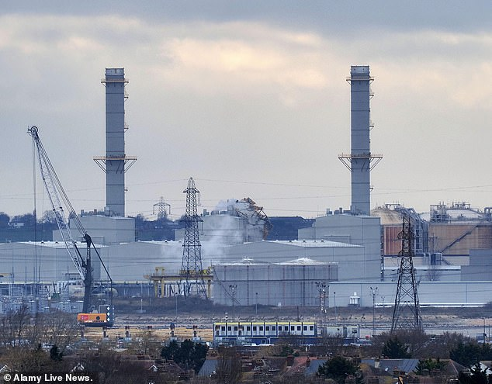
Fig 3; picture of Isle of Grain power station chimney collapse in Storm Eunice in 2022. Source: 54379881-10530003-A_chimney_has_collaped_at_a_Power_Plant_on_the_Isle_of_Graint_in-m-68_1645261658002.jpg (634×495) (dailymail.co.uk)

Case Study: drax power station
improved resilience of biomass fuel supply
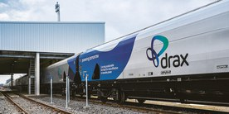
Drax Power Limited has 6 boilers with a maximum capacity of 3,945 MW, 3 of which are powered by biomass pellets. To maintain a reliable stream of biomass, Drax relies on the maritime transportation of wood pellets from North America, where bulk orders can be sourced. The UK has experienced several storm surges and coastal flooding in recent years. Drax Power has implemented numerous adaptation measures. These include structurally raising power plant equipment above potential storm surge water levels and constructing sea walls for protection at their Immingham terminal. Furthermore, subterranean tunnels have been fitted with storm surge barriers, while future tunnel constructions will take place above ground level. Finally, Drax has also adopted a geographically based adaptation strategy to avoid the impacts of localised storm surges through a multi-port strategy.

Assessing temperature risks
In a changing climate, summers in the UK are expected to get hotter and drier. 2022 was the hottest year for the UK on record, breaking the previous record temperature of 38.7C set in 2019. On average, winters in the UK are expected to get milder.

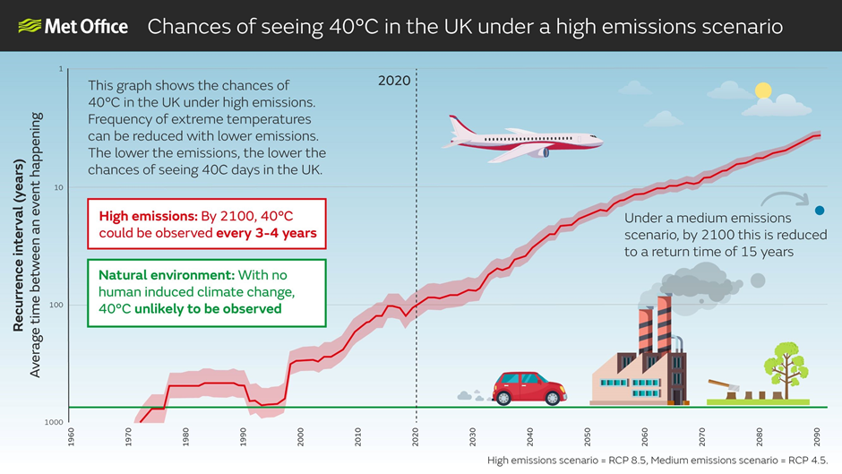
Fig 4; from met office UK & global extreme events report UK and Global extreme events – Heatwaves - Met Office
Note: this graphic may be updated following the extreme heat of 2022 and record-breaking daily temperatures. It is recommended to check the Met Office for an updated graphic if wishing to reference it.

However, cold winters with heavy snow may still occur. You should think about the following:
- Identify temperature thresholds which could affect your business.
- Check that suppliers have adaptation measures in place for extreme temperatures – would their ability to deliver/collect supplies and goods be affected?
- Check the UKCP18 climate change projections to see how temperatures could change.
- The Health and Safety Executive have guidance on heatwaves, cold conditions and how employers can ensure the workplace is at a comfortable temperature.
- Check the Heatwave Plan for England which aims to prepare and alert people on the avoidable effects on health during periods of severe heat.
Assessing different climate scenarios
An important aspect to consider is assessing climate risks based on different climatic scenarios. Analysing scenarios produced by the International Panel for Climate Change (IPCC) ‘Shared Economic Pathways’ and Representative Concentration Pathways. to think about potential temperature scenarios. Different levels of greenhouse gas emissions will lead to different levels of overall global heating. This in turn will impact the severity of extreme weather events. From a risk management point of view, it is important to plan for at least one high emissions scenario.
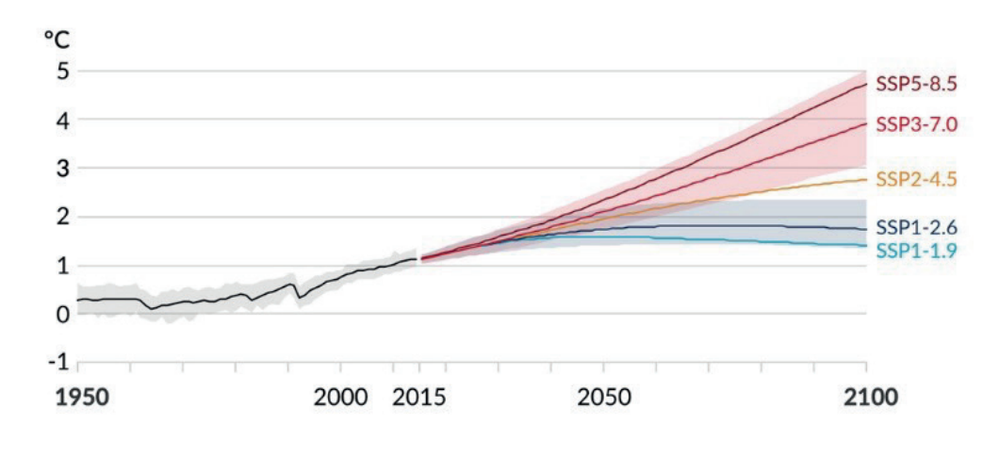
Fig 5: Different climatic scenarios and global temperature increases based on the IPCC. SSP5-8.5 is the highest warming pathway, SSP3-7.0 the second highest and so on. taken from Safeguarding chemical businesses in a changing climate How to prepare a Climate Change Adaptation Plan 2nd edition Note: SSP is shared socio-economic pathway

See EPR (England) EMS guidance and “Supplementary Green Book Guidance: 2020” for further information and for the expectation of 2°C and 4°C scenario planning for operating installations. Also, the risk assessment procedure may indicate that it is necessary to expand the risk assessment process to include more climate projections and scenarios or longer timescale assessment and planning for higher risk impacts or higher vulnerability installations or those with longer lifetimes, beyond 2100 (e.g. expanding assessments to include a wider set of RCP data, or including H++ scenarios).
Climate projects should be used to help to determine the expected climate change impact to an operator’s site. The UK climate projections (2018 or their successor) are to be used. For the initial screening process, the data relevant to a 4°C rise trajectory by 2100 should be used to identified threats – this could be specifically a 4°C by 2100 scenario or information associated with RCP8.5, which is a warming pathway consistent with reaching 4°C by 2100.
The Met Office maintains the current knowledge on climate predictions. UK climate projects can be viewed using the UK Climate Projection User Interface, which provides various projections at varying scales and for different scenarios. Updates and news regarding the UKCP probabilistic projections are also provided by the Met Office, as is e-learning, which can be accessed by contacting them.
Headline findings for the UKCP18 are provided in a short report from the Met Office. At the time of writing the August 2022 report was the latest version, but more recent versions may be available following publication of this document. Data for the 2 C and 4°C scenarios can also be sourced from the UKCP18 Derived Projections.
Additional support is provided by the BBC in the form of a climate change visualisation tool. This provides a range of data regarding the hottest day, number of days in the summer expected to exceed 25°C, average daytime summer temperatures, number of rainy days and the wettest day and winter rainfall outlook.
Similarly, the Environment Agency has published a Climate Impacts Tool * which can be used for screening climate change impacts consistent with a 4°C rise. This helps to understand climate risks in the Environment Agency’s high-level strategies and plans.
*Note, at the time of writing, this tool is being revised to align to UKCP18 and is due to be released in Summer 2023.

Case Study: network rail
improved resilience of railway assets
Climate change resilience within Network Rail, the national railway infrastructure managing authority in Great Britain, is driven by corporate strategic objectives defined by the Weather Resilience and Climate Change Adaptation Strategy (WRCCA), finalized in 2017. Network Rail drainage standards have been updated to include allowances for impacts from future climate, according to the recent UKCP18 projections, in the design of railway assets. Climate change allowance is an increase in the capacity of the drainage system to enable it to be effective in future as the weather changes due to global warming. These allowances have been developed and drainage standards updated in line with recommendations for flood and coastal risk management provided by the UK Government and Environment Agency.

Now you need to start pulling your risk assessment together.
You may wish to use the following example risk assessment template for this purpose:
Potential Impact  IMPACT (A) from table 1.1 | Critical Threshold  (if relevant) | LIKELIHOOD (B)  Likelihood *  (score:  highly likely = 4  likely = 3  low likelihood = 2  unlikely = 1) | SEVERITY (C)  Magnitude/Severity *  (score:  severe = 4  medium = 3  mild = 2  minor = 1) | RISK (D)  (D = B x C)  Total score | Priority (determined/ranking from total scores from risk)
Increased storm damage | Exceedance of design limits for critical infrastructure e.g. wind speed | 3 | 3 | 9 | ?
Table 1.2
Resources
- To look at examples of sector specific climate change risk assessments, please refer to the GOV.UK industry sector examples.

Identifying and implementing measures

Identifying and prioritising resilience options

For the priority risks that you have identified, brainstorm potential ways to minimise threat or maximise benefits involving others from across the business. Think about past experiences from similar risks that you already know and how you manage them such as via business continuity and accident management plans.
Resilience can be secured through a combination of activities. The Cabinet Office’s guidance on National Resilience Standards for Local Resilience Forums (LRFs) describes four key aspects to resilience describes four key aspects to resilience:
- Resistance - preventing damage
- Reliability - designing processes to operate under a range of conditions
- Redundancy - availability of backups or spare capacity
- Recovery - enabling a fast response to and recovery from disruptive events

Ask yourself: How could you improve resilience of your business generally by targeting consequences of incidents e.g. disruptions or costs? What physical changes or technology could you invest in to manage your priority risks? What information or skills do you need to improve your resilience?
Once you have selected potential measures, you should evaluate these to choose preferred measures. You may identify some little or no regret options and all suitable options should be assessed to avoid potential “lock-in” where investments are not future proofed and capable of being improved in future as the evidence of potential impacts becomes clearer.
Ask yourself: How much will it cost? Will it work? Are there any unintended consequences? Does it allow flexibility for adjustments later? Is it practical to implement within relevant timescales?

Impact | Mitigation action  MITIGATION ACTION (E) | Likelihood after mitigation  LIKELIHOOD (F) | Severity/Magnitude after mitigation  SEVERITY/MAGNITUDE (G) | RESIDUAL RISK  (F x G) | Priority (determined/ranking from total scores of residual risk)
Increased storm damage

Table 1.3

Making an adaptation plan

Now that resilience actions have been selected, build these to create an action plan. Incorporate existing processes such as business continuity, risk assessment and accident management into this plan. Your plan should set out what you intend to do, before, during and after an extreme weather event. It should clearly state, who is responsible for implementation, monitoring and reviewing as well as what timescales you will operate on. You should think about the following:
- Do you require communication activities to engage staff and external stakeholders?
- What are the potential barriers to actions? How can you overcome these?
- Are there any points in time that represent an opportunity to put in place physical resilience measures that have a cost associated with them in a cost-effective way?
- Ensure that you have appropriate organisational capacity and resources to deliver climate change adaptation actions.
For best outcomes the approach should be integrated into existing, cyclical business management systems (MS) – health, safety, environmental, quality and finance etc. This can be achieved by following the requirements of ISO 14090, supported by ISO 14091, which have been designed to dovetail with ISO 14001 and other business MS standards.

Near time options | Business risk |  | Description of available adaptation options
Short term option *e.g. 1-3 years)
Medium term options (*e.g. 3 – 10 years)
Longer term options (*e.g. 10+ years)
Table 1.4
*Note this timescale will vary between sites due to varying complexities and are illustrative only.

Resources
- For businesses which fall under the scope of the Environmental Permitting Regulations (EPR) in England, the management system procedure should reflect the need to consider climate change adaptation. To find out ways to introduce climate change adaptation into your management systems, refer to the Develop a management system: environmental permits - GOV.UK (www.gov.uk)
- You may also wish to view the associated supporting guidance climate change risk assessment and adaptation planning in your management system.

Monitoring and reviewing

It is vital that you monitor your climate adaptation action plan to ensure it is running smoothly and if it needs amending. You should:
- Monitor weather impacts and effectiveness of measures
Record the weather impacts that have affected your business and note the effectiveness of your planned measures to give you an indication to what extent your plan is achieving its objectives.
- Exercising
Ensure plans for dealing with incidents are regularly exercised.
- Regular review
Decide on how often your plan should be reviewed and who will review it. The outputs of monitoring and exercising should be recorded in a review of your plan. These could be scheduled with other business systems. You should consider reviewing your plan annually or if any new information becomes available that will now influence your plan such as new climate information or if you are hit by a severe weather event.

You may wish to consider using an event log such as below to help record incidents and near misses that are directly linked to climate change.

Business Area –
Date | Weather event | Extent of Incident | Damage/effect to the business or environment
Table 1.5

Reporting and communications

You may wish you communicate your climate adaptation plan to interested external parties. You should ensure that your communications shall:
- Be accurate, relevant, and verifiable
- Be unlikely to result in misinterpretations or be misleading
- Be reassessed and updated as necessary to reflect threats and opportunities of climate change
- Include qualitative and quantitative information about uncertainties

Resources
Examples of partnerships / forums which can support a business to take climate action.
Many local/reginal resources and networks available – for example from:
- Adaptation Scotland
- London Climate Partnership
- Yorkshire and Humber Climate Commission
- Sustainability West Midlands – Weathering the storm
- Task Force on Climate-Related Financial Disclosures

More guidance and resources
- Adaptation Scotland – Is your business climate ready
- Adapting to climate change: industry sector examples for your risk assessment - GOV.UK (www.gov.uk)
- Chemical Industry Association: Safeguarding chemical businesses in a changing climate. How to prepare a Climate Change Adaptation Plan
- Climate change: risk assessment and adaptation planning in your management system
- Climate Ready Food and Drink Federation Adaptation Guide.pdf (environment-agency.gov.uk)
- Develop a management system: environmental permits - GOV.UK (www.gov.uk)
- IEMA Climate Change Adaptation Practitioner Guidance
- IMechE Climate Change: Adapting to the Inevitable
- Mineral Productions Association - Climate change adaptation
- Sustainability West Midlands – Weathering the storm
- UK Climate Resilience outputs

