REA Draft Response: VAT energy saving materials relief – improving energy efficiency and reducing carbon emissions
The Association for Renewable Energy & Clean Technology (REA) is pleased to submit this response to the above consultation. The REA represents a wide variety of organisations, including generators, project developers, fuel and power suppliers, investors, equipment producers and service providers. Members range in size from major multinationals to sole traders. There are over 500 corporate members of the REA, making it the largest renewable energy trade association in the UK.
Do you think battery storage should be included in the relief when:

Question 1: Retrofitted to a solar panel or other ESMs (please provide details)?
Yes. We are supportive of the relief being applied to battery storage when retrofitted to solar panels or other on-site generation, such as small-scale wind and water turbines included in the list of ESMs. In addition, the relief should be applied in conjunction with heat pumps and EV charge points.
By interacting with low-cost renewables and other clean technologies, such as solar PV, small-scale wind and water turbines, heat pumps and electric vehicles, storage systems can maximise the efficiency of on-site generation, allowing homeowners to use this generation when their demand is highest and, as such, displace both fossil fuels and periods of high grid demand.
Question 2: As a standalone technology, not connected to another ESM?
Yes. Standalone battery storage reduces carbon emissions by enabling further demand-side flexibility. Carbon intensity and price are strongly correlated on the grid. By installing a battery storage device, homeowners can store energy when it is cheap and use that energy during peak hours, which are the most carbon-intensive hours as gas is used to meet peak demand.
Question 3. Can you explain how this type of battery storage would meet each of the 3 objectives set out in Chapter 2?
The REA strongly supports battery storage being included in the relief when both retrofitted to other ESM’, particularly solar panels, and as a standalone technology. We believe that both options meet the three objectives set out in the second chapter.
Objective 1: Improving energy efficiency and reducing carbon emissions
Domestic batteries, including lithium and thermal storage systems, provide energy efficiency services to homeowners by allowing them to shift and reduce their energy demand and lower their bills.
Households who have installed solar are currently penalised if they could not install solar and battery storage devices at the same time, be that due to financial or other reasons, as the VAT exemption currently only applies to battery storage devices when installed alongside solar panels. By making it less financially viable to retrofit battery storage, there is less consumer uptake of technologies that reduce carbon emissions and make the most of the ESM installation they have already made.
This impact on consumer uptake means that it will be harder for the Government to realise energy storage ambitions, which has been widely recognised by leading climate bodies. In 2021, BEIS and Ofgem proposed that the scale of deployment of total low carbon flexible capacity would need to be around 30GW of total low carbon flexible capacity in 2030, and 60GW in 2050,
More recently, the Committee on Climate Change (CCC) modelled that, by 2035, the UK would need 11 GW of grid storage output capacity (17GW if no unabated gas is included in the mix) and 41 GWh of grid storage capacity (with a range of 30-366 GWh). In addition, the Government’s Net Zero Strategy acknowledged that flexibility enabled through technologies, such as energy storage, could save up to £10 billion per year by 2050. Domestic energy storage is an essential part of providing this capacity, which cannot be achieved cost effectively without increases in storage capacity both domestically and at the utility scale.
As a standalone technology, battery storage devices still reduce carbon emissions by enabling further demand-side flexibility. Carbon intensity and price are strongly correlated on the grid. By installing a battery storage device, homeowners are able to store energy when it is cheap and use that energy during peak hours, which are the most carbon-intensive hours as gas is used to meet peak demand. If the household does not have solar installed on the property, standalone battery storage devices can maximise a time-of-use tariff, which reduces overall carbon emissions and the overall energy bill.
In addition, standalone battery storage can help to stabilise the network, including curtailment. On sunny days, the voltage goes up and solar inverters can be curtailed due to too much energy being in the grid, which standalone battery storage can absorb.
Ultimately, if homeowners do not have the technology installed to enable them to engage with flexibility signals and products, it will not be possible to achieve the shifts in energy demand required from a decentralised, low carbon and decentralised energy system we are aiming to transition to.
Objective 2: Cost effectiveness
Globally, the UK currently falls behind other markets. Consultancy IHS Markit surveys all major storage providers, with anonymised sales figures covering approximately 76% of the global market. The data shows that, in 2020, the UK market lagged equivalent markets globally.
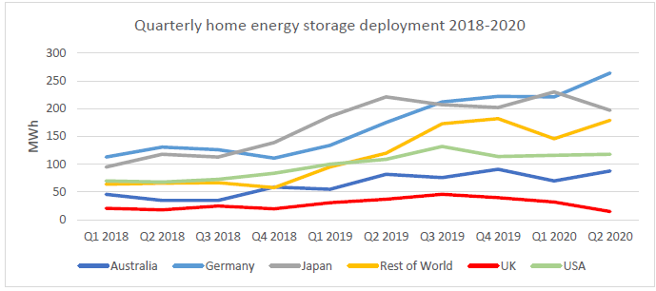
Figure 1: Global Home Energy Storage Deployment (Source: IHS Markit, 2020)
Mechanism such as the Feed in-Tariff, Domestic Renewable Heat Incentive, Clean Heat Grant and, most recently, the Boiler Upgrade Scheme have not encouraged the installation of storage systems alongside other decarbonisation and other energy efficiency measures. As a result, a large portion of decarbonisation projects have not gone as far as they could have, choosing to install generation technologies like solar without storage facilities.
While such installations have helped reduce carbon emissions, they themselves do not enable households to shift their demand and make the most of not using grid electricity at period of high demand and high cost. This is only possible when such measures are combined with storage, making the most ESMs and allowing households to reduce their bills. This only become even more pertinent as the UK seeks to electrify household heat and transport demand, both which are expected to double existing demand typically at during evening periods when solar has lower generation.
There are very few datasets available to monitor the installation of battery storage devices, which makes it difficult to determine what drives consumer uptake. However, it is possible to read across from the uptake of solar installations for an indication of how applying VAT exemption to battery storage installations could drive consumer uptake.
There are roughly 1.3 million UK buildings with solar panel installations, according to the latest MCS installations data. There was huge growth in solar systems being installed in 2022. The (MCS) recorded 130,596 solar photovoltaic (PV) systems were installed in UK homes in 2022, a 114% rise from 2021. This figure comprises most of the total 163,341 MCS certified installations, which is the highest number of installations since 2015, which saw 200,000 installations.
It is likely that this growth in installations was in part due to the energy crisis and rising energy bills, but it is notable that it also happened despite increasing solar installation costs resulting from global trade and supply chain issues. Over the period of January 2022 to January 2023, the average cost of installing solar increased from £7065.85 to £10298.15. As such, the zero-rated VAT on solar helped to offset some of the increased cost, contributing to solar being an attractive investment to homeowners during a period of high energy bills.
The BEIS Public Attitudes Tracker also provides insight into what drives consumer behaviour in the uptake of solar installation, and it can be inferred that the financial savings from solar being exempted from VAT has been a significant contributing factor.
Firstly, the Spring 2022 ‘BEIS Public Attitudes Tracker: Energy Infrastructure and Energy Sources’ notes the popularity of solar panels in owner-occupied homes, with 2/3 of people living in owner-occupied homes (66%) saying that they either already had or would be likely to consider installing solar panels in their home in the next few years.
Of those who did not already have solar panels, but said they were likely to install them in their home in the next few years, the two main motivations for installing solar were therefore economic and environmental concerns. 85% said that they were motivated to install them to cut electricity bills and 81% said it was due to solar providing a renewable source of electricity.
Importantly, the survey asked people living in owner-occupied homes who said they were unlikely to install solar panels their reasons for this choice. The financial expense was, by far, the main barrier with 63% of this group saying they were too expensive to install. Those who had not already installed solar panels were asked what list of possible factors would encourage them to install solar panels. Once again, more financial support for installation was by far the biggest factor that would encourage them to install solar, with 76% picking this factor, with 45% picking selling electricity to the national grid and 38% wanting more information.
It is clear from the government’s survey that installing solar panels on residential homes is popular with homeowners, which is driven by both environmental concerns and as a way of saving money over time. The biggest barrier faced by homeowners is the upfront financial costs, and measures such as 0% VAT on installing solar panels is one way of providing financial support to encourage an even greater uptake of solar installations.
There have been very few surveys on what drives consumer behaviour for installing energy storage devices. However, ClientEarth’s Climate Snapshot 2019, which surveyed UK attitudes towards climate change and its impacts, found that there was strong consumer demand for installing battery storage device if there was more financial assistance.
The survey asked whether there were actions participants would like to take personally or as a household, in response to climate change concerns, if there was greater assistance from the UK Government or through community or commercial schemes. 8% had already installed a home energy storage device, and 56% indicated they would be likely to if stronger government incentives were available (Fig. 2), and the response was nearly identical for installing solar panels.
Zero rating VAT on home energy storage would have a material impact on the economic case for consumers, bringing project costs within consumer ‘willingness to pay’ thresholds and shortening payback periods. Below we provide indicative data on common costs for home energy storage systems, demonstrating how the removal of 20% VAT could make a significant difference to the consumers investment case for buying storage.
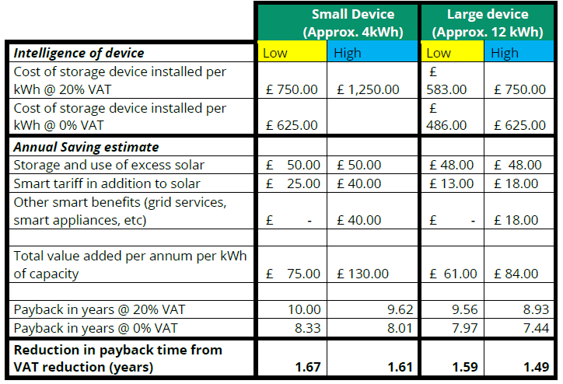Figure 2: Indicative cost and payback data on home energy storage. (Data provided by REA Members)
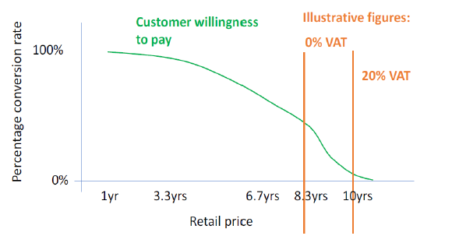
Figure 3: “Willingness to Pay” consumer thresholds for home energy storage and the impact of 0% VAT (Survey conducted by REA Member).
On average the zero-rated VAT could shorten payback periods for consumers by 1.5 years (see Figure 2). Survey data, conducted by one of our members, also demonstrates how this significantly increases the conversion rate for customers, bringing costs and payback within attractive payback periods (See Figure 3). This data is further backed up by pricing experiments and real sales data.
Corresponding with the BEIS Public Attitude Tracker, the results of the ClientEarth survey suggest that homeowners have similar attitudes towards both solar and battery energy storage installation. Homeowners are driven by a desire to generate a renewable source of electricity and cut their energy bills, and they would install these devices if there was more financial assistance available from Government through mechanisms such as the VAT relief. As indicated by the data above, consumers would be more willing to pay if the payback period was reduced due to VAT exemption being applied.
Objective 3: Alignment with broader VAT principles
The new VAT rules have created an inconsistent tax environment. Where storage is installed as part of a broader solar project, providing an ‘ancillary service’, then a zero rating can be applied. If storage is installed by itself, VAT is rated at the standard rate of 20%. This creates a 20% penalty for those who have already taken steps to install low carbon energy generation, and now wish to retrofit storage to optimise their existing energy efficiency and low carbon system.
Including both options for new install and retrofit in the energy saving materials list will make the tax rules simpler in terms of VAT. Currently, if a homeowner does a comprehensive retrofit to their property, including battery storage would mean that parts of the retrofit are taxed at the higher rate of VAT, while other parts of the retrofit are at a lower rate. If battery storage has different VAT rates for different types of installations, this ultimately distorts the market. Removing these anomalies would enable these technologies to have the same lower VAT rate apply, thereby simplifying the tax regime.
Question 4: Can you explain how this type of battery storage operates?
Domestic batteries, including lithium and thermal storage systems, provide energy efficiency services to homeowners by allowing them to shift and reduce their energy demand and lower their bills. Both the Government’s Net Zero Strategy and recent Smart System and Flexibility Plan note the importance of these services, identifying them as key enablers to both decarbonisation and delivering energy security.
By interacting with low-cost renewables and other clean technologies, such as solar PV, heat pumps and electric vehicles, storage systems help homes move away from fossil fuels. As solar panels produce energy during the day, batteries allow for the generated power to be stored and used when needed in the evening, displacing the need for the homeowners to rely on electricity from the grid when both demand and prices are at their highest. Ultimately, storage allows homeowners to make the most of home generation, electrified energy systems and time-of-use tariffs, reducing both bills and their reliance on fossil gas.
Question 5: What is the typical cost of installing this type of battery storage in residential accommodation?
As provided in the second question, the REA has provided indicative data on common costs for home energy storage systems below, demonstrating how the removal of 20% VAT could make a significant difference to the consumers investment case for buying storage. The cost of installing this type of battery storage depends on the size of the device. For small devices (approximately 4 kWh), the cost ranges from £750 - £1250 per kWh installed with the 20% VAT rate applied. For large devices (approximately 12 kWh), the cost ranges from £583 - £750 per kWh installed with the 20% VAT rate applied.
On average the zero-rated VAT could shorten payback periods for consumers by 1.5 years (see Figure 1). Survey data, conducted by one of our members, also demonstrates how this significantly increases the conversion rate for customers, bringing costs and payback within attractive payback periods (See Figure 2). This data is further backed up by pricing experiments and real sales data.
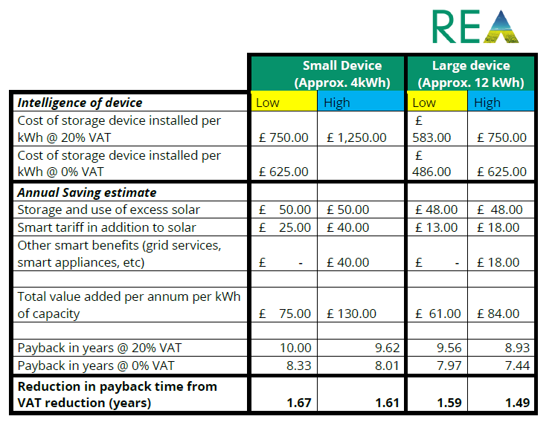
Figure 2: Indicative cost and payback data on home energy storage. (Data provides by REA Members)

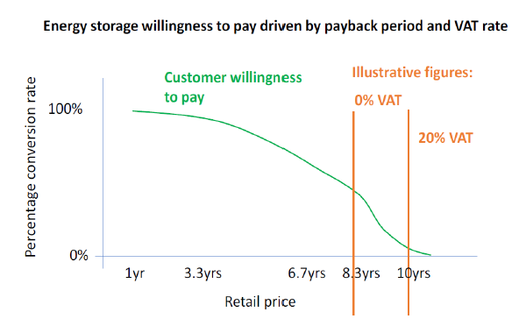
Figure 3: “Willingness to Pay” consumer thresholds for home energy storage and the impact of 0% VAT (Survey conducted by REA Member).
Question 6: What are the advantages and disadvantages of including this type of battery storage within the relief?
Advantages
- The addition of adding battery storage for both retrofitting and as a standalone technology would increase energy efficiency and reduce carbon emissions by allowing households to maximise the potential of their solar systems or use stored energy during peak times.
- Including both types of battery storage would simplify the VAT rules by removing the current distortion in the market.
- The current VAT rules effectively penalise those who cannot afford a complete energy saving system in one go, which could be removed by extending VAT exemption to both options.
- Zero rating VAT will likely lead to higher tax taking through increase in installations, resulting in jobs and higher income and corporation tax revenues.
- This will encourage the installation of storage as the UK increasingly electrifies its heat and transport demands with storage working well in conjunction with heat pumps and EV charging points.
Disadvantages
- Households who decided to retrofit their solar system with battery storage devices between the announcement of VAT exemption for energy saving materials in 2022 and the inclusion of battery storage when retrofitted to a solar panel would have already been penalised the 20% VAT rate. However, they will have made the economic case for installing storage at the time, so while an additional cost at the time, it is unlikely to have a long-term impact on such market participants.
Are there any other technologies you believe meet the 3 objectives, but do not currently qualify for the relief?
It is important that when including energy storage within the VAT, that all forms of storage technology are included, not just lithium batteries. In particular, we recommend that thermal storage systems should be included. These store energy as heat, which can be produced from low carbon on-site sources, such as heat pumps or solar thermal systems. They can charge at points of peak generation, or when grid electricity costs are low, and then provide heat to the house when grid demand is high or when generation may not be possible, such as in the evening. Thermal storage, along with battery and other storage devices, should be included in the relief. For example, Sunamp offer a commercially available thermal storage systems that could be used to deliver energy efficiency benefits in domestic situations.
Equally consideration should be given to VAT relief applying to the installation of domestic EV charging points, as an additional energy saving material that will also drive uptake of low carbon transport options.
If so, for each technology, can you answer the following questions (including evidence where possible):

Question 7: How would you describe and define this technology for the purposes of the ESMs relief?
Thermal Storage could be included the definition for storage, if defined suitably broadly to include all storage technologies capable of capturing onsite generation. It in important that the definition of storage does not only focus on batteries.
Question 8: How does the suggested technology meet each of the 3 objectives in Chapter 2?
Objective 1: Improving energy efficiency and reducing carbon emissions
Thermal storage helps to shift consumer demand for heat, and better align heat production to when the grid emissions are low and when energy production is cheaper. They work with heat pumps, wind and solar, grid and microgrid electricity, waste heat, combined heat and power (CHP) and boilers, and store 4 to 10 times more energy than conventional heat store. As such they maximise the energy efficiency benefits and emission saving of other low carbon heating systems.
Objective 2: Cost effectiveness
Thermal stores allow households to produce low carbon heat when grid electricity prices are lowest, or if combined with solar PV or Solar Thermal, during the daytime. The heat can then be released when it is needed, typically at night when grid demand is highest or other low carbon solutions may not work. This ability to shift when heat is produced, compared to when it is most needed, greatly enhances the cost effectiveness of other low carbon heat solutions, reducing their operational costs and enabling significant savings.
Objective 3: Alignment with broader VAT principles
Given proposals to provide VAT relief to Energy Storage devices, it would be appropriate to ensure consistent treatment of all potential storage technologies. The extension to VAT relief to thermal storage also fits in with wider tax aims of supporting energy efficiency and low carbon measures.
Question 9: Can you explain how this technology operates and does it work conjunction with other technology? If so, how?
Thermal storage works with a wide range of domestic low-carbon generation technologies, including heat pumps, solar thermal and traditional boilers. They use high performance phase change materials to store generated heat and can be used in a variety of heat and cooling applications in domestic homes. In doing so they shift generation and demand.
Question 10: What is the typical cost of installing this technology in residential accommodation?
Costs will depend on size and what the thermal store is being used for, however they are typically equivalent to battery storage units in most domestic homes.
Question 11: What are the advantages and disadvantages of including this technology within the relief?
- Ensures All forms of storage are included in VAT relief and maximises the energy efficiency and cost benefits of other low carbon heating systems already include on the energy savings material list.
- Will provide an incentive for homeowners to consider installation of storage alongside low carbon heat generations systems. This should be encouraged.
Are there any technologies which currently qualify for the relief which you believe do not meet the 3 objectives and should not qualify for the relief?
If so:
Question 12: Which technology does not meet the 3 objectives?
The REA does not plan to answer this question.
Question 13: Can you explain why you think that this technology does not meet any of the 3 objectives and therefore should not be included within the relief?
The REA does not plan to answer this question.
Question 14: Do you think the relief for the installation of ESMs in a building intended for use solely for a relevant charitable purpose should be reinstated? And if so, why?
The REA are supportive of removing financial barriers to the installation of ESMs and believe that the relief for the installation of ESMs in a building intended for use solely for a relevant charitable purpose should be reinstated. We believe the original relief was revoked due to VAT EU state aid rules around how support would need to be targeted. Given we are now outside the EU and have our own VAT rules in place, we believe it to be appropriate to reconsider the application of VAT relief to charities.
As of 2 May 2023, there were around 169,00 charities on the Charity Commission’s register, with an overall sector gross income of around £87.7 million. Small charities comprise 96% of the voluntary sector in the UK. In 2018/19, the overall number of charities in the UK was 163,150, 156,646 of which were small charities with an income of under £1m and the highest proportion had an income of under 10k. Given the extremely tight revenue-cost margins of most charities, any measures that remove financial barriers to the uptake of installing ESMs would be particularly beneficial.
Question 15: As a charity are you considering installing ESMs in your buildings?
The REA does not plan to answer this question.
if yes,
what ESMs are you considering installing?
Not applicable.
what impact would VAT relief have on this decision?
Not applicable.
Question 16: To what extent do you think that charities would benefit from the reinstatement of this relief?
The REA does not plan to answer this question.
Question 17: What are the advantages and disadvantages of reinstating the relief?
The REA does not plan to answer this question.
Question 18: Are there any other suggestions you have for making the relief more effective and efficient?
The REA suggest that the VAT relief provided to energy saving materials ought to be permanent rather than ending in 2027. By making the relief permanent, the Government would provide a signal to the market that there is long-term policy certainty on providing this relief to remain internationally competitive.
Question 19: Are there any other issues that you would like to raise?
No.

Transitioning to a net zero energy system: smart systems and flexibility plan 2021, BEIS & Ofgem [website], Transitioning to a net zero energy system: smart systems and flexibility plan 2021 - GOV.UK (www.gov.uk).
Delivering a reliable decarbonised power system, Climate Change Committee [website], https://www.theccc.org.uk/publication/delivering-a-reliable-decarbonised-power-system/;
Net zero strategy, build back better, HM Government [website]: https://assets.publishing.service.gov.uk/government/uploads/system/uploads/attachment_data/file/1033990/net-zero-strategy-beis.pdf
The MCS Data Dashboard, Microgeneration Certification Scheme [website], https://datadashboard.mcscertified.com/InstallationInsights
BEIS Public Attitude Tracker: Energy Infrastructure and Energy Sources, Spring 2022, UK, BEIS Public Attitude Tracker, https://assets.publishing.service.gov.uk/government/uploads/system/uploads/attachment_data/file/1082719/BEIS_PAT_Spring_2022_Energy_Infrastructure_and_Energy_Sources.pdf, p. 12.
Climate Snapshot 2019, ClientEarth, https://www.clientearth.org/latest/documents/clientearth-s-climate-snapshot-2019/, p. 24.
https://sunamp.com/en-gb/
Charities in England and Wales, Charity Commission, https://register-of-charities.charitycommission.gov.uk/sector-data/sector-overview
The number of small charities, Small Charities Data, https://smallcharitiesdata.org/topic/the-number-of-small-charities/

