REA suggested text for Resource Frameworks
EA’s draft suggestion during meeting in yellow – applicable to both ADRF and CRF.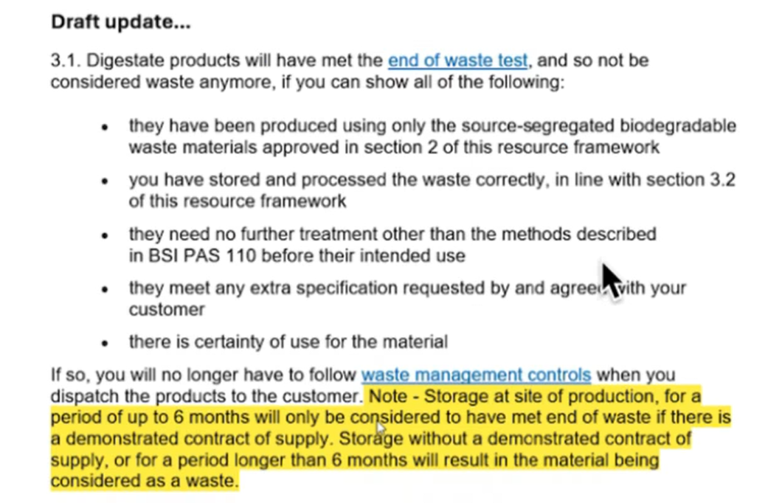
REA suggestion - ADRF
Draft replacement for last para of 3.1
If so, you will no longer have to follow waste management controls when you dispatch the products to the customer or when:
- you store the products at a production site or storage location under your control;
- no product you supply for growing media manufacture is in your store(s) for longer than 10 months;
- no product you supply for use other than growing media manufacture is in your store(s) for longer than 6 months; and
- there are contracts of supply and/or sales orders that cover the quantity of the same product type in storage at any one time, and/or your sales history for the most recent 12 months shows that at least as much of the same product type was supplied for use.
Note: the last bullet point describes a method by which you can demonstrate the material is certain to be used.

REA suggestion - CRF
Draft replacement for last para of 3.1
If so, you will no longer have to follow waste management controls when you dispatch the products to the customer or when:
- you store the products at a production site or storage location under your control;
- no product you supply for growing media manufacture is in your store(s) for longer than 10 months;
- no product you supply for use other than growing media manufacture is in your store(s) for longer than 6 months; and
- there are contracts of supply and/or sales orders that cover the quantity of the same product type in storage at any one time, and/or your sales history for the most recent 12 months shows that at least as much of the same product type was supplied for use.
Note: the last bullet point describes a method by which you can demonstrate the material is certain to be used.

